**AKUANA BCD Order Form**

Order No.： ________________ Dealer： _______________

Contacts： _______________ Phone： _______________

Email： _______________ Order Date： _________/_____/ _____

Memo： ______________________________________

Please Mark with color “□” at specific position “□”

1. Definition of customization parts

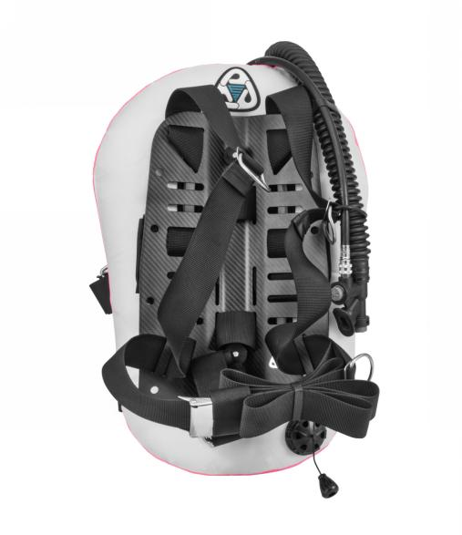 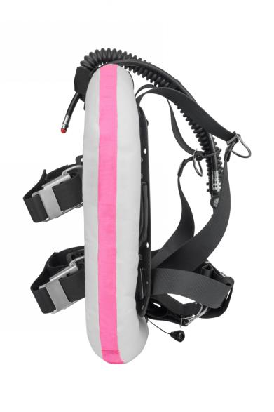 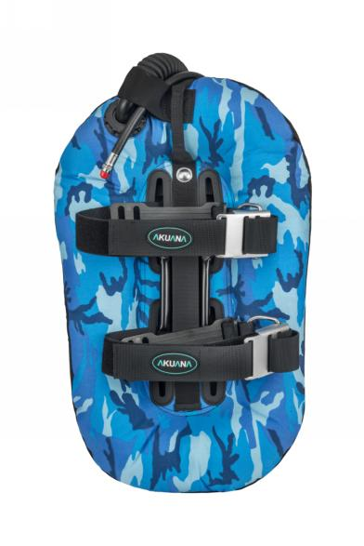

Front Side Back

1. Model

□Seal 25 □Seal 30 □Seal 50

□Sonic 20 □Sonic 30 □Tales 25 □Tales 50 □HB training sidemount

1. Color Pattern

**SEAL Common Series：**

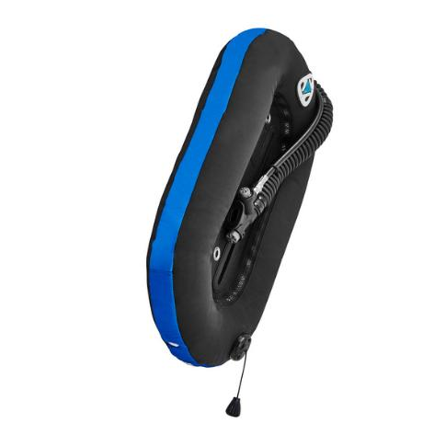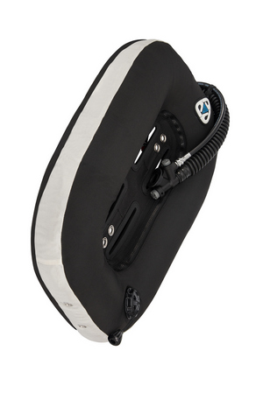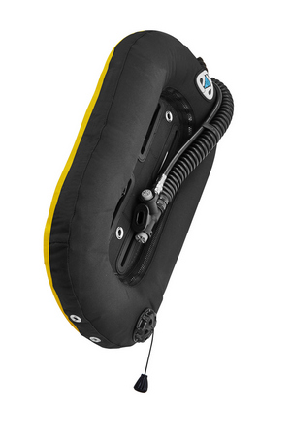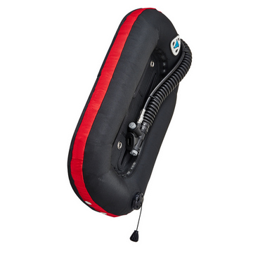

□All black（available for all models）

□Side Red □Side Blue □Side Yellow

（available for all models）

□Side white □Blue camo/Side black □ Snow camo

（only available for 30/50 lbs）

**SEAL Classic Series：(only available for 25lbs model)**

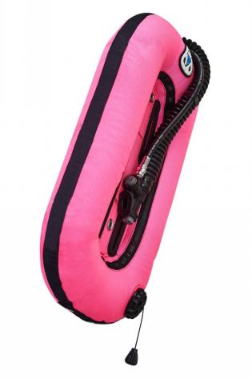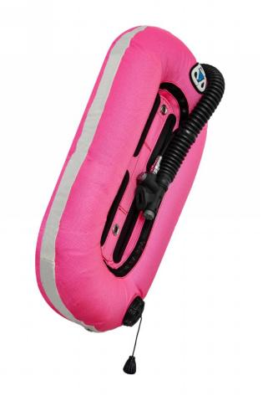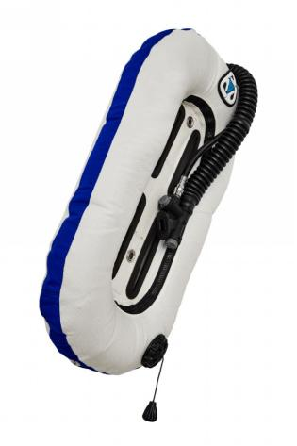

□Front&Back Pink/Side Black

□Front&Back Pink/Side White

□Front&Back Black/Side Pink

□Front&Back White/Side Pink

□Front&Back White/Side Blue

□Front&Back White/Side Black

□Front&Back Blue/Side White

Camo Series：(only available for 25lbs model)

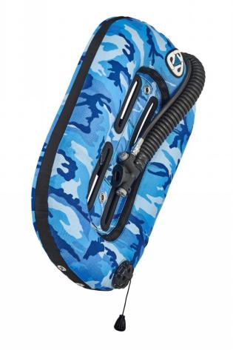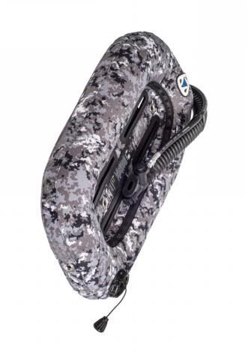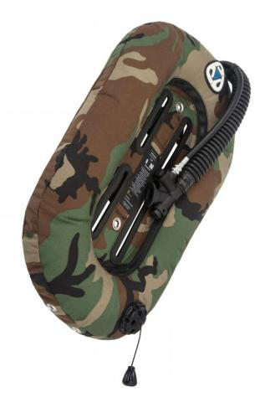

Please contact with dealer for customization price

□Front&Back Ocean Camo/Side Black

□Front&Back Ocean Camo/Side White

□Front&Back White/Side Ocean Camo

□Front&Back Snow camo/Side Snow camo

□Front&Back Jungle camo/Side Jungle camo

□Front&Back Jungle camo/Side Black

□Front&Back Black/Side Jungle camo

**SONIC BCD:**

□Front&Back&Side Purple

□Front&Back&Side Lake blue

□Front&Back&Side Black

□Front&Back&Side Pink

□Front&Back&Side Oliver

□Front&Back&Side White

□Front&Back&Side Peach fuzz

**TALES BCD:**

□Front&Back Purple,Side Green (25lb only)

□Front&Back lake blue,Side White(25lb only)

□Front&Back Front&Back&Side Oliver(25lb only)

□Front&Back Peach fuzz,Side white(25lb only)

□Front&Back Purple,Side black (50lb only)

□Front&Back Lake blue,Side white (50lb only)

□Front&Back Side Oliver (50lb only)

**HB training sidemount**

□HB extreme wing black

□HB wing( □Lake blue □Purple □Oliver □Pink)

□HB2 wing(□Camo □pink □blue camo □blue)

D. Customized color series：

(45 days of lead time, example: Front Blue, Side White, Back Red)

Please contact dealer for price

□Front_______/Back_______ /Side_______

Customized embroidery(Not available for HB and HB extreme wing)

Please refill information below if customized embroidery is needed.

Seal embroidery on the front side Sonic embroidery on the back side

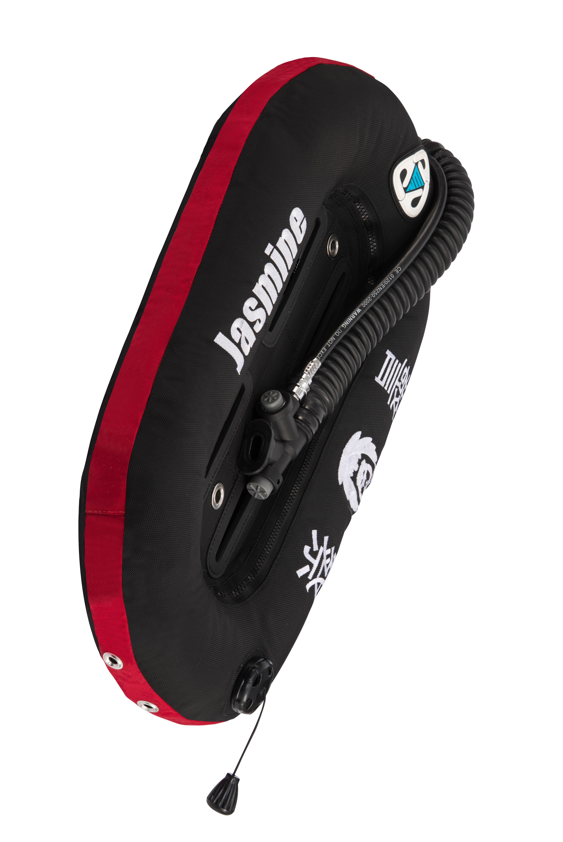

As shown by the pictures above

Left Content: ______________ Right Content: ______________

Font Color (Single Choice)：

□8465 Yellow □9461 Blue □8290 Red □8585 Silver Gray

□8430 White □8318 Pink □8739 Green □8429 Black

Craft：

Font：Impact Dimension：Height: 5cm X Width: 30cm

Width：12 characters (space included) Alignment：Bottom

Contents：

1234567890 ~!@#$%^&><-+”|❤★.:/?\

abcdefghijklmnopqrstuvwxyz

ABCDEFGIJKLMNOPQRSTUVWXYZ

~ FIN ~