**AKUANA Drysuit Order Forms**

Order No.： ________________ Dealer： _______________

Contacts： ______________ Phone： _______________

Email： _______________ Order Date：_____/_____/____

Memo： ______________________________________

Please Mark with color “□” at specific position “□”

(45 days of lead time)

Specifications

Sex： □ M/ □F

Model： □ MATRIX / □ ARCTIC TERN /□ PANGONG

Size：_______

International version color choice

Camo：□ Blue camo □ ACU camo □Jungle camo □ Snow camo

Pure color：□ Red □ Blue □ White □ Pink □ Purple □ Lake blue □ Yellow □ Black □ Oliver □ Peach fuzz □ Yellow

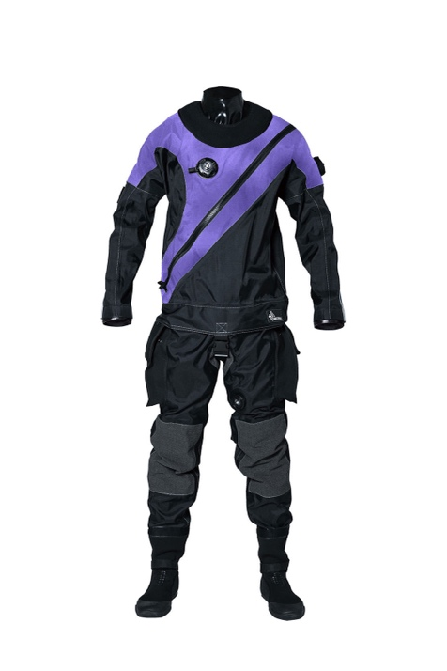

Position: _______

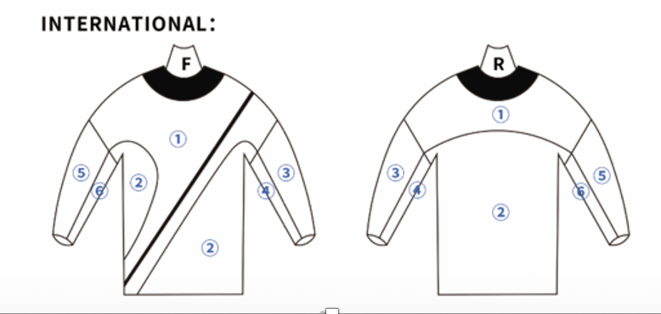

1. Pangong color choice

Position： □ Chest Upper arm Upper back □ Side □ Color stripe

Camo：□ Blue camo □ ACU camo □Jungle camo □ Snow camo

Pure color：□ Red □ Blue □ White □ Pink □ Purple □ Lake blue □ Yellow □ Black □ Oliver □ Peach fuzz

穿军服的男子

中度可信度描述已自动生成穿军服的男子

中度可信度描述已自动生成穿着黑色衣服的男人

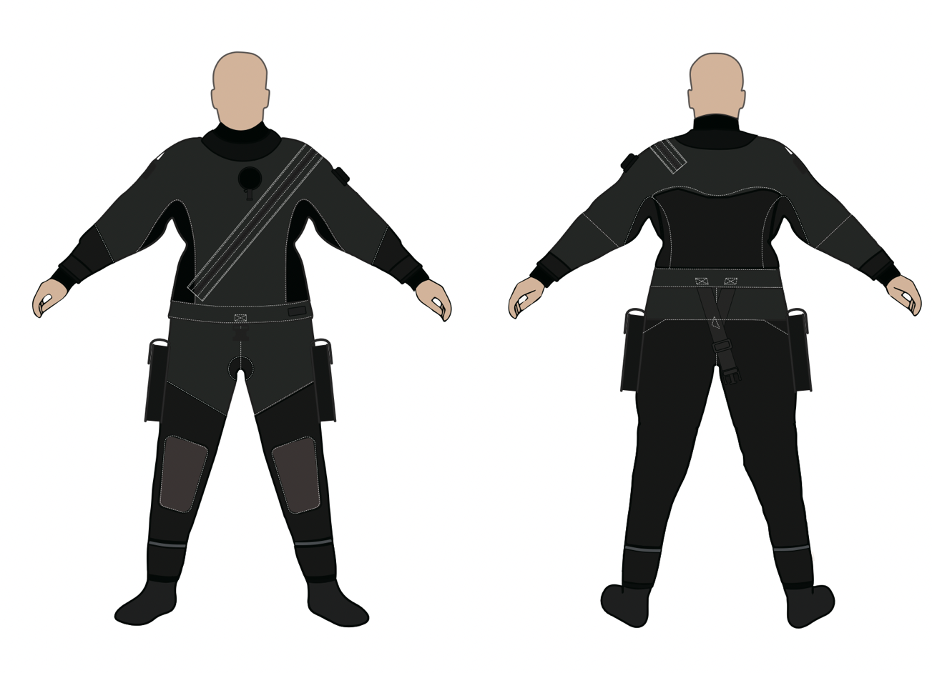

Others

1.□ Quick release systems(Silicone) □ Fix seal (Latex)

2.Quick Release Neck Seal （AKUANA, Silicone）

Size □ S □ M □ L

1. □ Quick Release Wrist Seal （AKUANA, Silicone）

Size □ S □ M □ L

1. □ Dry glove System (Additional fee)
2. □ Sitec Pee-Valve (Additional fee)

□ AKUANA Dry suit Socks (Dry suit boots available) or □ Integrated Boot

Size of Socks □ XS □ S □ M □ L □ XL □ XXL

Size of Boots □ S □ M □ L □ XL □ XXL

1. AKUANA Hood

Thickness □ 3mm/ □6mm

Hood Size □ M □ L □ XL

1. □ Undergarment

Size □ XXS □ XS □ S □ M □ MK □ L □ XL

Thickness □ 300

1. Embroidery：□ Yes □ No Content：_____________________

Color：□ Red □ Yellow □ White □ Black □ Silver □ Blue

Special request：_______________________