Please see below an extract from HDC’s email dated 24th July, re their planned Community Safety Vehicle Visit to South Kilworth, 8th Sept’26

The community safety vehicle has been funded jointly by the CSP and the Office of Police and Crime Commission (OPCC). We are now using the vehicle to visit parishes throughout the district over the next few months.

The vehicle facilities include a variety of useful information regarding community support and advice, an inside seating area, and an area to provide refreshments. Arrival times and parking locations will be confirmed with you nearer the time so this can be communicated to residents via social media/newsletters etc to encourage them to attend.

Our aim is to assist the residents with any Community Safety concerns, or issues relating to their local community. For any other concerns we will try and assist and contact the relevant department within the authority.

Diane Peacock
Community Safety Officer

Anti Social Behaviour (ASB) Reporting Form | Community Safety Form | Harborough District Council

D.Peacock@harborough.gov.uk

01858 821199
Mobile: 07880053932

Harborough District Council
The Symington Building Adam & Eve Street
Market Harborough, Leicestershire, LE16 7AG
www.harborough.gov.uk

www.harborough.gov.uk/communitysafety
Twitter: @HarbCSP
Facebook: Harborough District Community Safety Partnership

Please do not print this email unless you really need to
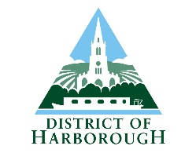
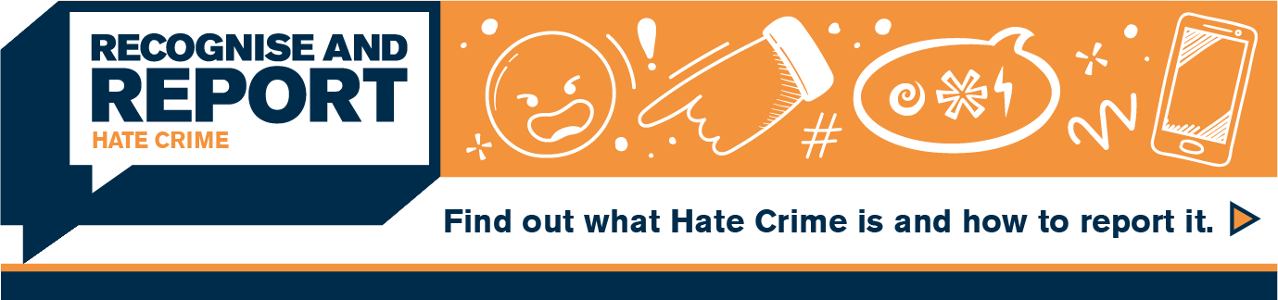
https://www.leics.police.uk/advice/advice-and-information/hco/hate-crime/

The Council’s Anti-Social Behaviour Policy and information on how victims can request a review of the response to their report/s of ASB under the ASB Case Review process can be found on our website at www.harborough.gov.uk/communitysafety . Information in other formats can be requested by emailing communitysafety@harborough.gov.uk



