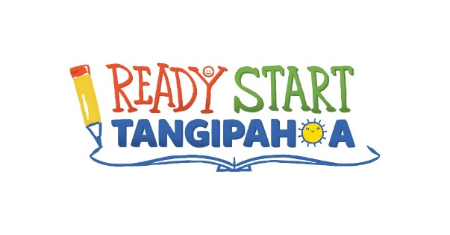

2026-2027 Request for Early Childhood Seats

For the 2026-2027 school session, The Ready Start Tangipahoa Early Childhood Community Network is requesting 692 LA4 seats. This maintains the number of seats offered during the 2025-2026 school session. LA4 students will be placed in all Tangipahoa Parish School System elementary schools. Diverse delivery LA4 classes at The Early Learning Center of Ponchatoula (40 seats), Ponchatoula Prep Academy (20 seats) and Explore and Learn Early Learning Center in Hammond (20 seats) will continue to be funded by LA4.

We are encouraging public input for the 2026-2027 funding plan. Please direct all comments to Carmen.brabham@tangischools.org. Comments may also be mailed to 59656 Puleston Rd. Amite, LA 70422, faxed to 985-748-2455, or hand delivered to the Academics Department at the Tangipahoa Parish School System District Office.

