Morgen Long 2023 Willamette Valley Chardonnay

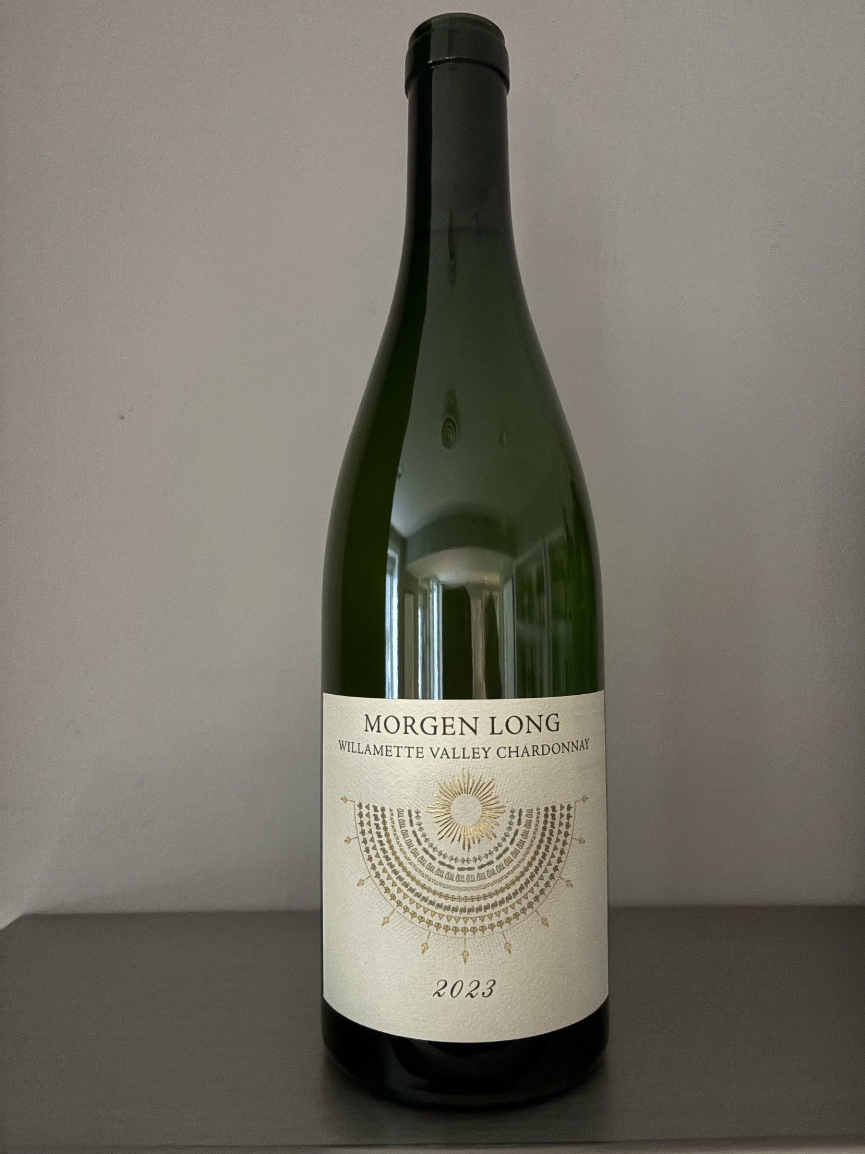

Founded in 2014, Morgen Long has quickly emerged as one of the most exciting names in American Chardonnay.
From its beginnings in the Willamette Valley, the winery has remained singularly focused on crafting expressive, site-driven Chardonnays that showcase the remarkable potential of Oregon's premier wine region. His wines are defined by precision, energy, and balance, offering a transparent expression of vineyard and vintage rather than a prescribed house style. The result is an exclusive collection of Chardonnays distinguished by freshness, texture, and a compelling sense of place.

The 2023 Willamette Valley Chardonnay brings together eight vineyards from four distinct areas, creating a beautifully layered express‍ion of the region. Precise, textured and age-worthy, it combines orchard fruit generosity with refreshing acidity and a striking saline finish.

‍

About this wine

Appellation/Region: Willamette Valley, Oregon, USA.

Grape Variety: 100% Chardonnay.

Alcohol content: 12.5%

Location/Climate/Soil: Cool-climate vineyards across South Salem Hills, Dundee Hills, Eola-Amity Hills and Yamhill-Carlton. The blend reflects the Willamette Valley’s varied volcanic and marine sedimentary terroirs and Pacific-influenced growing conditions.

Farming Practices: Sustainable viticulture combining traditional methods with meticulous vineyard management.

Vinification: Harvested September 6-22, 2023. Individual lots were pressed and the must allowed to brown before sulfur addition. Vineyard-specific native yeasts starters-initiated fermentation in stainless steel, followed by fermentation in French oak on full solids and spontaneous malolactic fermentation. Aged approximately one year in French oak then six months in stainless steel on lees. Unfined and unfiltered.

Tasting notes: Fragrant pear, nectarine, citrus oil, wild herbs and subtle floral notes meet wet stone and a delicate almond nuance. The palate is silky yet energetic, with ripe orchard fruit, tart citrus, vivid acidity and chalky, saline minerality. The finish is long, focused and remarkably fresh.

Food pairings: Ideal partner to oysters, seared scallops, lobster, roasted seafood, sophisticated roasted poultry and vegetable dishes.

Scores/Awards: Consistently scored in the high/mid -90s across respected critics: 96 points – Paul Gregutt, 95 points – Decanter, 94 points from Vinous – James Suckling .

Proudly distributed in MA by Dolce Vita Wine Merchant LLC
www.dolcevitawines.com

