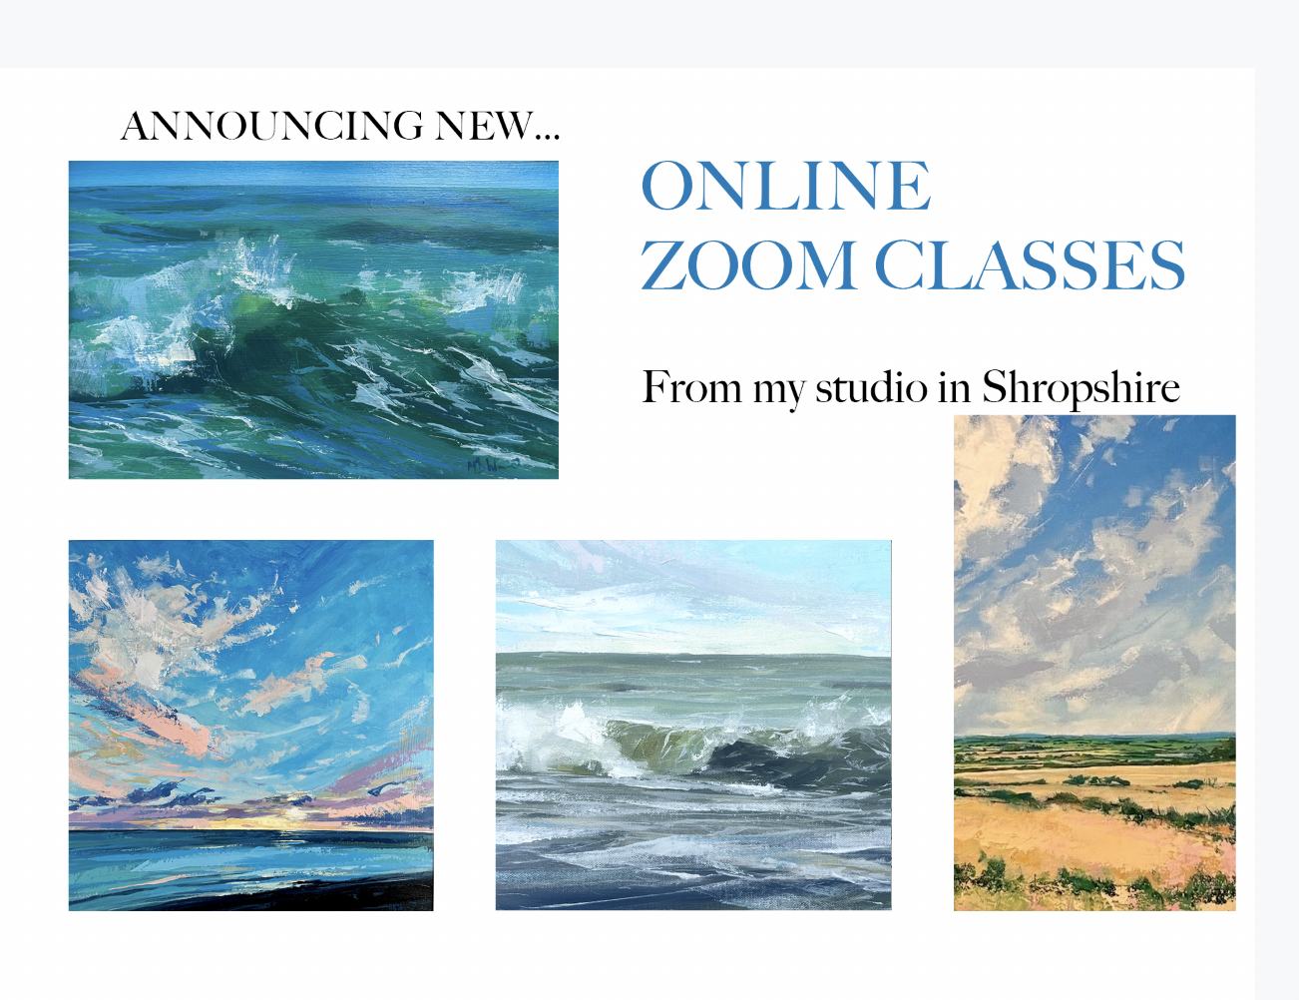

A few spaces left... online zoom classes
It's cold and raining outside but warm in my studio!
A few spaces still remaining if you fancy joining me?
First class is this Monday morning 17th Nov.....
Other classes 1st, 8th & 15th Dec (10am - 12)

Classes are only £30 each.... could be a Christmas present!
The idea is that you can either paint along, just watch or watch back at a later date with the video link I send you following the class.
Please note: All classes will be Acrylics but you are more than welcome to use Oils if you prefer.

To take part: you will need the Zoom App. (on your computer/tablet/phone)
During the session: Following an initial welcome, you will be muted so that everyone can concentrate on Mark’s voice. Although you can switch on your mic if you have a question.
Paint along or just watch and concentrate on his techniques and processes.
At the end of the demo: There is an opportunity to discuss any points from the session.
After the session: You will be emailed a link to the recording of the session (this is just for you so please do not share). You will have a couple of weeks to watch again where you will be able to pause or fast forward the session so that you may paint along again or just watch.
Being able to watch the video back proved very popular last year. Indeed a couple of people who could not attend a certain date, purchased the class and watched it back in their own time on numerous occasions.

