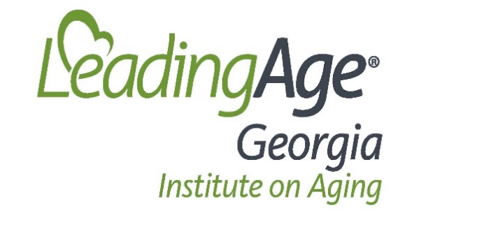

2020 LeadingAge Georgia Institute on Aging (Center for Positive Aging)
Board of Directors

2020 Officers
Chair Karon Winston, Lutheran Towers
Chair-Elect Weyman Perry, Personal Care, Inc.
Treasurer James Larson, Dixon Hughes Goodman
Secretary Suzanne Brown, St. George Village

Class of 2020
Weyman Perry Personal Care, Inc. HCBS
Karon Winston Lutheran Towers HUD
Carolyn Roper Consumer (Glen Memorial UMC) Consumer
Kevin Shaw King’s Bridge Retirement Community IL/AL
Suzanne Brown St. George Village LPC

Class of 2021
Antoinette Sturm Saint Anne’s Terrace IL
Beth Cayce CaraVita HCBS
James Larson Dixon Hughes Goodman Business
Mary Helton A.G. Rhodes & Rehab NCF

Class of 2022
Pat Coppin Alice Williams Towers HUD
Tim Knight Park Springs LPC
Julie Parker Canterbury Court LPC
Laura Rice Briarcliff Oaks HUD

