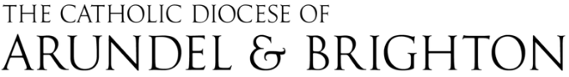 | Annual Review | Employee name

Evidence and reflection form:
POINTS FOR REFLECTION | COMMENTS
What has gone well over the past year?
What are my strengths and what skills have I developed?

How do I want my career to progress?
What barriers/difficulties have I encountered this year, and what have I learnt from dealing with them?

Summing up the year
REVIEWER STATEMENT
REVIEWEE STATEMENT

objectives for the year AHEAD
Objective 1: | Describe
Actions to be taken to achieve the objective
Support / training / resources that will be needed
Objective 2: | Describe
Actions to be taken to achieve the objective
Support / training / resources that will be needed
Objective3: | Describe
Actions to be taken to achieve the objective
Support / training / resources that will be needed

Professional development and other support for the year:
PROFESSIONAL DEVELOPMENT TO BE PROVIDED | BY WHO? / WHEN?
ANY OTHER SUPPORT NEEDED? PLEASE CONSIDER AND DISCUSS THE FOLLOWING SAFETY MATTERS
- Display Screen Equipment – e-learning is available via E: amanda.jones@abdiocese.org.uk
- Lone Working Arrangements where applicable – resources are available via E: stefy.jurado-montoya@abdiocese.org.uk

Signed (Reviewee) …………………………………… Signed (Reviewer)

Date:

