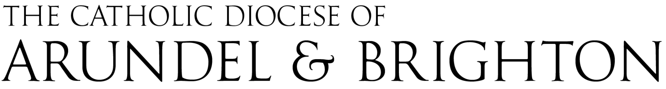

CASH DONATIONS DECLARATION FOR GASDS CLAIM
This submission will be used to claim a grant of 25% under the Gift Aid Small Donations Scheme
The maximum claim per church is £8,000 per tax year (bringing a receipt of £2,000 per year).

Name of Parish: |  |  | Parish Code  (Office Use)  __ __ __ __ __
Town: |  |  | Parish Code  (Office Use)  __ __ __ __ __

 | CASH COLLECTIONS - GASDS ELIGIBLE |  |  | TOTAL
 | Church A | Church B | Church C | TOTAL
Cash Offertory | £ | £ | £ | £
Cash Second Collections | £ | £ | £ | £
Donations Into Wallboxes  Not Honesty Boxes or Third-Party Charities | £ | £ | £ | £
TOTAL CASH DONATIONS | £ | £ | £ | £

Table A - 1 January to 5 April

Table B - 6 April to 31 December
 | CASH COLLECTIONS - GASDS ELIGIBLE |  |  | TOTAL
 | Church A | Church B | Church C | TOTAL
Cash Offertory | £ | £ | £ | £
Cash Second Collections | £ | £ | £ | £
Donations Into Wallboxes  Not Honesty Boxes or Third-Party Charities | £ | £ | £ | £
TOTAL CASH DONATIONS | £ | £ | £ | £

Name of Church/es: |  | Gift Aid Code  (Office Use)
Church A:
Church B:
Church C:

DECLARATION
I confirm that the sums identified are eligible for submission under the GASDS rules
- Each cash donation was £30 or less
- Counting records by denomination are maintained in the parish - these must be held for six years
- All claimed sums were banked in full (no deductions for petty cash)

Parish Priest  Name |  | Signature
Chair of Finance  Name |  | Signature

Date

Wallbox donations e.g. Poor Box, Parish Maintenance are fully allowed for this return.

Wallboxes or collections for specific third-party charities e.g. CAFOD Box, and honesty boxes for newspapers etc are not eligible.

Please complete this declaration and send it to E: finance@abdiocese.org.uk by 28 February.

E-signatures and e-mail are encouraged, rather than printing and signing.

