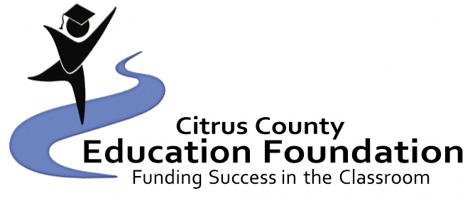




$1000 JROTC Scholarship Application Spring 2023
One student from each high school will be awarded – one time
(Application MUST be typed, or computer generated)

Last Name: First Name: Middle Initial:

Address:

City/Zip Code: Telephone Number:

High School: GPA:

Date of Birth: Social Security Number:

Parent(s)/Guardian(s) Name:

Parent(s)/Guardian(s) Occupation(s):

Place(s) of Employment:

Do you live with your parent(s)/guardian(s)? How many children in your family?

Ages of each child:

Please list school activities, honors, hobbies, clubs/organizations, talents and community activities. Also, include information about leadership roles you may have had. (You may use additional sheets):

Does attending post-secondary school depend on outside help?

Name of School/College you plan to attend:

School/College Major/Area of Study:

Attach an essay explaining why you are seeking this scholarship, why you want to attend post secondary school and your goals for the future. (300 words or less.)

Student’s Signature:

Parent(s)/Guardian(s) Signature:

The application, essay, letters of reference and transcript must be returned to the Citrus County Education Foundation’s Scholarship Committee, Attention: Tiffani King, PO Box 2004, Inverness, FL 34451. Applications MUST be received NO LATER than April 7th, 2023. If you have any questions, please call Tiffani King at (352) 726-1931 x4369.

$1000 JROTC Scholarship

Procedures:

- All applications must be typed or computer-generated and complete.

- All applications must be returned to the:
Citrus County Education Foundation Scholarship Committee
Attention: Tiffani King
PO Box 2004, Inverness, FL 34451

Applications MUST be received NO LATER than April 7th, 2023.

- The recipient will be announced at the high school academic awards programs.

- The monetary award will be forwarded to the selected post-secondary institution upon documentation (student ID and proof of registered classes) obtained by the student from the school that the recipient is currently enrolled in.

Criteria Checklist:

_____1. The applicant must be a Citrus County resident of at least one year.

_____2. The applicant must be a graduating senior.

_____3. Grades: The transcript of the applicant must be submitted. The transcript must include the current GPA and SAT/ACT scores. Students should have taken academically rigorous courses, and must have earned a least a 3.0 GPA.

_____4. Leadership Activities: Students must also demonstrate leadership in extracurricular activities.

_____5. Community Involvement: List all contributions to the community and/or work and/or volunteer experience. Evidence of involvement in community activities may help to document a student's leadership skills.

_____6. It is preferred that the applicant demonstrate an aptitude and interest in political science or photography.

_____7. References:
a. Two (2) letters of reference are required.
b. References may come from a teacher, advisor, guidance counselor, school administrator, employer, clergy, a person with whom the student has done volunteer or community work, or any other adult who is aware of the student's leadership skills.

_____8. Essay (300 words or less): Each applicant must write an essay explaining why the student is seeking this scholarship, why the student wants to attend college and the student’s goals for the future.

