INVERNESS CULTURAL HERITAGE COUNCIL OF THE CITRUS COUNTY HISTORICAL SOCIETY, INC.
SCHOLARSHIP AWARD CRITERIA - DUE MARCH 16, 2026
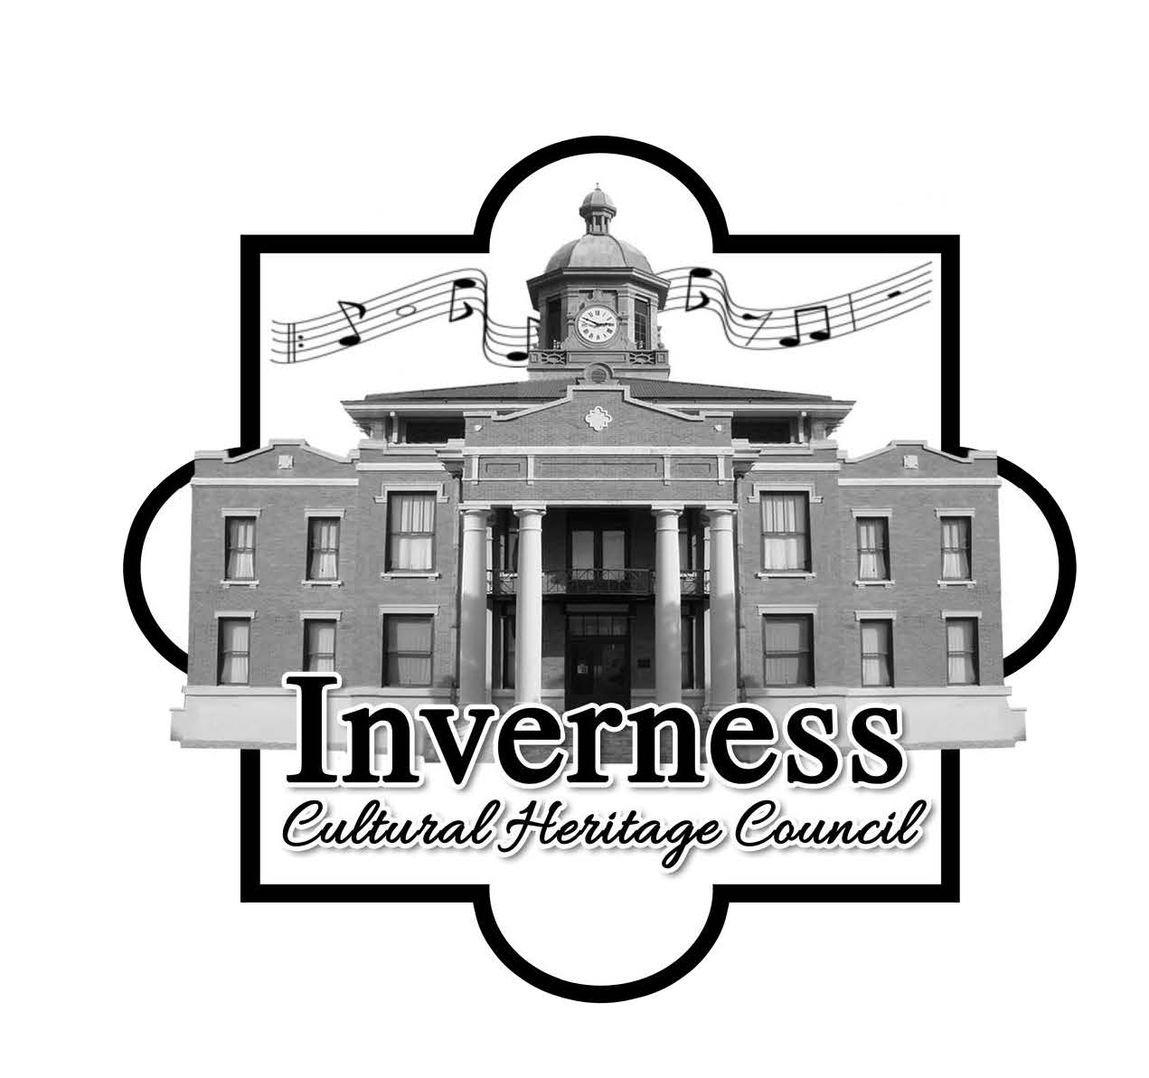
MAIL TO:
Attention: Inverness Cultural Heritage Council
1 Courthouse Square
Inverness, Florida 34450

Listed below are the criteria and guidelines for students applying for a $1000.00 scholarship given by the Inverness Cultural Heritage Council.

Three $1,000.00 scholarships are available.

The ICHC Scholarship is for students with the drive to succeed and who are planning to major in history or humanities related fields. Humanities graduates can transition into many diverse and rewarding careers like anthropologist, economist, geographer, historian, art curator, political scientist, survey researcher, technical writer, or lawyer.
Humanities majors include, but are not limited to:

- Study of languages
- Literature
- Philosophy
- History
- Human geography
- Law and political science
- Social sciences
- Religion
- The performing and visual arts

When in doubt, students are encouraged to apply. This is a one-time nonrenewable scholarship and can only be used for books, tuition fees, or other incidentals. This is a one-time, non-renewable scholarship and can only be used for books, tuition, fees, or other incidentals.
Criteria:
- The applicant must be a resident of Citrus County, and a graduating student of any state recognized educational operation, i.e. public high school, private, parochial, or certified home school situation.

- Application package must include proof of acceptance for enrollment at an accredited university, college, or technical school.

- Applicant must have a GPA of 2.5 or better to be eligible for consideration. The application must include a copy of the applicant’s transcript. Unofficial transcripts are accepted.

- An essay of at least 400 words on the following: Think about a personal challenge that you have faced. Write an essay of no less than 400 words explaining how you have worked to overcome these challenges. Explain how these experiences will influence your future educational or career goals.

- Two letters of recommendation outside of the applicant’s direct family addressing the student’s personal character.

- Information on any honors, extra-curricular activities, hobbies, and community service.

Completed Scholarship packages must include:

- The attached application form
- A copy of your transcript
- An essay at least 400 words
- Two letters of reference (outside of applicant’s immediate family)

Package must be received by the Education Committee by March 16, 2026.

This is a one-time, non-recurring scholarship.

Inverness Cultural Heritage Council of the
CITRUS COUNTY HISTORICAL SOCIETY, INC.
Scholarship Application
Application must be complete to be processed by the awards committee.
PERSONAL INFORMATION
Item | Information
Applicant’s Name
Parent/Guardian 1 Name
Parent/Guardian 1 Occupation
Parent/Guardian 2 Name
Parent/Guardian 2 Occupation
Address (Number, Street Name, City, State, Zip Code)
Telephone Number
Date of Birth
GPA (Attach Proof)
School Name
School Address (Number, Street Name, City, State, Zip Code)
Number of Children under 18 years of age living in the home supported by the parent(s).
Number of siblings presently attending facilities of higher education supported by parent(s).

ACTIVITIES, LEADERSHIP, & HONORS (INCLUDING SPORTS)
Activity | # of years | Position, office, honor | Leadership role

COMMUNITY SERVICE
Organization | Dates |  |  | Activity | Supervisor | Total hours
 |  | to
 |  | to
 |  | to
 |  | to
 |  | to

WORK EXPERIENCE
Business | Dates |  |  | Job Description | Supervisor | Phone
 |  | to
 |  | to
 |  | to

What college/technical school will you attend?
What is your planned major?
ESSAY (please type and attach):
An essay of at least 400 words on the following:
The humanities may be defined as any academic discipline that seeks to study aspects of human society and culture. Why have you chosen a field of study in the humanities and why do you think the humanities are an important field of study and how will you apply these studies to your career?

All applications and enclosed information will be destroyed after the scholarship winners are determined. Please type your first name, last name, and date.

Student Signature: | Date:
Parent/Guardian Signature: | Date:
☐ I understand that checking (clicking) this box constitutes a legal signature confirming that I acknowledge and warrant the truthfulness of the information provided in this document.

