JAMES & CLARINE KENNEDY MEMORIAL HEALTH CARE SCHOLARSHIP
2025-26 SCHOLARSHIP: $1,000.00
DUE APRIL 3, 2026

COMPLETED APPLICATION MAY BE EMAILED TO ccefscholarshipwinner@gmail.com OR GIVEN TO YOUR CRHS GUIDANCE COUNSELOR.
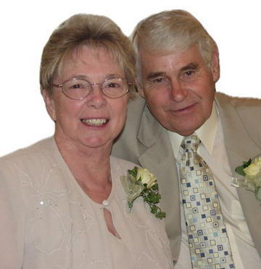
The James & Clarine Kennedy Memorial Scholarship, established within the Citrus County Education Foundation, honors the remarkable lives and contributions of James and Clarine Kennedy.

REQUIREMENTS
- Applicants must be graduating members of the 2025-2026 senior class of the Academy of Health Careers at Crystal River High School.
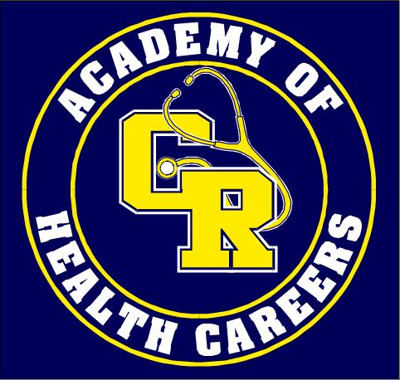
- Applicants must be pursuing a career in health care or a health-care-related field at an accredited college, university, or post-secondary technical school.
- Applicants must submit an application and their transcript (unofficial is fine).
If you have any questions regarding this scholarship, you may email Mrs. Thomasine Kennedy at thomasinekennedy@gmail.com.

The James & Clarine Kennedy Memorial Health Care Scholarship Committee will be selecting a student who has demonstrated fortitude and initiative in preparing himself or herself for a future career in health care or a health-care-related related field.
The winner will be announced in May at Crystal River High School’s award ceremony. The monetary award will be forwarded to the selected post-secondary institution upon documentation (student ID and proof of registered classes) obtained by the student or from the school that the recipient enrolls in.
JAMES KENNEDY AND CLARINE KENNEDY
James E. Kennedy Sr. and Clarine Kennedy, married for nearly 58 years, dedicated a combined five decades to careers in health care and health care administration. Their work exemplified a steadfast commitment to the Christian mission of hospital care and a passion for serving others.
Clarine Kennedy: A Trailblazer in Health Care
Clarine Kennedy's strong desire to serve the Seventh-day Adventist Church inspired her to pursue nursing as a means of fulfilling her mission. She began her studies at Madison SDA College in Madison, Tennessee, but family circumstances brought her back to New England. Undeterred, she earned her Licensed Practical Nurse (LPN) certification through the Rhode Island School of Practical Nursing at Kent County Hospital in Warwick, Rhode Island.
Clarine’s dedication to health care and her Christian mission led to numerous advancements in her career. In 1984, she became the first Director of Patient Relations at New England Memorial Hospital, a groundbreaking role in the organization. She continued to break barriers as the hospital's first woman to serve as Director of Risk Management and later as Director of Quality Assurance, where her leadership and vision left a legacy.
James E. Kennedy Sr.: A Devoted Leader and Innovator
James E. Kennedy Sr. began his career in the Housekeeping Department at Kent County Hospital in Warwick, Rhode Island, where his hard work and leadership earned him a promotion to Supervisor. During this time, James also proudly served in the Army National Guard during the Korean War, where he was assigned to the 147th AAA Detachment Operations. His service exemplified his dedication to duty and his country. Shortly before the birth of his first child, James honorably completed his service in the National Guard.
James’s dedication to the Christian mission of hospital care mirrored that of his wife. His responsibilities grew, and in 1977, he was promoted to Director of Environmental Services at New England Memorial Hospital. During this time, James pursued higher education at the University of Massachusetts, completing all coursework for an associate degree in Business Management. Despite his achievements, James was unable to formally receive the degree due to the challenges he faced with severe dyslexia, which had prevented him from completing high school.
Legacy of Service and Dedication
The James & Clarine Kennedy Memorial Health Care Scholarship, provided through the James & Clarine Kennedy Memorial Endowment in association with the Citrus County Education Foundation, serves as a testament to their lifelong commitment to health care and their unwavering dedication to faith and service. It is our hope that their legacy continues to inspire future generations within the Citrus County community and beyond.
APPLICATION
(APPLICATION MUST BE TYPED)

PERSONAL INFORMATION
ITEM | INFORMATION
Full Name
Phone Number
Email (Use your personal email as your school email will not be available after graduation.)
Current High School
Parent/Guardian Name
Parent/Guardian Name

POSTSECONDARY APPLICATIONS
Name(s) of College/University/Technical School (Add additional rows if needed.) | Have you applied? | Have you been accepted yet?
 | ☐ Y ☐N | ☐ Y ☐N
 | ☐ Y ☐N | ☐ Y ☐N
 | ☐ Y ☐N | ☐ Y ☐N
 | ☐ Y ☐N | ☐ Y ☐N

Intended major or course of studies:

EXTRACURRICULAR (This includes clubs, sports, science fair, etc., as well as activities outside of high school. HIGH SCHOOL YEARS ONLY)
ACTIVITY (Add additional rows if needed.) | # OF YEARS | LEADERSHIP ROLE AND GRADE LEVEL YOU SERVED IN THAT ROLE

AWARDS/HONORS/ACHIEVEMENTS/INDUSTRY CERTIFICATIONS (This includes awards/honors/achievements/certifications earned outside of high school. HIGH SCHOOL YEARS ONLY)
AWARDS/HONORS/ACHIEVEMENTS/INDUSTRY CERTIFICATIONS (Add additional rows if needed.) | GRADE LEVEL

WORK EXPERIENCE (HIGH SCHOOL YEARS ONLY)
Employer(s) (Add additional rows if needed.) | Job Title | Length of Employment | Hours per Week  (approx.)

COMMUNITY SERVICE (HIGH SCHOOL YEARS ONLY)
PROJECT and/or ACTIVITY | ORGANIZATION | LEADERSHIP ROLE

Total number of documented Community Service Hours:

When you submit this application, must attach a current copy your unofficial high school transcript.

REQUIRED PERSONAL STATEMENT: The Scholarship Committee will be selecting a student who has demonstrated fortitude and initiative in preparing himself or herself for a future career in health care or a health care-related field. Please attach a personal statement explaining how you have demonstrated your commitment to a career in health care.

By signing below, the applicant is confirming that all information provided is accurate and is giving permission to Citrus County Schools to provide the JAMES & CLARINE KENNEDY MEMORIAL HEALTH CARE SCHOLARSHIP Committee his/her transcripts where academics, community service, and test scores (i.e., SAT/ACT scores) will be reviewed. High school counselors may also be consulted regarding the financial needs of applicants. All applications, transcripts, and information gathered is confidential.

Signature: | Date:
☐ I understand that checking (clicking) this box constitutes a legal signature confirming that I acknowledge and warrant the truthfulness of the information provided in this document.

