
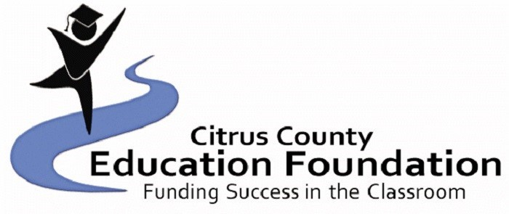
The Barbieri-Hunt Scholarship Application
18th Annual
$1,000.00 and $500 Scholarships-one time
Spring 2026

Dear Applicant:

Congratulations on all your hard work and thank you for considering applying for the Barbieri-Hunt Scholarship. We are LHS graduates and established this unique scholarship to provide LHS graduates the financial and advisory support needed to achieve their academic and professional goals. We hope this letter explains a little about our background and our hopes for this scholarship.

Lisa Barbieri (maiden name Hunt), class of 1997. The 1997 LHS Female Athlete of the Year, in her senior year, Lisa was the District Champion in 300-meter low hurdles, member of the 200m freestyle relay team which went to the Florida State Championships and a Varsity Basketball Cheerleader. Lisa earned her A.A. degree from Central Florida Community College (CFCC) and B.A. in Education, Master of Education, and Specialist in Education degrees from the University of Florida (UF). Lisa was a guidance counselor in elementary and middle schools prior to leaving that role to raise our three children, Louie, Emma and Rowan.

Lou Barbieri, class of 1998. Lou was a four-year member of the LHS basketball team and LHS’ first ever sweet sixteen Varsity Basketball team. He was also a member of several volunteer organizations, including Fellowship of Christian Athletes. Lou received his B.S. in Political Science from Stetson University and his Juris Doctorate from the Levin College of Law at the University of Florida. Lou is a Partner with Kilpatrick Townsend & Stockton, LLP, practicing corporate law in its Atlanta, Georgia office and is a Board member of Georgia Appleseed.

We remain grateful to the teachers, staff, coaches and counselors of LHS for establishing the foundation upon which we built our academic and professional careers. We hope that this scholarship positively impacts the community and inspires others to give back to the LHS legacy.

Recipients should show financial need and dedication to LHS, the Citrus County community and their academics. The enclosed application includes criteria we believe exhibit these characteristics, but we encourage you to provide any other information you deem pertinent in your essay and resume, including examples of your academic success, ability to overcome adversity, financial or otherwise, and service to others. Unlike many scholarships, the Barbieri-Hunt Scholarship may be awarded to students who have goals which do not relate directly to attending a university immediately after high school. We encourage students with alternative academic or professional goals to apply.

The Barbieri-Hunt Scholarship will be awarded at the 2026 LHS Scholarship Award Ceremony. All scholarship funds must be used for actual post-secondary education expenses. Questions with the application may be directed to Lou Barbieri, lbarbieri@ktslaw.com or (404) 815-6079 or Tiffani King kingt@citrusschools.org (352) 726-1931 ext .4385. The deadline for applications is April 7th, 2026.
Go Panthers!

Lou Barbieri III Lisa E. Barbieri
The Barbieri-Hunt Scholarship Application
$1,000.00 and $500 Scholarships
Spring 2026
Eligibility Requirements:
- Minimum Grade Point Average: 2.5
- Graduate of Lecanto High School in December 2025 or May 2026
- Substantiated Financial Need for the Student

Full Name:
Email address:
Parent/Guardian Name: Employer:
Parent/Guardian Name: Employer:
Combined Gross Family Income: # of family members in household:
Ages of Brothers & Sisters:
Name of Community College, Technical College or University you plan to attend (have you applied/been accepted):

Anticipated Florida Bright Futures Scholarship Recipient? Yes No

Please attach:
- A current transcript with certified GPA, ACT and SAT scores, and total community service hours performed.
- Resume, including a summary of service work, work experience, sports, honors, clubs, and offices held.
- Up to 2 letters of recommendation. Recommendations may come from a teacher, advisor, guidance counselor, school administrator, employer, clergy, a person with whom the student has done volunteer or community work, or any other adult who is aware of the student's leadership skills.
- An essay (up to 500 words) describing your inspiration for post-secondary education (career goals, if any), major obstacles to achieving these goals and life experience that shows you can accomplish these goals.

Student Signature Parent Signature

All applications will be held confidential.

Winners will be announced at the LHS Awards Ceremony. The monetary award will be forwarded to the selected post-secondary institution upon documentation (student ID and proof of registered classes) obtained by the student from the school that the recipient is currently enrolled in.

COMPLETED APPLICATIONS MUST BE RECEIVED NO LATER THAN April 7, 2026
Turn application in to your high school guidance counselor.

