Andi Reid

Sharepoint site owner manual

Course Modules at a Glance 2
What SharePoint Is (and Isn't) 3
SharePoint vs OneDrive vs Teams — The "Me, We, Us" Model 4
SharePoint Building Blocks 5
Step 1: Plan Your Site Before You Build 6
Step 2: Create a New Site — Step by Step 7
Team Site vs Communication Site — Choosing the Right Type 8
Three Ways to Create a Site — Understanding the Difference 9
Search & Findability 10
The Three SharePoint Permission Groups 11
How to Add Someone to Your Site 12
Permission Levels Explained 13
Permission Best Practices 13
How to Check Who Has Access to Your Site 14
Understanding Permission Inheritance 15
Creating and Configuring a Document Library 16
Folders vs Metadata — Choosing the Right Approach 17
Library Views: Filters, Groups and Formatting 18
Site Navigation — Do's and Don'ts 19
Metadata 101 — Why It Matters 20
How to Create and Use Columns 21
Lists vs Excel — When to Use Each 22
Managing Lists: Views, Forms and Rules 23
Pages — Create, Edit and Publish 24
Web Parts You'll Use Most 25
News and Hero — Highlight Key Content 26
Share Files and Links the Right Way 27
Link Settings & Scope — Control Who Sees What 28
Co-authoring, Version History and Check-Out 29
Work Across SharePoint, Teams and OneDrive 30
Site Owner Responsibilities 31
Keep Sites Organised and Secure 32
Content Lifecycle — Your 7-Stage Process 33
Checking Who Has Access 34
Permissions Best Practice Checklist 34
Site Owner Monthly Checklist 34

Course Overview
Welcome to the SharePoint Site Owner Training. This manual covers everything you need to know to create, manage and maintain a successful SharePoint site within your organisation.

Who Is This For?
This training is designed for Site Owners and Power Users in Microsoft 365 — anyone responsible for creating, managing or maintaining a site.

What You Will Learn
• What SharePoint is and when to use it
• How to create and configure a SharePoint site
• How to manage site structure, settings and navigation
• How to manage owners, members and visitors
• How to organise content with metadata and lists
• How to apply governance and security best practices

Course Modules at a Glance
# | Module | Description
01 | Introduction to SharePoint | Understanding the platform, its role, and how it connects with Teams and OneDrive.
02 | Creating and Setting Up a SharePoint Site | Master the foundations: site types, structure, navigation and search.
03 | Managing People and Permissions | Security model, roles, access control and safe sharing practices.
04 | Document Libraries & Content Organisation | Libraries, folders vs metadata, views, filters and navigation.
05 | Working with Metadata and Lists | Custom columns, structured lists, and when to use lists vs Excel.
06 | Pages and SharePoint Components | Creating and editing pages, web parts, news and hero components.
07 | Collaboration and Day-to-Day Use | Safe sharing, co-authoring, version history and M365 integration.
08 | Governance and Best Practices | Site owner responsibilities, security protocols and content lifecycle.

MODULE 01
Introduction to SharePoint
Understanding the platform, its role in the digital workplace, and how it connects with Teams and OneDrive.

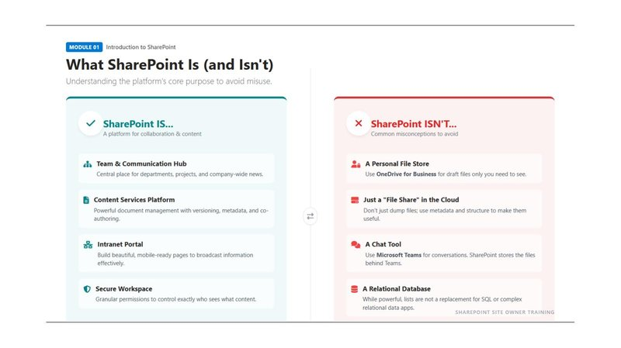

What SharePoint Is (and Isn't)
SharePoint is a platform within Microsoft 365 for collaboration and content management. Understanding what it is designed to do — and what it isn't — will help you use it effectively.

SharePoint IS designed for:
• Team & Communication Hub: A central place for departments, projects and company-wide news.
• Content Services Platform: Powerful document management with versioning, metadata and co-authoring.
• Intranet Portal: Build mobile-ready pages to broadcast information effectively.
• Secure Workspace: Granular permissions to control exactly who sees what content.

SharePoint IS NOT:
• A Personal File Store: Use OneDrive for Business for draft files only you need to see.
• Just a "File Share" in the Cloud: Don't just dump files; use metadata and structure to make them useful.
• A Chat Tool: Use Microsoft Teams for conversations. SharePoint stores the files behind Teams.
• A Relational Database: While powerful, lists are not a replacement for SQL or complex relational data apps.

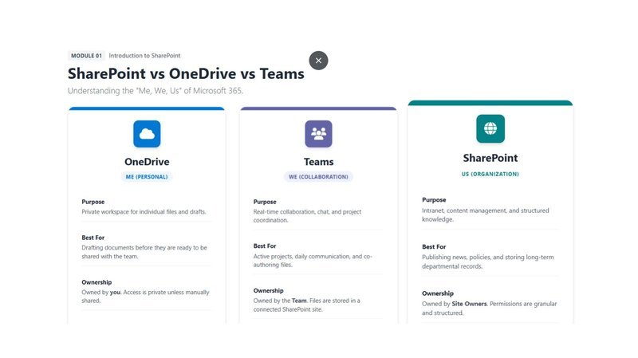

SharePoint vs OneDrive vs Teams — The "Me, We, Us" Model
Think of the three tools this way:

Tool | Mental Model | Best For | Ownership
OneDrive | ME (Personal) | Drafting documents before sharing | Owned by you. Private unless shared.
Teams | WE (Collaboration) | Active projects, daily comms, co-authoring files | Owned by the Team. Files in SharePoint.
SharePoint | US (Organisation) | Publishing news, policies, long-term departmental records | Owned by Site Owners. Structured permissions.

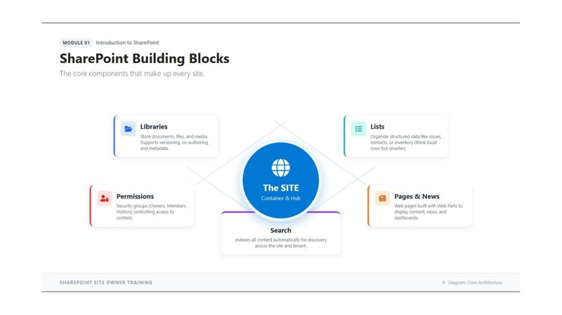

SharePoint Building Blocks
Every SharePoint site is made up of the same core components:
• Libraries: Store documents, files and media. Supports versioning, co-authoring and metadata.
• Lists: Organise structured data like issues, contacts or inventory (think Excel rows but smarter).
• Permissions: Security groups (Owners, Members, Visitors) controlling access to content.
• Pages & News: Web pages built with Web Parts to display content, news and dashboards.
• Search: Indexes all content automatically for discovery across the site and tenant.

MODULE 02
Creating and Setting Up a SharePoint Site
Master the foundations: site types, structure, navigation and search.

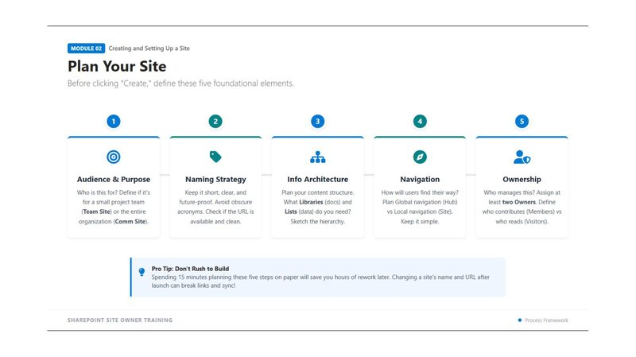

Step 1: Plan Your Site Before You Build
Before clicking "Create", define these five foundational elements. Spending 15 minutes planning on paper will save hours of rework later — changing a site's name and URL after launch can break links and syncs.

Five Planning Elements:
• 1. Audience & Purpose: Who is this for? Is it for a small project team (Team Site) or the entire organisation (Comm Site)?
• 2. Naming Strategy: Keep it short, clear and future-proof. Avoid obscure acronyms. Check the URL is available and clean.
• 3. Information Architecture: Plan your content structure. What Libraries (docs) and Lists (data) do you need? Sketch the hierarchy.
• 4. Navigation: How will users find their way? Plan Global navigation (Hub) vs Local navigation (Site). Keep it simple.
• 5. Ownership: Who manages this site? Assign at least two Owners. Define who contributes (Members) vs who reads (Visitors).

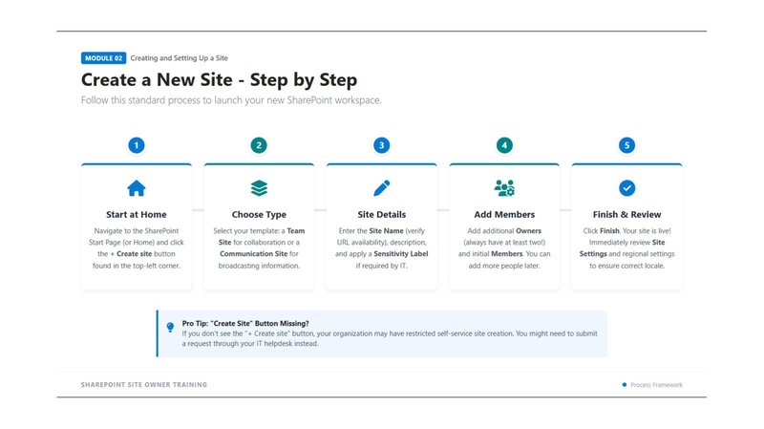

Step 2: Create a New Site — Step by Step
Follow this standard process to launch your new SharePoint workspace:

Step 1: Start at SharePoint Home
Navigate to the SharePoint Start Page (or Home) and click the "+ Create site" button found in the top-left corner.
Step 2: Choose Your Site Type
Select your template: a Team Site for collaboration, or a Communication Site for broadcasting information.
Step 3: Enter Site Details
Enter the Site Name (verify URL availability), description, and apply a Sensitivity Label if required by IT.
Step 4: Add Members
Add additional Owners (always have at least two!) and initial Members. You can add more people later.
Step 5: Finish & Review
Click Finish. Your site is live! Immediately review Site Settings and regional settings to ensure correct locale.

⚠️ Note: If you don't see the "+ Create site" button, your organisation may have restricted self-service site creation. You might need to submit a request through your IT helpdesk instead.

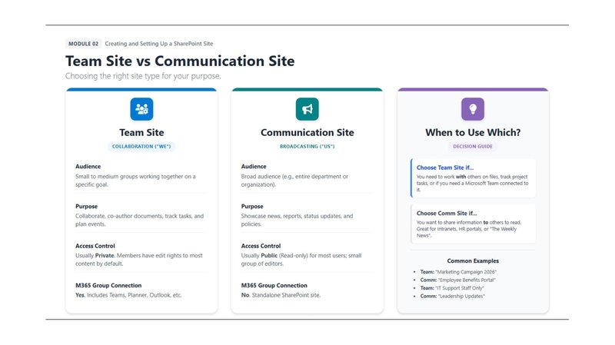

Team Site vs Communication Site — Choosing the Right Type

Team Site (Collaboration — "WE") | Communication Site (Broadcasting — "US")
• Audience: Small to medium groups working together on a specific goal.  • Purpose: Collaborate, co-author documents, track tasks and plan events.  • Access Control: Usually Private. Members have edit rights to most content by default.  • M365 Group Connection: YES. Includes Teams, Planner, Outlook, etc.  • Example: "Marketing Campaign 2026", "IT Support Staff Only" | • Audience: Broad audience (e.g., entire department or organisation).  • Purpose: Showcase news, reports, status updates and policies.  • Access Control: Usually Public (Read-only) for most users; small group of editors.  • M365 Group Connection: NO. Standalone SharePoint site.  • Example: "Employee Benefits Portal", "Leadership Updates"

Three Ways to Create a Site — Understanding the Difference
There are three common routes to creating a SharePoint site. Each has different results:

1. Create a New SharePoint Site Directly
You start in SharePoint. This creates a SharePoint site (pages, document libraries, lists, metadata) and a Microsoft 365 Group (if it's a Team Site). Note: it does NOT automatically create a Microsoft Teams team — you can add one later.

2. Add a Team to an Existing SharePoint Site
If you already have a well-structured SharePoint site and want to add real-time collaboration, choose "Add Microsoft Teams" from within the site. This is often the cleanest and safest approach — it reuses existing files, permissions and structure without creating duplicates.

3. Create a New Team in Microsoft Teams
You start in Teams. A SharePoint site is automatically created in the background to store the files. The Files tab in each Teams channel is actually a folder in that SharePoint document library. Teams is the primary experience; SharePoint is supporting storage.

💡 Pro Tip: Always check "Does one already exist?" before creating a new site. Creating a SharePoint site AND a separate Team for the same purpose leads to duplicate files, confused users and permission mismatches.

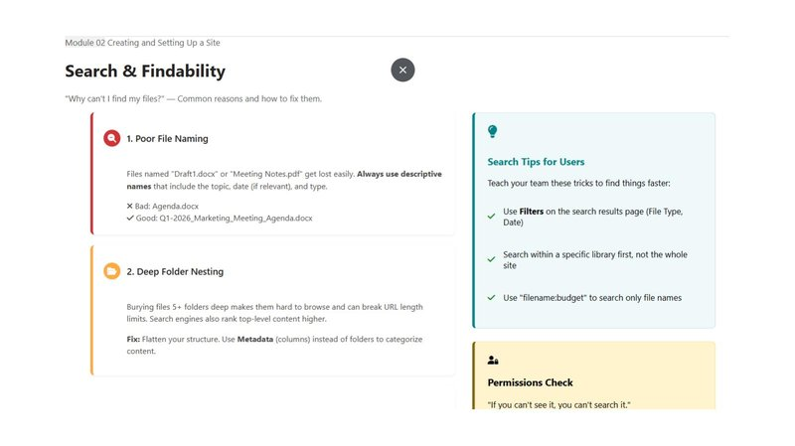

Search & Findability
"Why can't I find my files?" — Two common reasons and how to fix them:

1. Poor File Naming
Files named "Draft1.docx" or "Meeting Notes.pdf" get lost easily. Always use descriptive names that include the topic, date (if relevant) and type.
• Bad example: Agenda.docx
• Good example: Q1-2026_Marketing_Meeting_Agenda.docx

2. Deep Folder Nesting
Burying files 5+ folders deep makes them hard to browse and can break URL length limits. Search engines also rank top-level content higher.
Fix: Flatten your structure. Use Metadata (columns) instead of folders to categorise content.

Search Tips for Users:
• Use Filters on the search results page (File Type, Date)
• Search within a specific library first, not the whole site
• Use "filename:budget" to search only file names

MODULE 03
Managing People and Permissions
Security, roles, and access control for your SharePoint site.

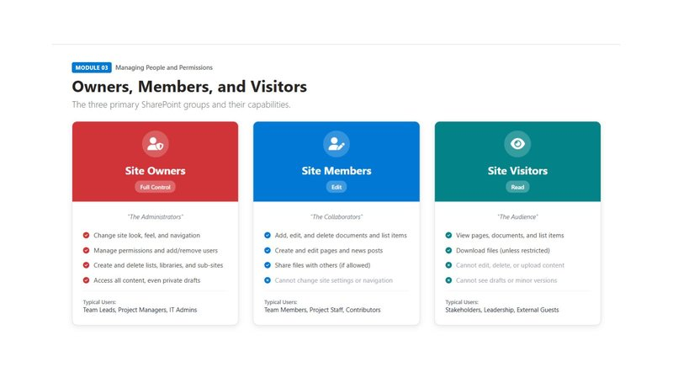

The Three SharePoint Permission Groups
Every SharePoint site has three default groups that control access:

Role | Permission Level | What They Can Do | Typical Users
Site Owners | Full Control | Change look/feel/navigation, manage permissions, create/delete lists and libraries, access all content | Team Leads, Project Managers, IT Admins
Site Members | Edit | Add, edit and delete documents; create and edit pages; share files (if allowed); cannot change site settings | Team Members, Project Staff, Contributors
Site Visitors | Read Only | View pages, documents and list items; download files (unless restricted); cannot edit or upload | Stakeholders, Leadership, External Guests

How to Add Someone to Your Site
When you add someone to a modern SharePoint Team Site, you are actually adding them to the Microsoft 365 Group behind it. This automatically grants them access to SharePoint, Outlook Group, Calendar, Planner, OneNote, and Teams (if connected).

Steps to Add a Member:
Step 1: Go to Site Permissions
Click the Settings icon (⚙️) in the top right → Select "Site permissions".
Step 2: Choose the Group
Select "Site Owners", "Site Members" or "Site Visitors" depending on the level of access required.
Step 3: Add People
Click the group → Add members → Search for the person's name or email address → Confirm.
Step 4: Verify Access
The user will receive an email notification. They should have access within a few minutes (may take up to 30-60 minutes in large organisations).

💡 Pro Tip: For Communication Sites, there is no Microsoft 365 Group — adding Owners/Members/Visitors only updates SharePoint permissions (no Outlook Group, no Planner, no Teams).

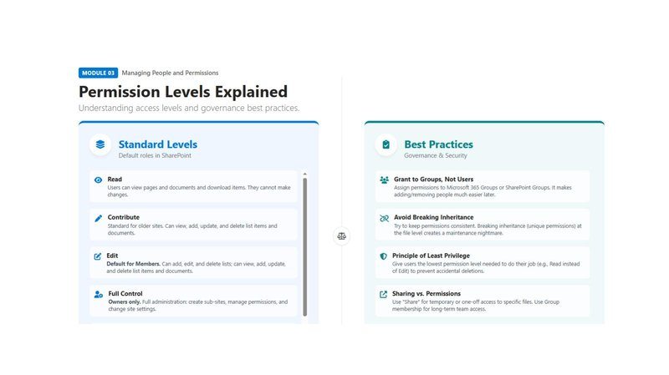

Permission Levels Explained
Standard permission levels within SharePoint:
• Read: Users can view pages and documents and download items. They cannot make changes.
• Contribute: Standard for older sites. Can view, add, update and delete list items and documents.
• Edit: Default for Members. Can add, edit and delete lists; view, add, update and delete list items and documents.
• Full Control: Owners only. Full administration: create sub-sites, manage permissions and change site settings.

Permission Best Practices
• Grant to Groups, Not Users: Assign permissions to Microsoft 365 Groups or SharePoint Groups. This makes adding or removing people much easier later.
• Avoid Breaking Inheritance: Try to keep permissions consistent. Breaking inheritance (unique permissions at the file level) creates a maintenance nightmare.
• Principle of Least Privilege: Give users the lowest permission level needed to do their job (e.g., Read instead of Edit) to prevent accidental deletions.
• Sharing vs. Permissions: Use "Share" for temporary or one-off access to specific files. Use Group membership for long-term team access.

How to Check Who Has Access to Your Site
As a Site Owner, you are responsible for knowing who can access your site. Follow these steps:

Step 1: Open Site Permissions
Go to your SharePoint site → Click the Settings icon (⚙️) → Choose "Site permissions". This shows the three default groups: Owners, Members and Visitors.

Step 2: See Who Is in Each Group
In Site Permissions, click the arrow next to each group → Select the group name → Choose "Members" to see the full list of people and their access level.

Step 3: Check for Additional or Unique Permissions
Go to Settings (⚙️) → Site permissions → Advanced permission settings. This opens the classic permissions page where you can see all groups with access, identify custom groups and spot libraries or lists with unique (broken inheritance) permissions.

Step 4: Check Access for a Specific Person
Go to Advanced permission settings → Select "Check Permissions" → Enter the person's name or email. SharePoint will show all permissions they have and where those permissions come from (group, direct access or sharing link).

Step 5: If the Site Is Connected to Microsoft Teams
Open the Team in Microsoft Teams → Click "..." (ellipsis) next to the Team → Choose "Manage team" → Review Owners, Members and Guests. This mirrors SharePoint site access.

💡 Pro Tip: Best practices: Manage access via groups (not individuals), keep the number of Owners small (2-4 maximum), conduct regular permission reviews, and avoid breaking inheritance unless absolutely necessary.

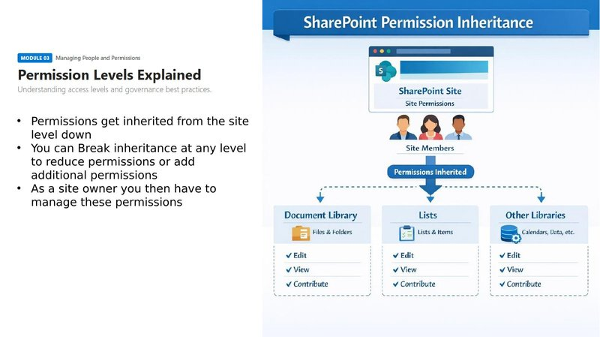

Understanding Permission Inheritance
Permissions flow downwards: from the Site level, to Document Libraries, to individual folders, and finally to individual files. By default, all content inherits permissions from the site.
As a Site Owner, you can "Break Inheritance" at any level to reduce permissions for specific content or grant additional access. However, this creates unique permissions that you then have to manage separately — so only do this when genuinely necessary.

MODULE 04
Document Libraries & Content Organisation
Mastering the structure of your site: libraries, folders, metadata, views and navigation.
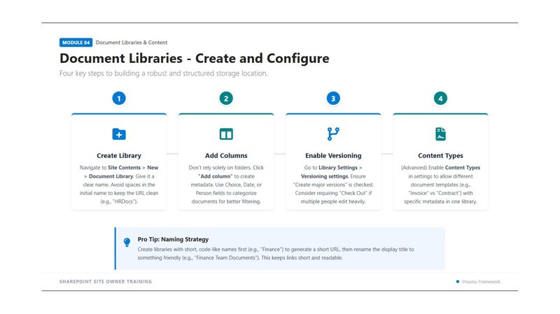

Creating and Configuring a Document Library
Document libraries are where your files live. Follow these four steps to build a robust and structured storage location:

Step 1: Create the Library
Navigate to Site Contents > New > Document Library. Give it a clear name. Avoid spaces in the initial name to keep the URL clean (e.g., "HRDocs"). You can rename the display title afterwards.
Step 2: Add Columns (Metadata)
Don't rely solely on folders. Click "Add column" to create metadata. Use Choice, Date or Person fields to categorise documents for better filtering.
Step 3: Enable Versioning
Go to Library Settings > Versioning settings. Ensure "Create major versions" is checked. Consider requiring "Check Out" if multiple people edit heavily.
Step 4: Content Types (Advanced)
Enable Content Types in settings to allow different document templates (e.g., "Invoice" vs "Contract") with specific metadata in one library.

💡 Pro Tip: Create libraries with short, code-like names first (e.g., "Finance") to generate a short URL, then rename the display title to something friendly (e.g., "Finance Team Documents"). This keeps links short and readable.

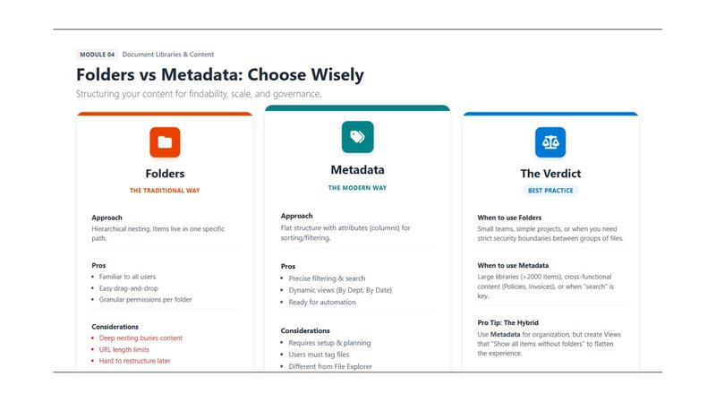

Folders vs Metadata — Choosing the Right Approach

Folders — The Traditional Way | Metadata — The Modern Way
• Approach: Hierarchical nesting. Items live in one specific path.  • Pros: Familiar to all users, easy drag-and-drop, granular permissions per folder.  • Cons: Deep nesting buries content, URL length limits, hard to restructure later.  • Best for: Small teams, simple projects or when strict security boundaries are needed between groups of files. | • Approach: Flat structure with attributes (columns) for sorting and filtering.  • Pros: Precise filtering & search, dynamic views (By Dept, By Date), ready for automation.  • Cons: Requires setup and planning. Users must tag files. Different from File Explorer.  • Best for: Large libraries (>2000 items), cross-functional content (Policies, Invoices) or when search is key.

💡 Pro Tip: Pro Tip — The Hybrid Approach: Use Metadata for organisation, but create Views that "Show all items without folders" to flatten the experience for users.

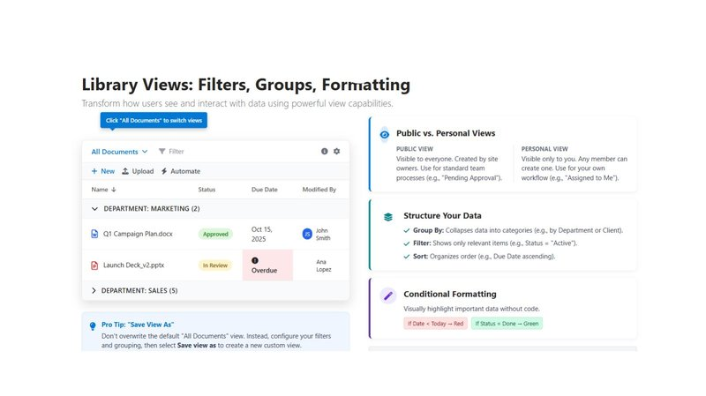

Library Views: Filters, Groups and Formatting
Views control how your users see and interact with data in a library. They are one of the most powerful tools for making content accessible.

Public vs Personal Views:
• Public View: Visible to everyone. Created by site owners. Use for standard team processes (e.g., "Pending Approval").
• Personal View: Visible only to you. Any member can create one. Use for your own workflow (e.g., "Assigned to Me").

How to Structure Data in a View:
• Group By: Collapses data into categories (e.g., by Department or Client)
• Filter: Shows only relevant items (e.g., Status = "Active")
• Sort: Organises order (e.g., Due Date ascending)

Conditional Formatting:
Visually highlight important data without code. For example: If Date < Today → highlight Red, If Status = Done → highlight Green.

💡 Pro Tip: Don't overwrite the default "All Documents" view. Instead, configure your filters and grouping, then select "Save view as" to create a new custom view.

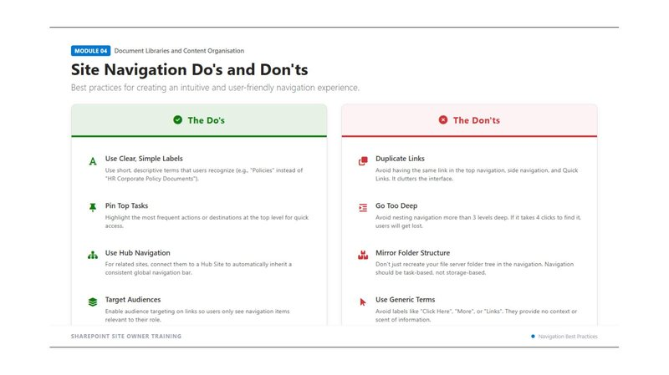

Site Navigation — Do's and Don'ts

✅ The Do's | ❌ The Don'ts
• Use Clear, Simple Labels: Use short, descriptive terms that users recognise (e.g., "Policies" instead of "HR Corporate Policy Documents").  • Pin Top Tasks: Highlight the most frequent actions or destinations at the top level for quick access.  • Use Hub Navigation: For related sites, connect them to a Hub Site to automatically inherit a consistent global navigation bar.  • Target Audiences: Enable audience targeting on links so users only see navigation items relevant to their role. | • Duplicate Links: Avoid having the same link in the top navigation, side navigation and Quick Links. It clutters the interface.  • Go Too Deep: Avoid nesting navigation more than 3 levels deep. If it takes 4 clicks to find, users will get lost.  • Mirror Folder Structure: Navigation should be task-based, not storage-based. Don't recreate your file server folder tree.  • Use Generic Terms: Avoid labels like "Click Here", "More" or "Links". They provide no context or scent of information.

MODULE 05
Working with Metadata and Lists
Transforming how you organise information using custom columns, structured lists and knowing when to use a List vs Excel.

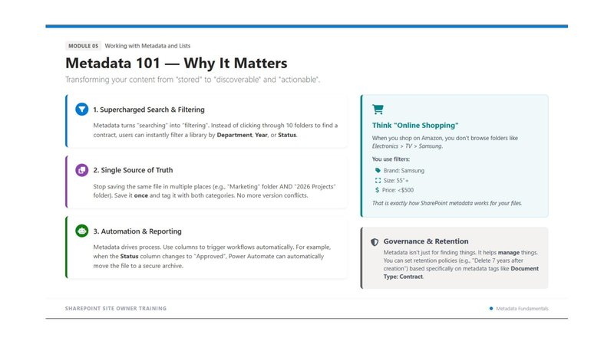

Metadata 101 — Why It Matters
Metadata transforms your content from "stored" to "discoverable" and "actionable". Think of it like online shopping: instead of clicking through folders like Electronics > TV > Samsung, you use filters like Brand: Samsung, Size: 55"+, Price: <£500. That's exactly how SharePoint metadata works for your files.

Three Key Benefits of Metadata:
• Supercharged Search & Filtering: Instead of clicking through 10 folders to find a contract, users can instantly filter a library by Department, Year or Status.
• Single Source of Truth: Stop saving the same file in multiple places. Save it once and tag it with both categories. No more version conflicts.
• Automation & Reporting: Metadata drives process. Use columns to trigger workflows automatically. For example, when the Status column changes to "Approved", Power Automate can move the file to a secure archive.

💡 Pro Tip: Metadata isn't just for finding things — it helps manage things. You can set retention policies (e.g., "Delete 7 years after creation") based specifically on metadata tags like Document Type: Contract.

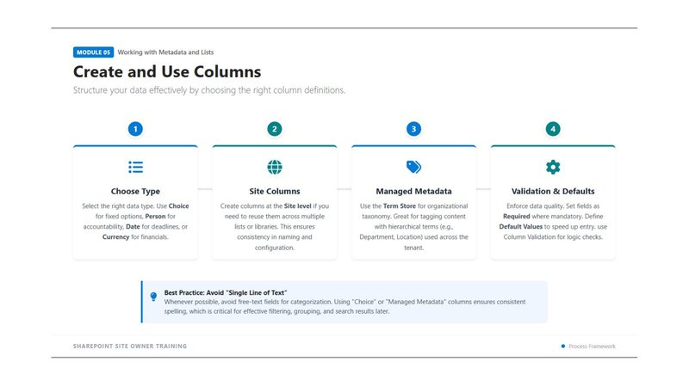

How to Create and Use Columns
Structure your data effectively by choosing the right column types:

Step 1: Choose the Column Type
Select the right data type. Use Choice for fixed options, Person for accountability, Date for deadlines or Currency for financials.
Step 2: Consider Site Columns
Create columns at the Site level if you need to reuse them across multiple lists or libraries. This ensures consistency in naming and configuration.
Step 3: Use Managed Metadata
Use the Term Store for organisational taxonomy. Great for tagging content with hierarchical terms (e.g., Department, Location) used across the whole tenant.
Step 4: Set Validation & Defaults
Enforce data quality. Set fields as Required where mandatory. Define Default Values to speed up entry. Use Column Validation for logic checks.

⚠️ Note: Best Practice: Avoid free-text fields for categorisation. Using "Choice" or "Managed Metadata" columns ensures consistent spelling, which is critical for effective filtering, grouping and search results.

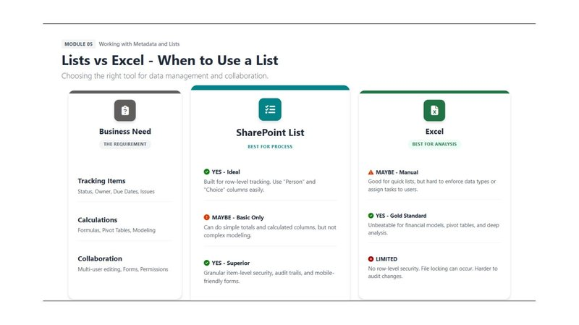

Lists vs Excel — When to Use Each

SharePoint List — Best for Process | Excel — Best for Analysis
• Tracking Items (Status, Owner, Due Dates): SharePoint List is IDEAL. Built for row-level tracking with Person and Choice columns.  • Calculations & Formulas: SharePoint List can do basic totals and calculated columns only. For complex modelling, use Excel.  • Multi-user Collaboration: SharePoint List is SUPERIOR. Granular item-level security, audit trails and mobile-friendly forms. | • Tracking Items: Excel is possible for quick lists but hard to enforce data types or assign tasks to users.  • Complex Calculations: Excel is the Gold Standard. Unbeatable for financial models, pivot tables and deep analysis.  • Collaboration: Excel is LIMITED. No row-level security, file locking can occur, harder to audit changes.

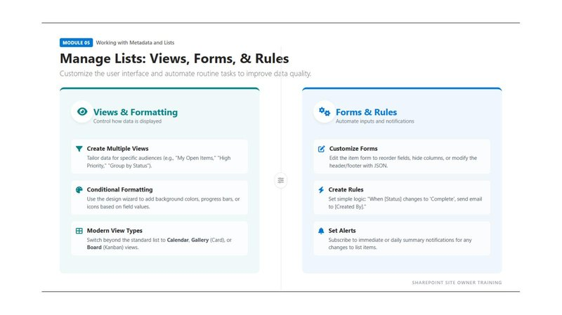

Managing Lists: Views, Forms and Rules

Views & Formatting:
• Create Multiple Views: Tailor data for specific audiences (e.g., "My Open Items", "High Priority", "Group by Status").
• Conditional Formatting: Use the design wizard to add background colours, progress bars or icons based on field values.
• Modern View Types: Switch beyond the standard list to Calendar, Gallery (Card) or Board (Kanban) views.

Forms & Rules:
• Customise Forms: Edit the item form to reorder fields, hide columns or modify the header/footer with JSON.
• Create Rules: Set simple logic: "When [Status] changes to 'Complete', send email to [Created By]."
• Set Alerts: Subscribe to immediate or daily summary notifications for any changes to list items.

MODULE 06
Pages & SharePoint Components
Building engaging user experiences with modern pages, versatile web parts, and news features.

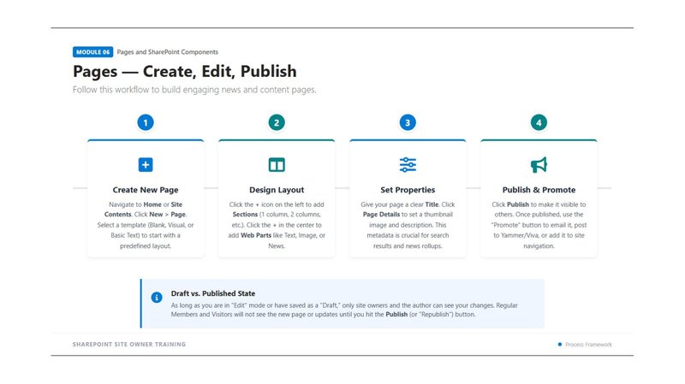

Pages — Create, Edit and Publish
Follow this workflow to build engaging news and content pages:

Step 1: Create a New Page
Navigate to Home or Site Contents. Click New > Page. Select a template (Blank, Visual or Basic Text) to start with a predefined layout.
Step 2: Design the Layout
Click the + icon on the left to add Sections (1 column, 2 columns, etc.). Click the + in the centre to add Web Parts like Text, Image or News.
Step 3: Set Properties
Give your page a clear Title. Click "Page Details" to set a thumbnail image and description. This metadata is crucial for search results and news rollups.
Step 4: Publish & Promote
Click Publish to make it visible to others. Once published, use the "Promote" button to email it, post to Viva Engage, or add it to site navigation.

⚠️ Note: Draft vs. Published: As long as you are in "Edit" mode or have saved as a "Draft", only site owners and the author can see your changes. Regular Members and Visitors will not see the new page or updates until you hit the Publish (or "Republish") button.

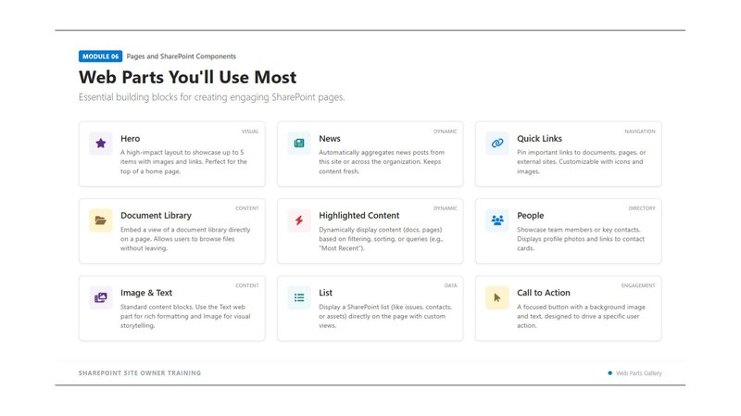

Web Parts You'll Use Most
Web parts are the building blocks for creating engaging SharePoint pages. These are the essential ones to know:

Web Part | Type | What It Does
Hero | Visual | A high-impact layout to showcase up to 5 items with images and links. Perfect for the top of a home page.
News | Dynamic | Automatically aggregates news posts from this site or across the organisation. Keeps content fresh.
Quick Links | Navigation | Pin important links to documents, pages or external sites. Customisable with icons and images.
Document Library | Content | Embed a view of a document library directly on a page. Allows users to browse files without leaving.
Highlighted Content | Dynamic | Dynamically display content (docs, pages) based on filtering, sorting or queries (e.g., "Most Recent").
People | Directory | Showcase team members or key contacts. Displays profile photos and links to contact cards.
Image & Text | Content | Standard content blocks. Use the Text web part for rich formatting and Image for visual storytelling.
List | Data | Display a SharePoint list (like issues, contacts or assets) directly on the page with custom views.
Call to Action | Engagement | A focused button with a background image and text, designed to drive a specific user action.

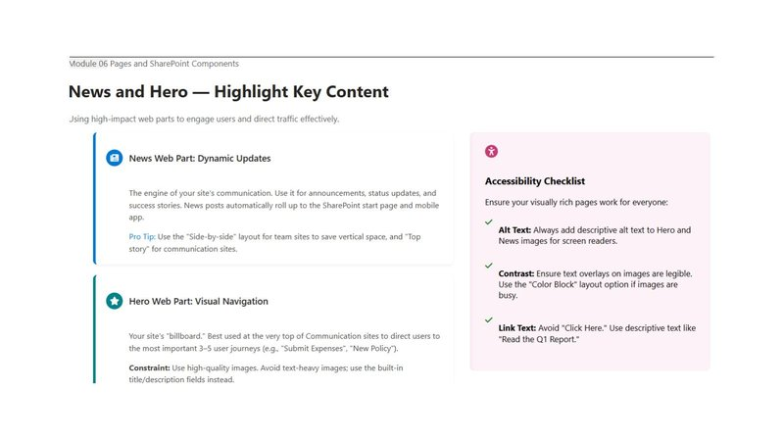

News and Hero — Highlight Key Content

News Web Part — Dynamic Updates:
The engine of your site's communication. Use it for announcements, status updates and success stories. News posts automatically roll up to the SharePoint start page and mobile app.
💡 Pro Tip: Use the "Side-by-side" layout for team sites to save vertical space, and "Top story" for communication sites.

Hero Web Part — Visual Navigation:
Your site's "billboard." Best used at the very top of Communication sites to direct users to the most important 3-5 user journeys (e.g., "Submit Expenses", "New Policy"). Use high-quality images and avoid text-heavy images — use the built-in title/description fields instead.

Accessibility Checklist for Visual Web Parts:
• Alt Text: Always add descriptive alt text to Hero and News images for screen readers.
• Contrast: Ensure text overlays on images are legible. Use the "Colour Block" layout option if images are busy.
• Link Text: Avoid "Click Here." Use descriptive text like "Read the Q1 Report."

MODULE 07
Collaboration & Day-to-Day Use
Mastering the art of working together: safe sharing, real-time co-authoring, and seamless integration across Microsoft 365.

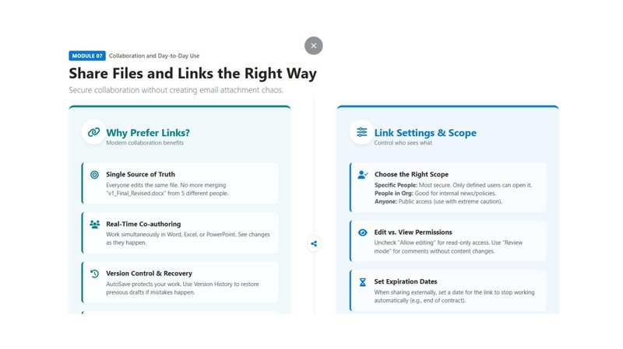

Share Files and Links the Right Way
Sharing links rather than email attachments is the modern, secure way to collaborate. Here's why:
• Single Source of Truth: Everyone edits the same file. No more merging "v1_Final_Revised.docx" from 5 different people.
• Real-Time Co-authoring: Work simultaneously in Word, Excel or PowerPoint. See changes as they happen.
• Version Control & Recovery: AutoSave protects your work. Use Version History to restore previous drafts if mistakes happen.

Link Settings & Scope — Control Who Sees What

Sharing Scope Options | Permission Controls
• Specific People: Most secure. Only defined users can open it. Use for sensitive documents.  • People in Org: Good for internal news and policies. Anyone in your organisation can access.  • Anyone (Anonymous): Public access. Use with extreme caution — only for genuinely public content. | • Edit vs. View: Uncheck "Allow editing" for read-only access. Use "Review mode" for comments without content changes.  • Set Expiration Dates: When sharing externally, set a date for the link to stop working automatically (e.g., end of contract).  • Review Shared Links: Periodically check "Shared with Everyone" links to prevent unintended over-sharing.

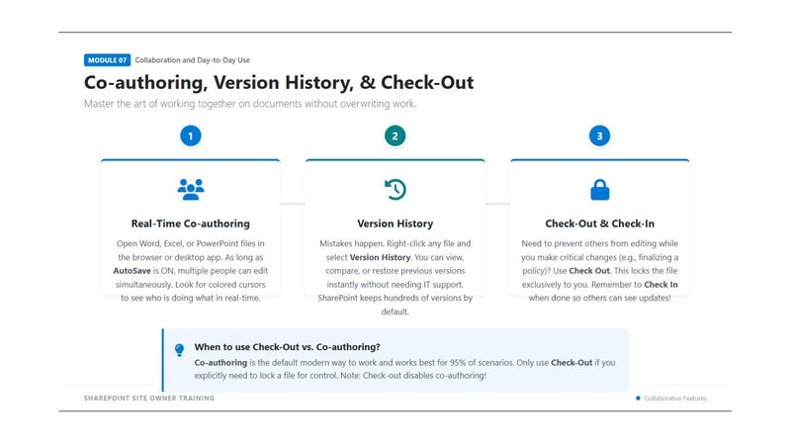

Co-authoring, Version History and Check-Out

1. Real-Time Co-authoring
Open Word, Excel or PowerPoint files in the browser or desktop app. As long as AutoSave is ON, multiple people can edit simultaneously. Look for coloured cursors to see who is doing what in real-time.

2. Version History
Mistakes happen. Right-click any file and select "Version History". You can view, compare or restore previous versions instantly without needing IT support. SharePoint keeps hundreds of versions by default.

3. Check-Out and Check-In
Need to prevent others from editing while you make critical changes (e.g., finalising a policy)? Use "Check Out". This locks the file exclusively to you. Remember to Check In when done so others can see your updates!

💡 Pro Tip: Co-authoring is the default modern way to work and covers 95% of scenarios. Only use Check-Out if you explicitly need to lock a file for control. Note: Check-out disables co-authoring!

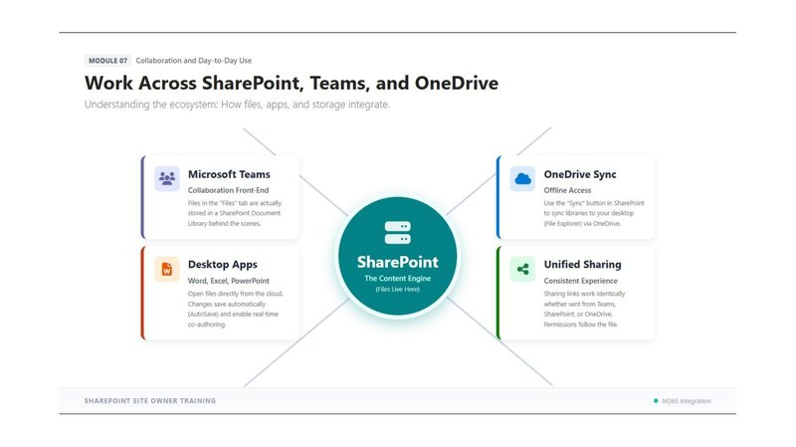

Work Across SharePoint, Teams and OneDrive
SharePoint is the content engine at the heart of Microsoft 365. Everything connects to it:
• Microsoft Teams: The collaboration front-end. Files in the "Files" tab are actually stored in a SharePoint Document Library behind the scenes.
• OneDrive Sync: Use the "Sync" button in SharePoint to sync libraries to your desktop (File Explorer) via OneDrive. Work offline and changes sync automatically when you reconnect.
You can also use Add Shortcut to OneDrive to easily access you files in the windows explorer.
• Desktop Apps (Word, Excel, PowerPoint): Open files directly from the cloud. Changes save automatically (AutoSave) and enable real-time co-authoring.
• Unified Sharing: Sharing links work identically whether sent from Teams, SharePoint or OneDrive. Permissions follow the file.

MODULE 08
Governance & Best Practices
Essential guidelines for maintaining a healthy SharePoint environment: site owner responsibilities, security protocols and content lifecycle.

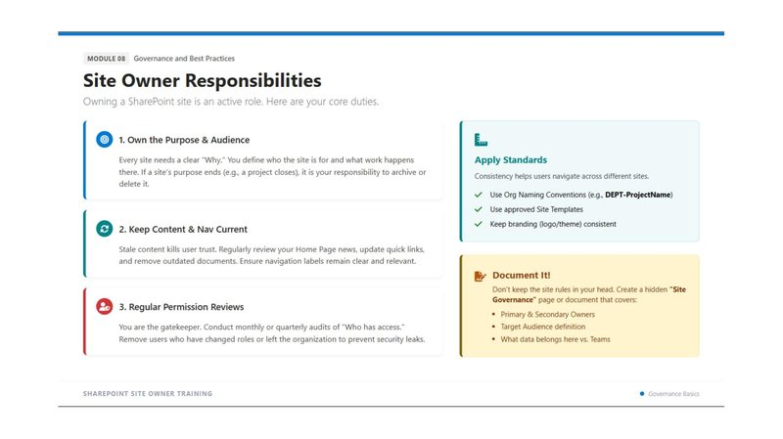

Site Owner Responsibilities
Owning a SharePoint site is an active role. These are your core duties:

• 1. Own the Purpose & Audience: Every site needs a clear "Why." You define who the site is for and what work happens there. If a site's purpose ends (e.g., a project closes), it is your responsibility to archive or delete it.
• 2. Keep Content & Navigation Current: Stale content kills user trust. Regularly review your Home Page news, update quick links and remove outdated documents. Ensure navigation labels remain clear and relevant.
• 3. Regular Permission Reviews: You are the gatekeeper. Conduct monthly or quarterly audits of "Who has access?" Remove users who have changed roles or left the organisation to prevent security leaks.
• 4. Apply Organisational Standards: Use org naming conventions (e.g., DEPT-ProjectName), approved site templates, and keep branding (logo/theme) consistent.
• 5. Document Your Site Governance: Create a hidden "Site Governance" page or document that covers: Primary & Secondary Owners, Target Audience definition, and what data belongs here vs Teams.

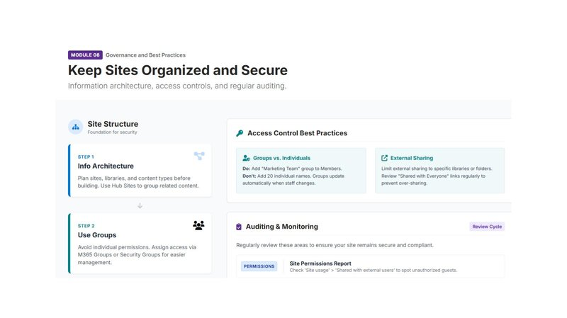

Keep Sites Organised and Secure

Access Control Best Practices:
• Use Groups, Not Individuals: Add "Marketing Team" group to Members — not 20 individual names. Groups update automatically when staff change.
• Manage External Sharing: Limit external sharing to specific libraries or folders. Regularly review "Shared with Everyone" links to prevent over-sharing.

Auditing & Monitoring:
Regularly review these areas to ensure your site remains secure and compliant:
• Site Permissions Report: Check "Site usage" > "Shared with external users" to spot unauthorised guests.
• Review Access Requests: Approve or deny pending requests promptly.
• Check for Broken Inheritance: Identify libraries or folders with unique permissions that need to be managed separately.

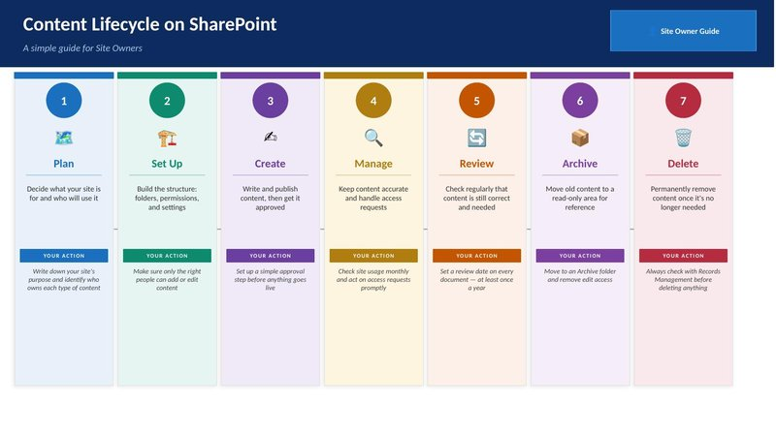

Content Lifecycle — Your 7-Stage Process
As a Site Owner, every piece of content on your site should follow this lifecycle. Use it as your action checklist:

# | Stage | Description | Your Action
1 | 🗺️ Plan | Decide what your site is for and who will use it. | Write down your site's purpose and identify who owns each type of content.
2 | 🏗️ Set Up | Build the structure: libraries, permissions and settings. | Make sure only the right people can add or edit content.
3 | ✍️ Create | Write and publish content, then get it approved. | Set up a simple approval step before anything goes live.
4 | 🔍 Manage | Keep content accurate and handle access requests. | Check site usage monthly and act on access requests promptly.
5 | 🔄 Review | Check regularly that content is still correct and needed. | Set a review date on every document — at least once a year.
6 | 📦 Archive | Move old content to a read-only area for reference. | Move to an Archive folder and remove edit access.
7 | 🗑️ Delete | Permanently remove content once it's no longer needed. | Always check with Records Management before deleting anything.

QUICK REFERENCE CARD
SharePoint Site Owner — Essential Steps and Checklists

Checking Who Has Access
Follow these steps to verify access on your site at any time:
Step 1: Open Site Permissions
Settings (⚙️) → Site permissions. View Owners (full control), Members (edit) and Visitors (read-only).
Step 2: See Who Is in Each Group
Expand each group → Select the group name → Members to see the full list.
Step 3: Check for Extra Permissions
Settings → Site permissions → Advanced permission settings. Find custom groups and broken inheritance.
Step 4: Check One Person's Access
Advanced permission settings → Check Permissions → Enter name or email.

Permissions Best Practice Checklist
• ✅ Manage access using groups, not individual users
• ✅ Keep the number of Site Owners small (ideally 2-4)
• ✅ Conduct permission reviews monthly or quarterly
• ✅ Avoid breaking inheritance unless genuinely necessary
• ✅ Use "Specific People" sharing scope for sensitive documents
• ✅ Set expiry dates on all external sharing links
• ✅ Review "Shared with Everyone" links regularly

Site Owner Monthly Checklist
• Review and remove any users who have left or changed roles
• Check for any new access requests and process them
• Review site analytics to understand what content is being used
• Update or remove any outdated news or announcements
• Check navigation links are all working and relevant
• Review any documents with review dates due this month

