SharePoint Site Owner Exercises

Exercise 1: Create a SharePoint Site and Assign Owners
Exercise Objective
By completing this exercise, learners will be able to:
- Create a new SharePoint site
- Choose an appropriate site type
- Assign site owners correctly
- Confirm ownership settings
Important:
Do not add document libraries, lists, or pages yet — these will be completed in later exercises.
Choose ONE Site Scenario
Learners should choose one of the following site scenarios. Or you can choose your own scenario if you prefer.
Option 1: Project Team Site
Scenario
You are creating a SharePoint site for a project team to collaborate on a specific piece of work.
Example site name:
( Your Name ) + Project Phoenix
Recommended site type:
✅ Team site

Option 2: Knowledge / Information Hub
Scenario
You are creating a central knowledge site where staff can find guidance and information.
Example site name:
(Your Name) +Staff Knowledge Base

Step-by-Step Instructions (All Options)
Follow these steps regardless of which site option you choose.
Step 1: Go to SharePoint
- In an incognito or inprivate browser
- Go to acatalyst.sharepoint.com
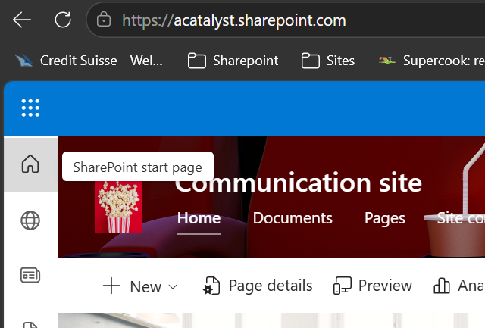
- Select SharePoint home icon
Step 2: Create the Site
- Select Create site
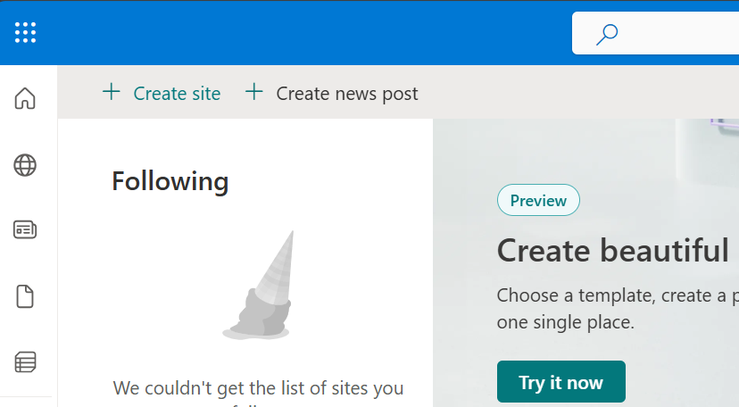
- Choose the site type:
- Team site (for Option 1+2)
- If prompted, choose any available design (this can be changed later)
Step 3: Enter Site Details
Fill in the following:
- Site name:
(Use the name from your chosen scenario)
- Description:
A short sentence explaining the purpose of the site
Select Create site.
✅ Checkpoint: The site is created and you are on the site home page.
Step 4: Add Site Owners
Add Andrea as an Owner
- Select Settings (⚙️) in the top-right
- Select Site permissions
- Select Advanced permissions (or More permissions settings, depending on layout)
- Select the Owners group (e.g. Site Owners)
- Select Add users
- Add: Andrea@acatalyst.onmicrosoft.com
- Confirm the role is Owner
- Select Share / Save

Confirm You Are Also an Owner
- In the same Owners group:
- Check that your own name appears
- If not:
- Add yourself as an Owner
✅ Checkpoint:
Both you and Andrea@acatalyst.onmicrosoft.com are listed as site owners.
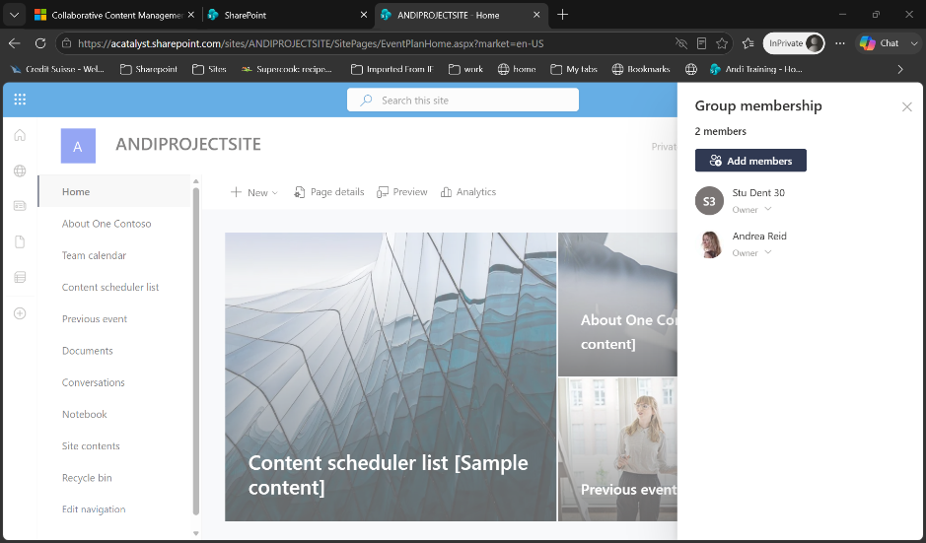

Step 5: Final Checks
Before finishing, confirm:
- The site exists
- The site name matches your chosen scenario
- There are at least two owners:
- You
- Andrea@acatalyst.onmicrosoft.com
Do not:
- Create document libraries
- Add lists
- Create pages
- Change navigation

Exercise 2: Add additional Members and Visitors
Exercise Objective
By completing this exercise, learners will be able to:
- Add users as Site Members
- Add a user as a Site Visitor
- Understand where membership is managed for group-connected sites
- Verify access has been applied correctly
Scenario
You have already created a SharePoint site and confirmed the site owners.
Now you need to grant access to additional users.
Users to Add
- Members (Edit access):
  - Thurza@acatalyst.onmicrosoft.com
  - Fred@acatalyst.onmicrosoft.com
- Visitor (Read-only access):
  - Emma@acatalyst.onmicrosoft.com

Step-by-Step Instructions
Follow all steps carefully and do not change any other permissions.
Part 1: Add Members to the Site
Step 1: Open Site Permissions
- Go to your SharePoint site
- Select Settings (⚙️) in the top-right
- Select Site permissions
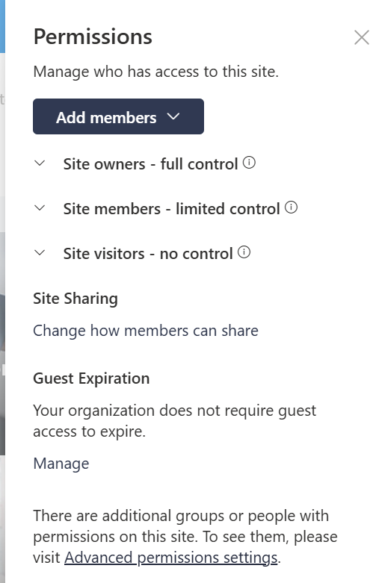
- Go to advanced permission settings at the bottom of this tab
Step 2: Open Group Membership
- In the Advanced Site permissions panel, look for Site Members
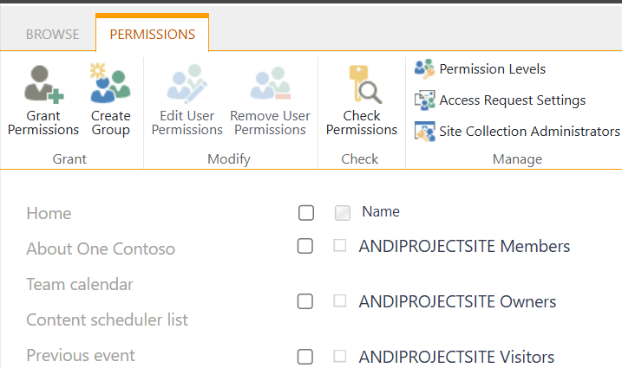
- Select Members
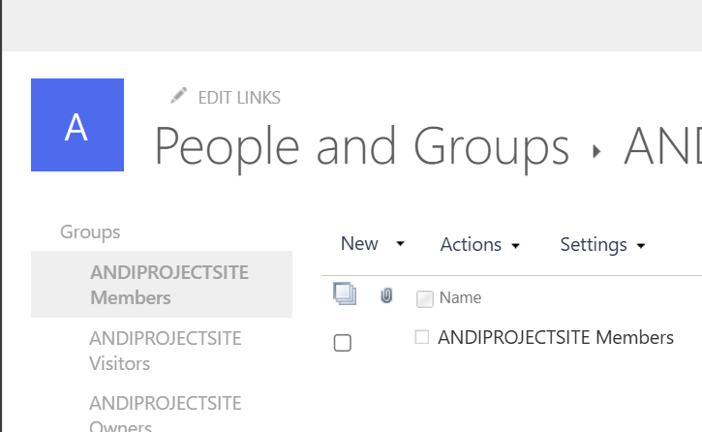
Step 3: Add New Members
- Select New
- Add users to this group
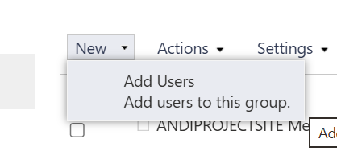
- Add the following users:
- Thurza@acatalyst.onmicrosoft.com
- Helen@acatalyst.onmicrosoft.com
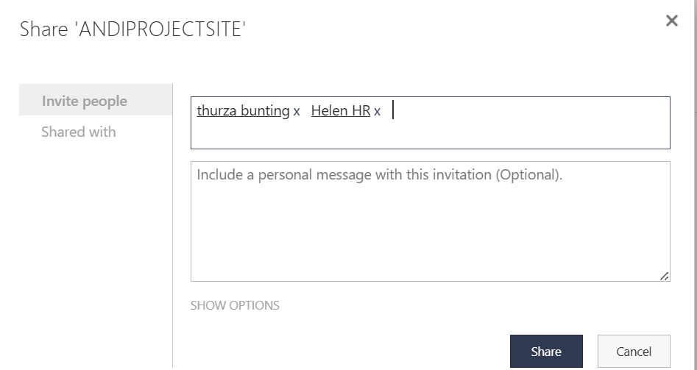
- Add a message welcoming them to the site
- Select Share
Part 2: Add a Visitor to the Site
Step 1: Open Advanced Permissions
- Select Settings (⚙️)
- Select Site permissions
- Select Advanced permissions settings
✅ The classic permissions page opens.
Step 2: Open the Site Visitors Group
- Select Site Visitors
- Select New → Add Users
- Enter:
- andireid70@gmail.com
- Ensure the permission level is Read
- Select Share
Part 3: Verify Access
Step 6: Confirm Membership
Confirm the following:
- Members:
  - Thurza@acatalyst.onmicrosoft.com ✅
  - Fred@acatalyst.onmicrosoft.com ✅
- Visitor:
  - andireid70@gmail.com ✅
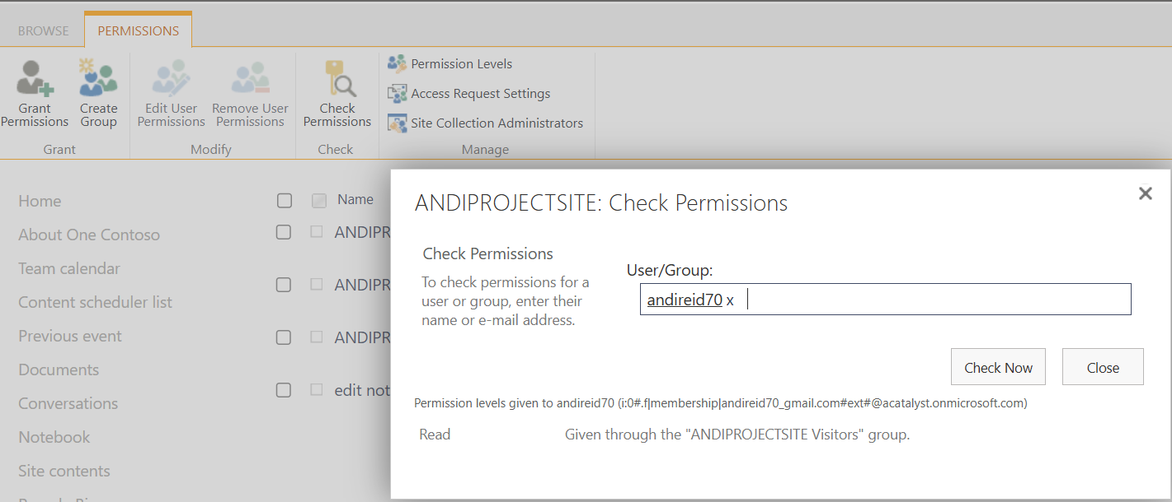

Exercise 3
You will be given 3 scenarios. For each one:
- Discuss how you would grant access to the external person
- Choose ONE option:
  - SharePoint direct sharing
  - Add as a Guest in Teams
  - Use a Teams Shared Channel
- Be ready to explain:
  - Why your option is best
  - Why you didn’t choose the other options

Scenario 1: Ongoing Project Collaboration
Situation:
You are working on a project with an external partner for the next 3 months.
They need access to:
- Multiple files
- Conversations
- Updates from your team
👉 Discuss:
- How can they collaborate most effectively?

Scenario 2: One-Off Document Review
Situation:
You are working on a document and need a supplier to review and make comments.
They only need access to this one document, and only for a short time.
👉 Discuss:
- What is the simplest and safest way to give access?

Scenario 3: Working with Another Organisation’s Team
Situation:
You need to collaborate with another company’s team.
They already use their own Teams environment, and you want:
- Seamless collaboration
- No need for them to switch tenants/accounts
- A shared workspace between both organisations
👉 Discuss:
- What is the most efficient and modern way to work together?

Exercise 4
Create a Document Library
Exercise Objective
By completing this exercise, learners will be able to:
- Create a new document library
- Rename and configure a library
- Add custom columns to capture metadata
- Design metadata that supports the purpose of their site
Before You Start
You should already have:
- A SharePoint site created in Exercise 1
- The site type chosen based on one of these scenarios:
- Project Team Site
- Knowledge / Information Hub
- Your own site
✅ Do not upload documents yet — this exercise focuses on structure, not content.

Step-by-Step Instructions
Step 1: Decide Which Library You Are Creating
Match your library to the site scenario you chose earlier.
Option A: Project Team Site
Library name:
Project Documents
Purpose:
Store working documents for a project team.
Option B: Knowledge / Information Hub
Library name:
Knowledge Articles
Purpose:
Store guidance, how-to documents, and reference material.
Step 2: Create the Document Library
- Go to your SharePoint site
- Select New
- Select Document library
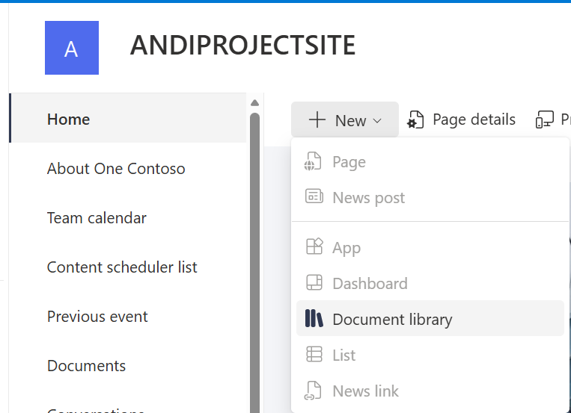
- Choose Blank library
- Enter the library name that matches your scenario
- Select Create
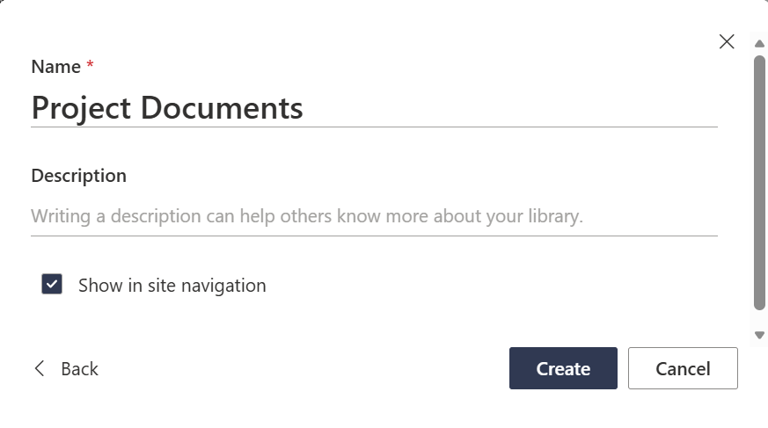
✅ Checkpoint:
The new document library opens.
Step 3: Add Metadata Columns
You will now add columns to capture information about each document.
Metadata helps users filter, sort, and find documents without relying on folders.

Step 4: Add Columns (Based on Your Scenario)
🔹 Option A: Project Team Site — Metadata
Add the following columns to your Project Documents library:
Column 1: Document Type
- Type: Choice
- Choices:
- Planning
- Meeting Notes
- Report
- Deliverable
- Require this column: Yes

- Select add column
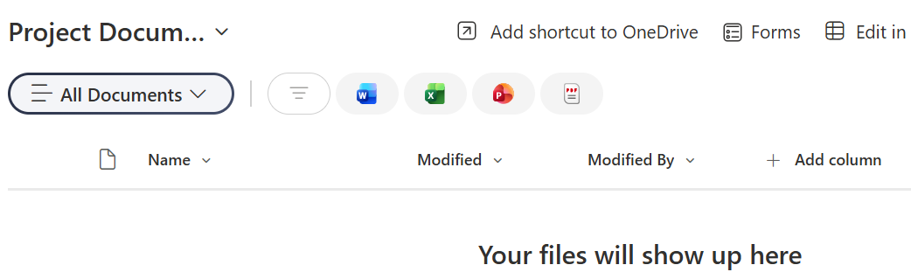
- Choose choice and click next
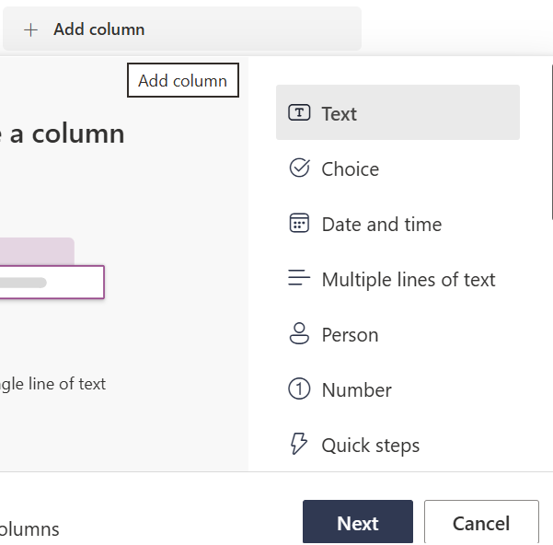
- Enter the name of the column and type in the choices
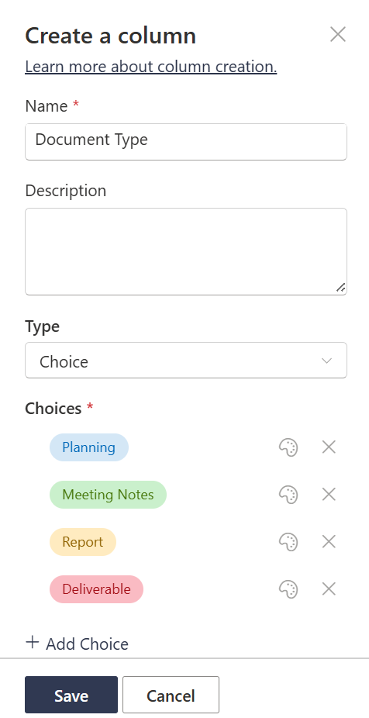
- Click Save
- Complete the steps for the additional columns
Column 2: Project Phase
- Type: Choice
- Choices:
- Initiation
- Design
- Delivery
- Closure
Column 3: Document Owner
- Type: Person or Group
✅ Teaching point:
This metadata supports tracking work over time, not just storing files.
🔹 Option B: Knowledge / Information Hub — Metadata
Add the following columns to your Knowledge Articles library:
Column 1: Topic
- Type: Choice
- Choices:
- IT
- HR
- Finance
- General
Column 2: Content Type
- Type: Choice
- Choices:
- How-To
- FAQ
- Troubleshooting
- Reference
Column 3: Last Reviewed
- Type: Date and Time
- Date only: Yes
This metadata supports search, filtering, and self-service.
- If using your own site – create a document library that would be applicable for your scenario.

Step 5: Reorder Columns (Optional but Recommended)
- In the document library, select Add column → Show/hide columns
- Move your new metadata columns near the top
- Hide columns that are not useful yet (optional)
✅ This improves the user experience immediately.
Step 6: Quick Validation
Confirm the following:
- ✅ The document library exists
- ✅ The library name matches your site scenario
- ✅ At least 3 custom metadata columns have been added
- ✅ The metadata makes sense for the type of site
Do not:
- Upload documents
- Create folders
- Create views

Exercise 5
Create a SharePoint List
Exercise Objective
By completing this exercise, learners will be able to:
- Create a new list in a SharePoint site
- Choose a suitable list name and purpose
- Add columns to collect useful information
- Add sample list items
- Check that the list is ready for team use
Scenario
You have already created a SharePoint site. You now need to create a simple list to track work or information for your site.
Choose ONE List Scenario
- Option A: Project Team Site — create a list called Project Tasks to track tasks, owners, due dates, and progress.
- Option B: Knowledge / Information Hub — create a list called Article Review Tracker to track guidance articles, reviewers, review dates, and status.
- Option C: Your Own Site — create a list that supports your own site purpose.
Before You Start
- Use the SharePoint site you created in Exercise 1.
- Do not change site permissions during this exercise.
- Do not create a document library — this exercise is for a list.

Step-by-Step Instructions
Step 1: Open Your SharePoint Site
- Go to the SharePoint site you created earlier.
- Check that you are on the site home page.
- Confirm the site name matches your chosen scenario.
Step 2: Create a New List
- Select New from the site command bar.
- Select List.
- Choose Blank list.
- Enter the list name for your chosen scenario.
- Add a short description explaining what the list will be used for.
- Choose whether to show the list in site navigation.
- Select Create.
✅ Checkpoint: The new list opens and is ready to customise.
Step 3: Add Columns to the List
Columns help you organise and filter the information in your list. Add the columns that match your scenario.
Option A: Project Tasks — Suggested Columns
- Task Name — Single line of text
- Owner — Person
- Due Date — Date and time
- Status — Choice: Not started, In progress, Complete
- Priority — Choice: Low, Medium, High
Option B: Article Review Tracker — Suggested Columns
- Article Title — Single line of text
- Topic — Choice: IT, HR, Finance, General
- Reviewer — Person
- Review Date — Date and time
- Status — Choice: Draft, In review, Approved
How to Add Each Column
- Select Add column.
- Choose the correct column type.
- Select Next.
- Enter the column name.
- Add any choices if the column is a Choice column.
- Select Save.
- Repeat until all required columns have been added.
Step 4: Add Sample Items
- Select Add new item.
- Complete the fields for the first item.
- Select Save.
- Add at least three sample items to your list.
Example Items
- Project Tasks: Draft project plan, Book kickoff meeting, Prepare status update.
- Article Review Tracker: Password reset guide, Expenses process, New starter checklist.
Step 5: Review the List
- Check that the list name is clear.
- Check that the columns are useful and easy to understand.
- Check that your sample items have been saved.
- Use the column headings to sort or filter the list.
✅ A SharePoint list is useful when you need to track information in rows and columns, such as tasks, issues, requests, assets, reviews, or actions.
Final Checks
- ✅ The list has been created in the correct SharePoint site.
- ✅ The list name matches the chosen scenario.
- ✅ At least four useful columns have been added.
- ✅ At least three sample items have been added.
- ✅ The list can be sorted or filtered.

Exercise 6: Edit the Site Homepage
Make the Homepage Easy to Use
Exercise Objective
By completing this exercise, learners will be able to:
- Edit the homepage of a SharePoint site
- Add useful homepage content using web parts
- Make key information easy to find
- Use Quick Links to guide users to important areas
- Publish the homepage when it is ready
Scenario
You have created a SharePoint site, added owners and members, created a document library, and created a list. Now you need to improve the homepage so that people can quickly understand what the site is for and where to go next. You can design the homepage however you would like however if you need some inspiration there is a step by step guide below.
Before You Start
- Use the same SharePoint site you created in Exercise 1.
- Use the document library from Exercise 4.
- Use the list from Exercise 5.
- Do not change permissions during this exercise.

Step-by-Step Instructions
Step 1: Open the Homepage in Edit Mode
- Go to your SharePoint site.
- Check that you are on the site homepage.
- Select Edit in the top-right corner of the page.
- The page opens in edit mode.
✅ Checkpoint: You can see editing controls on the page.
Step 2: Update the Title Area
- Add a page title area section.
- Add a title so it clearly explains the purpose of the site.
- Add a short description underneath the title if available.
- Keep the wording short and useful.
Example homepage title: Project Phoenix Team Site
Example description: A central place for project documents, tasks, updates, and useful links.
Step 3: Add a Welcome or Purpose Section
- Hover below the title area until you see the + button.
- Select Text.
- Add two or three short sentences explaining what the site is for.
- Avoid long paragraphs — users should understand the site quickly.
Example text: Welcome to the Project Phoenix site. Use this site to access project documents, track tasks, and keep up to date with key information. Start with the quick links below.
Step 4: Add Quick Links
- Hover where you want the links to appear and select the + button.
- Search for or select Quick links.
- Rename the web part title to something useful, such as Start Here or Useful Links.
- Select Add links.
- Add links to important areas of the site or other links.
- Use short link names that make sense to users.
Suggested Quick Links
- Project Documents or Knowledge Articles document library
- Project Tasks or Article Review Tracker list
- How to Use This Site page or guidance section, if available
✅ Quick Links help users find important content without searching through menus.
Step 5: Add a Document Library Web Part
- Choose a suitable place on the page below the welcome text or quick links.
- Select the + button.
- Search for or select Document library.
- Choose the library you created in Exercise 4.
- Rename the section title to something clear, such as Key Documents.
- Keep this section near the top if documents are important to site users.
Step 6: Add a List Web Part
- Select the + button in the area where the list should appear.
- Search for or select List.
- Choose the list you created in Exercise 5.
- Rename the section title to something clear, such as Current Tasks or Review Tracker.
- Check that the list is useful on the homepage and does not take up too much space.
Step 7: Add a News or Updates Section
- Select the + button where you want updates to appear.
- Search for or select News, if available.
- Rename the section to Latest Updates.
- If you do not want to use News, add a simple Text section called Latest Updates instead.
Example update: This site is now ready for team members to access documents, tasks, and useful links.
Step 8: Tidy the Page Layout
- Place the most important information near the top of the page.
- Use clear headings for each section.
- Remove anything that does not help users understand or use the site.
- Keep text short and easy to scan.
- Check the page on your screen before publishing.
Recommended Homepage Order
- Clear title and short description
- Welcome or purpose statement
- Quick Links
- Key documents
- Current tasks or tracker
- Latest updates
Step 9: Save or Publish the Page
- Review the homepage carefully.
- If you are still working, select Save as draft.
- If the page is ready, select Republish or Publish.
- Open the homepage again and check that it looks clear for site users.
Final Checks
- ✅ The homepage has a clear title and purpose.
- ✅ The homepage includes useful Quick Links.
- ✅ The document library is easy to find.
- ✅ The list or tracker is easy to find.
- ✅ Section headings are clear and helpful.
- ✅ The homepage has been saved or published.
Do not spend time making the homepage perfect. The goal is to make it useful, simple, and easy for other people to understand.

