Excel Level 3 – Tasks
Absolute Referencing and Naming Cells
Exercise 1
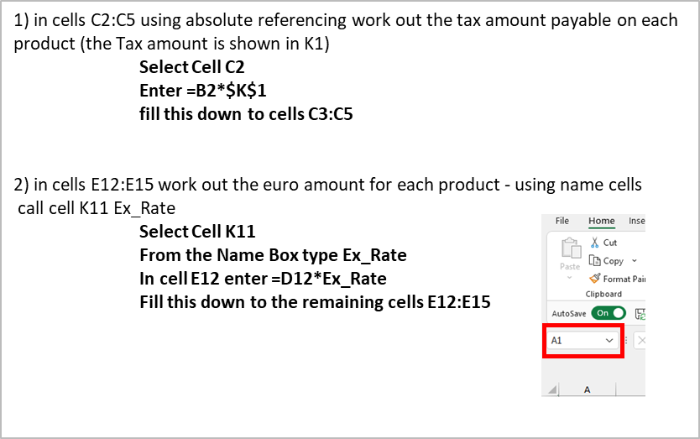

Tables Exercise 1
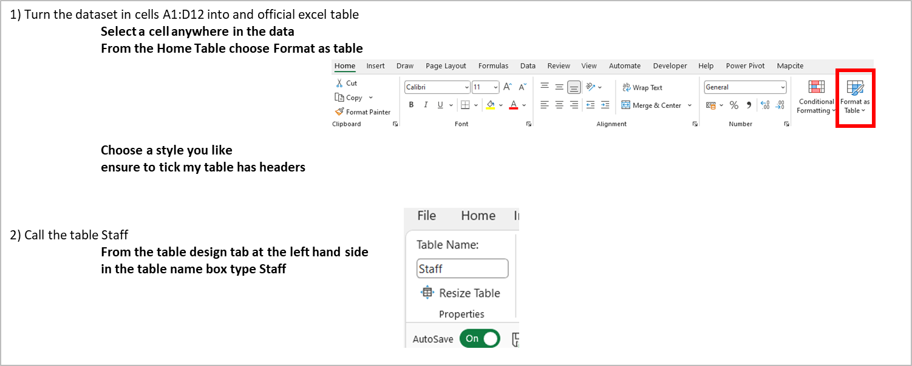

Vlookup exercise 1
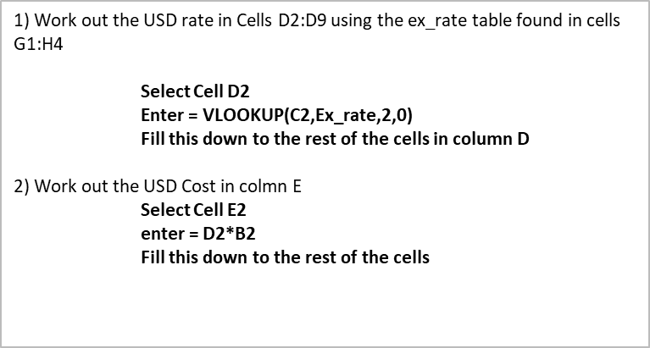
XLOOKUP exercise
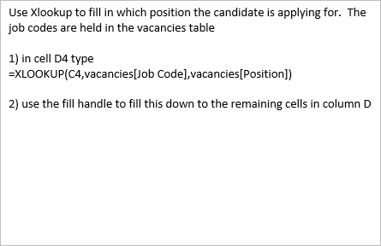

Pivot Tables Exercise 1
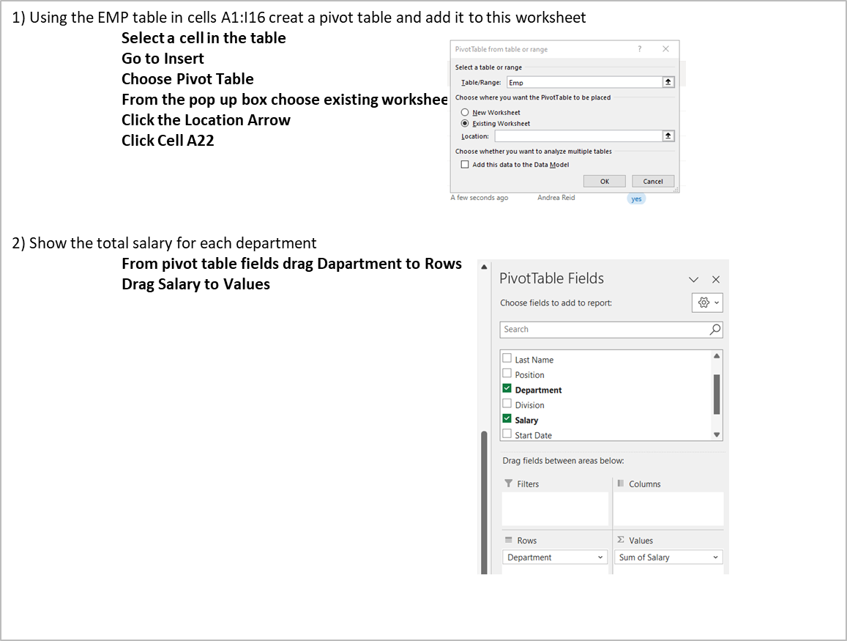
Pivot Table advanced exercise 1
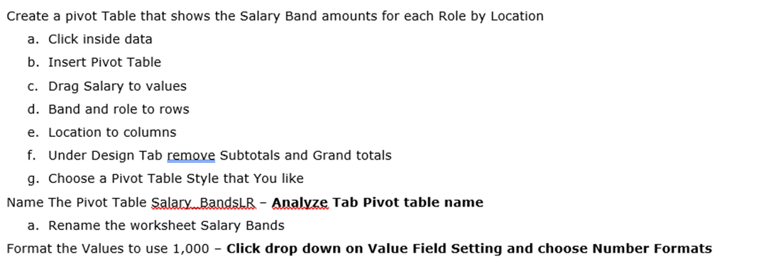

Sumproduct exercise 1
