Exercises

Exercise 1 – OneDrive discussion
Discuss benefits of cloud storage
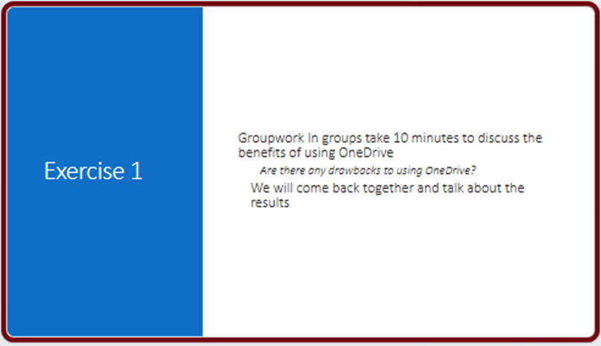

Exercise 2 – Create document
Open Word
Create file Lotto
Save to OneDrive
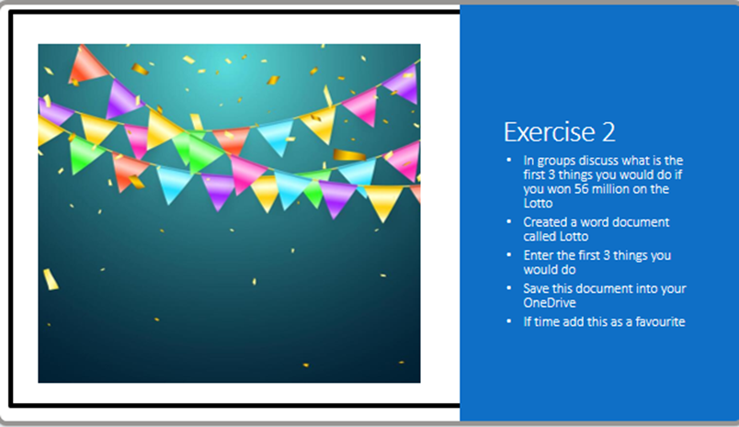

Exercise 3 – Organise files
Create folder
Move file
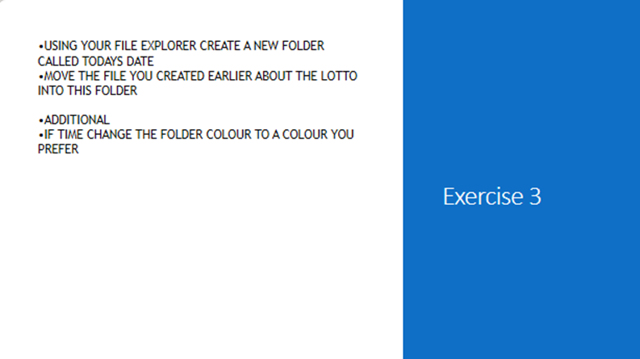

Exercise 4 – Web access
Open OneDrive in browser
Find your Lotto File
Test Immersive Reader
If time Add an excel spreadsheet called lotto Purchases
What would you like to purchase
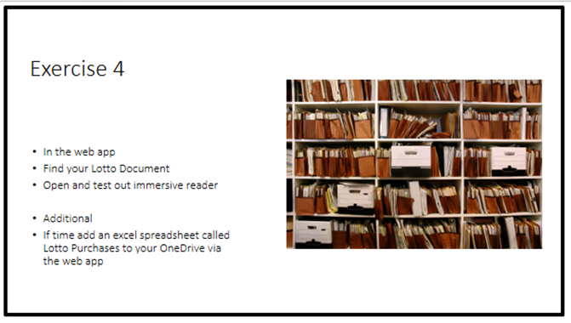

Exercise 5 – Share file
Share file with user
- Using whichever method you prefer
- Create a new word document called Desert Island
- Add which 3 people you would like to have with you on the island
- Save this file to your OneDrive
- Share this file with your group and Andrea@acatalyst.onmicrosoft.com

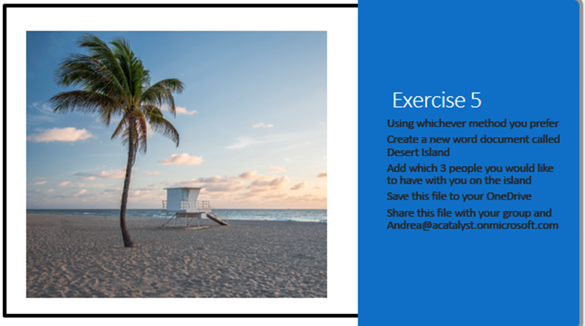

Exercise 6 – OneDrive vs SharePoint
Decide correct storage location for each document
- The completed HR Policy document
- Your To Do list
- The latest Project Plan
- Company Newsletter
- Holiday Photos
- The draft proposal you and your colleague are working on
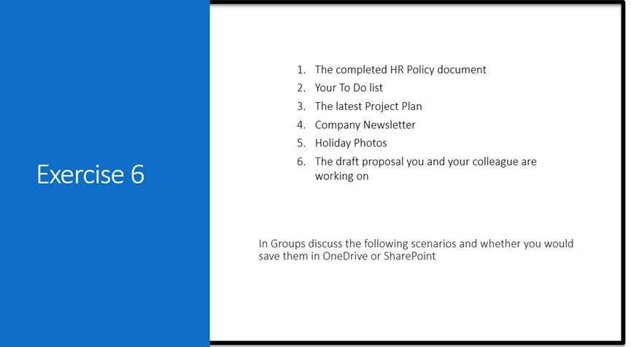

Exercise 7 – Upload SharePoint
Upload file to library
- Navigate to the SharePoint site using the link provided
- Enter the username and password given
- Upload the file you created this morning to todays document library
Additional
- If time create a new powerpoint presentation called your name
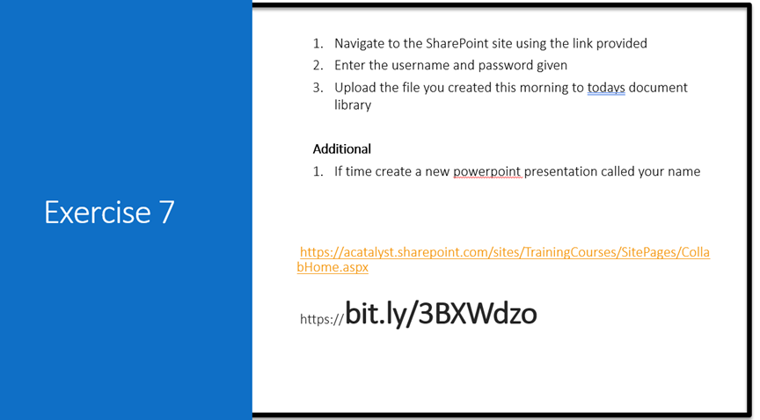

Exercise 8 – Co-author
Edit shared file
- Open the What is your favourite Animal Document
- Type in your name and your favourite animal
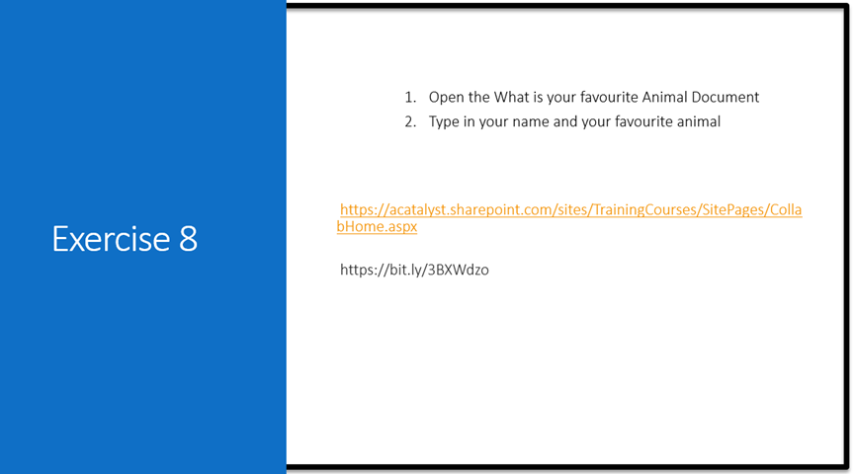

Exercise 9 – Search
Find files
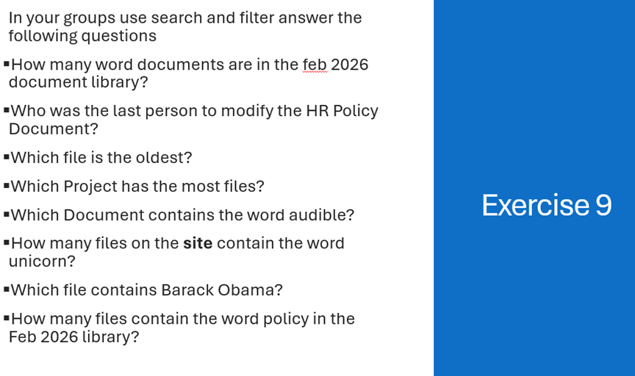

Exercise 10 – Views
Create custom view
Create Your Own View
Go to the document library
Select Add view or Create new view
Give your view a name (e.g.ANDI View)
Choose how you want to organise your files:
Sort by name or date
Filter by file type or who modified it
Save your view

Additional
If time – find any documents in the document library that were created by you.
Delete these documents

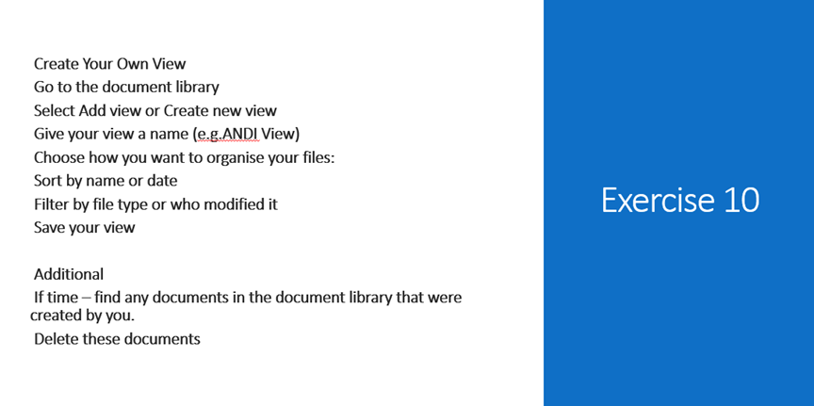

Groupwork for Lists

- In your group
- Create a to do list for an event of your choice
- Enter the first five actions you need to do

