Intro to Power BI Tasks

Exercise 1 Get Data

Open Power BI  Connect to the Student training sales excel file  Click on either Excel Workbook from the Home Tab or the Import data from excel icon in the centre of the screen | 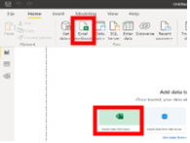
Select the file and the navigator should appear you will see a preview of any sheets in the file. Click the checkbox beside Data1 and then click the Load Button. | 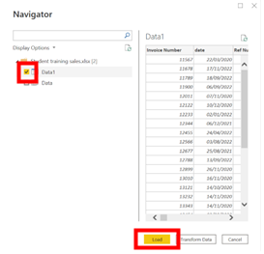
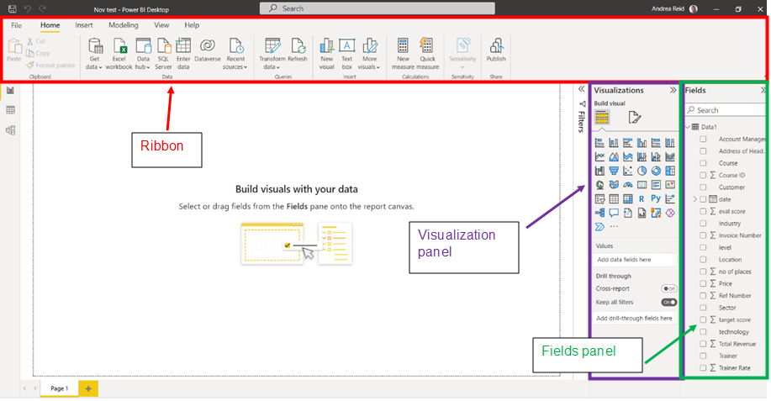.

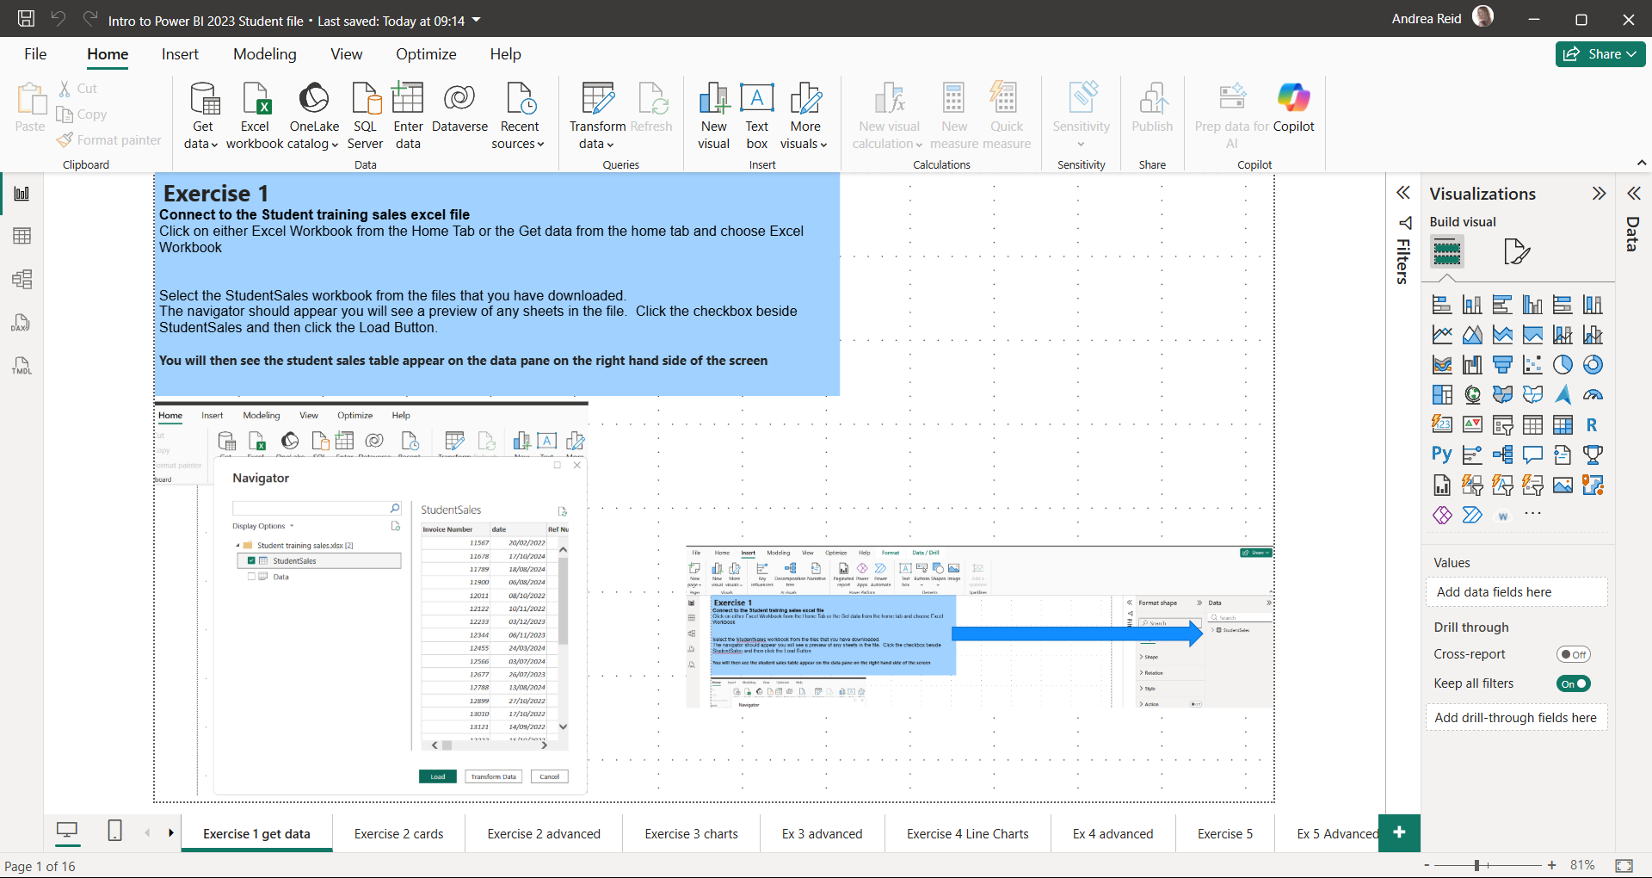

Exercise 2 Cards

Add a card to this page that shows the Total Revenue
- from the visuals pane choose the card visual
- from the data pane on the right of the screen select the revenue field
- update the formatting to formatting that you prefer
if time include another card to show the average number of places
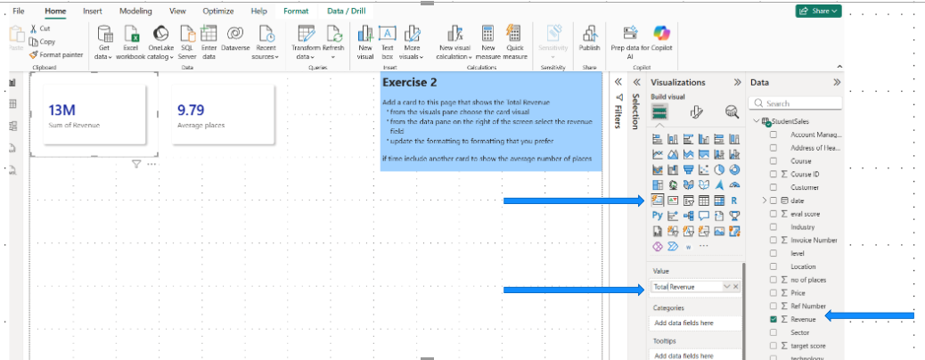

Exercise 3 Charts

Which course generates the most revenue? Create a bar chart that shows course by revenue
Choose the clustered bar chart visual
Select Courses from the fields list
Select Total Revenue from the fields list

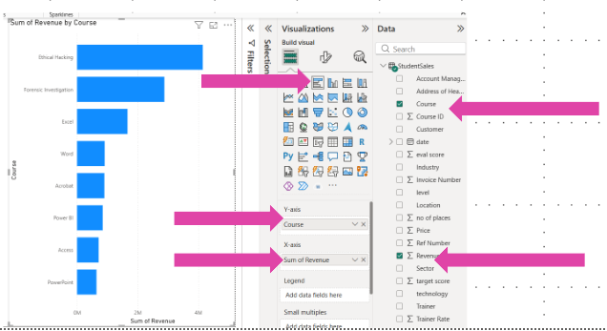

Exercise 4 Line Charts
Add a line chart to show the trend in revenue over the months
Choose the Line Chart
Select total revenue and add it to Y Axis and add Date to the X-axis
Remove the day field
Rename Chart to say Monthly Revenue Trend
Formatting, General, Title
Add Tootips to show the number of places and the number of courses
Drag no of places and course ID into the tooltips section (visualizations pane scroll down)
Rename these for the visual as shown

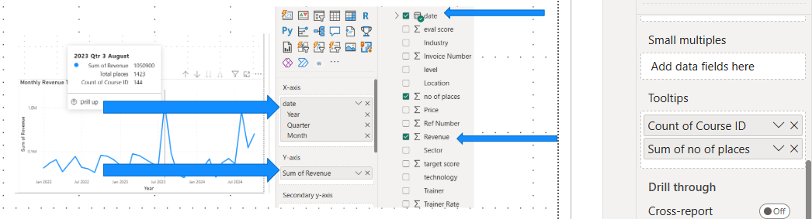

Exercise 5

Create a map
Add a map to show the locations of the courses with bubble size based on total revenue
Select map visual
Drag Location into the location space and Revenue into the size space
If time experiment with a map style you like
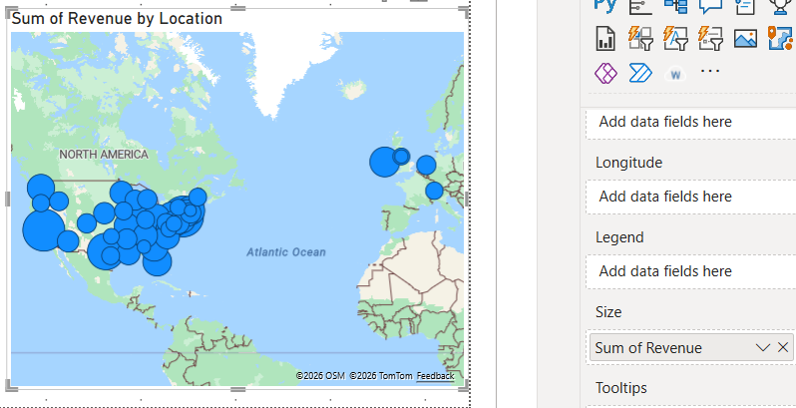

Exercise 6 Data Model

You are interested in looking at where the courses were purchased however this information isn’t in your original spreadsheet but instead in a CSV file. You need to get this data from the Purchase Type CSV File  Go to get data, select Text/CSV  Choose the file and click Load | 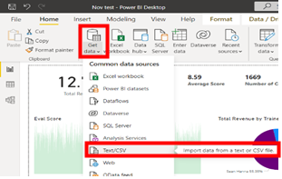
To be able to use this information you need to create a relationship between this file and the original data  Go to the Model View  Drag Invoice # on top of Invoice Number | 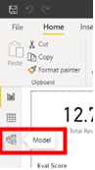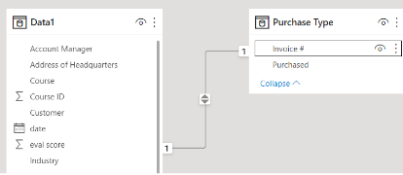

On a new page called Purchase Type in your report create a column chart that shows the amount of revenue generated from online, direct contact and events  Select Clustered column from visualizations  Drag Purchased into X axis and drag total revenue into Y axis  Format the chart as you prefer and update the title to something more relevant | 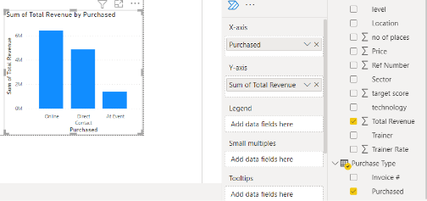
Exercise 7 Measures

Create a measure to show the average evaluation score
From the home tab, select New Measure, type the formula below
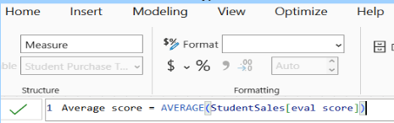
Create a measure to show the maximum places we ever sold on a course
From the home tab, select New Measure, type the formula below
Create a card to show both these values - if time apply formatting you prefer
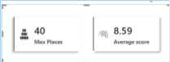

Exercise 8 – Filters and Slicers

Add some visuals you created on the course to this page
Add a slicer at the top of the page so that you can filter by Year

Slicer visual
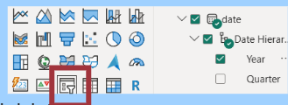
Select Year from the Hierarchy
Choose 2023 to see it update the visuals
If time add another slicer to let you filter by Industry
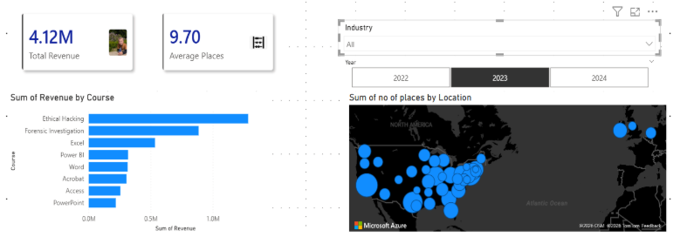
Questions

What was the maximum places we ever allowed on a course?

What was the minimum places we ever allowed on a course?

What course had the highest average eval in 2022?

What course had the lowest average eval in 2022?

Which account manager makes the highest revenue?

Who sells the most Adobe courses?

Which Quarter would you run a marketing campaign?

