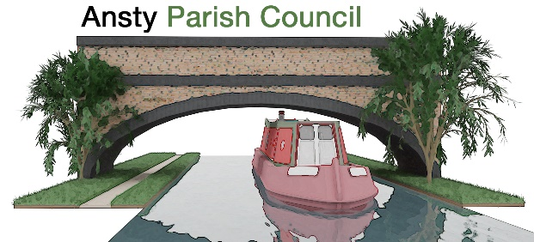

**NOTICE OF ANNUAL PARISH MEETING**

You are hereby invited to attend a meeting at 7.00pm on 20 May 2025 at The Ansty Club, Grove Road, Ansty.

Photographing, reporting, filming, or transmitting the proceedings of the meeting may occur, and therefore all persons participating in the meeting should be aware that such recording, reporting, or filming may take place.

Signed

Grahame Fox-Dowden Dated 09 May 2025

Chair to Ansty Parish Council

Email: clerk.anstypc@gmail.com

# **THE PUBLIC AND PRESS ARE WELCOME TO ATTEND**

**A G E N D A**

1. **Apologies**

To receive apologies for absence from the meeting.

1. **Report by the Chairman**

To receive a report on the council activities over the last 12 months

1. **Report from Borough Council**

To receive a report from Borough Councillor

1. **Report from County Council**

To receive a report from County Councillor

1. **Report from village organisations**

To receive any reports from any village organisations

1. **To receive financial report**

To receive end of year financial status

1. **Open Forum**

To receive any questions from residents