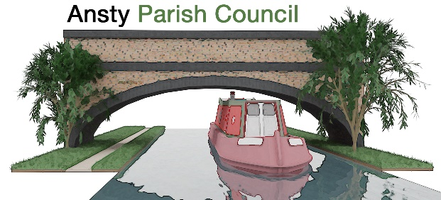

**NOTICE OF A PARISH COUNCIL MEETING**

You are hereby summoned to attend Annual Meeting of Ansty Parish Council at 7.10pm on 20 May 2025 at The Ansty Club, Grove Road, Ansty.

Photographing, reporting, filming, or transmitting the proceedings of the meeting may occur, and therefore all persons participating in the meeting should be aware that such recording, reporting, or filming may take place.

Signed

L Foster

Lindsay Foster Dated 14 May 2025

Clerk to Ansty Parish Council

Email: clerk.anstypc@gmail.com

# **THE PUBLIC AND PRESS ARE WELCOME TO ATTEND**

**A G E N D A**

1. **To appoint Chairman and receive declaration of acceptance**

To appoint chairman of the Parish Council

1. **To approve Vice Chair**

To appoint Vice Chair of the Parish Council

1. **Apologies**

To receive apologies for absence from the meeting.

1. **Declarations of Interest**

To receive any declarations of interest and approve the grant of dispensations in respect of any item to be discussed at the meeting.

1. **Minutes**

To approve the minutes of the meeting held on April 2025.

1. **Parishioners’ Time**

Members of the public are invited to raise issues and ask questions**.**

1. **Warwickshire County Council and Rugby Borough Council Update**

To receive updates from Warwickshire County Councillor Warwick and Rugby Borough Councillor Gillias.

1. **To approve Standing Orders**
2. **To approve financial regulations**
3. **Finance Matters**
4. To approve and pay invoices and accounts as required

# **Future Projects**

Village Gateway Signs

Bin replacement

# **Planning Applications and Matters**

To consider any planning applications and matters.

* Local Plan update

1. **Enforcement Issue – update**

Update on enforcement action at the site on Hinckley Road.

1. **Bridge Works**

To receive an update on the bridge repairs.

1. **Correspondence**

* Improvements to playing field

1. **Items for next Meeting**
2. **Dates of Next Meetings**

17 June 2025

1. **Exclusion of the public under public bodies (Amendment act 1960, Section 1)**

To consider the exclusion of the public for the following item in view of the confidential nature of business to be discussed.

1. **Playing Field Matters**