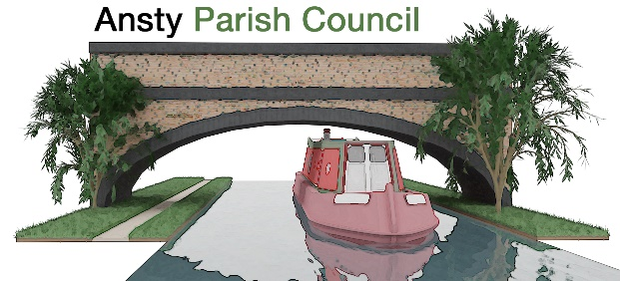

**NOTICE OF A PARISH COUNCIL MEETING**

You are hereby summoned to attend the Meeting of Ansty Parish Council at **7.00pm** on **17th June 2025** at Ansty Hall, Main Road, Ansty.

Photographing, reporting, filming, or transmitting the proceedings of the meeting may occur, and therefore all persons participating in the meeting should be aware that such recording, reporting, or filming may take place.

Signed

L Foster

Lindsay Foster Dated: 11th June 2025

Clerk to Ansty Parish Council

Email: clerk.anstypc@gmail.com

# **THE PUBLIC AND PRESS ARE WELCOME TO ATTEND**

**A G E N D A**

1. **Apologies**

To receive apologies for absence from the meeting.

1. **Declarations of Interest**

To receive any declarations of interest and approve the grant of dispensations in respect of any item to be discussed at the meeting.

1. **Minutes**

To approve the minutes of the meeting held on 22nd May 2025.

1. **Parishioners’ Time**

Members of the public are invited to raise issues and ask questions**.**

1. **Warwickshire County Council and Rugby Borough Council Update**

To receive updates from Warwickshire County Councillor Warwick and Rugby Borough Councillor Gillias.

1. **Finance Matters**
2. To approve and pay invoices and accounts as required
3. To note internal audit
4. To approve section 1
5. To approve section 2
6. To approve exemption from audit
7. To approve end of year accounts

# **Ongoing Project updates**

1. New bin
2. Gateway repairs

# **Planning Applications and Matters**

To consider any planning applications and matters.

1. **Bridge Works**

To receive an update on the bridge repairs.

1. **Enforcement**

To discuss enforcement action at ‘The Layby’

1. **Correspondence**
2. **Items for next Meeting**
3. **Dates of Next Meetings**

15th July 2025

1. **Exclusion of the public under public bodies (Amendment act 1960, Section 1)**

To consider the exclusion of the public for the following item in view of the confidential nature of business to be discussed.

1. **Playing Field Matters**