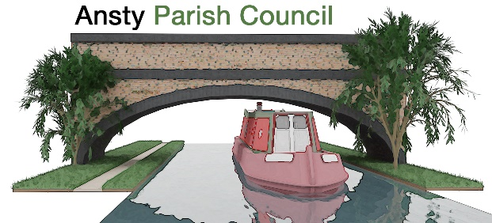

**NOTICE OF A PARISH COUNCIL MEETING**

You are hereby summoned to attend the Meeting of Ansty Parish Council at **7.00pm** on **16th September 2025** at Ansty Club Grove Road, Ansty.

Photographing, reporting, filming, or transmitting the proceedings of the meeting may occur, and therefore all persons participating in the meeting should be aware that such recording, reporting, or filming may take place.

Signed

L Foster

Lindsay Foster Dated: 10th September 2025

Clerk to Ansty Parish Council

Email: clerk.anstypc@gmail.com

# **THE PUBLIC AND PRESS ARE WELCOME TO ATTEND**

**A G E N D A**

1. **Apologies**

To receive apologies for absence from the meeting.

1. **Declarations of Interest**

To receive any declarations of interest and approve the grant of dispensations in respect of any item to be discussed at the meeting.

1. **To discuss Co-option**
2. **Minutes**

To approve the minutes of the meeting held on 15th July 2025.

1. **Parishioners’ Time**

Members of the public are invited to raise issues and ask questions**.**

1. **Warwickshire County Council and Rugby Borough Council Update**

To receive updates from Warwickshire County Councillor Warwick and Rugby Borough Councillor Gillias.

1. **Finance Matters**
2. To approve and pay invoices and accounts as required
3. To approve Q1 accounts
4. To discuss tree works quote
5. To discuss brook works quote

# **Ongoing Project updates**

1. New bins update and to approve replacement bin Grove Road

# **Planning Applications and Matters**

To consider any planning applications and matters.

1. **Bridge Works**

To receive an update on the bridge repairs.

1. **Enforcement**

To discuss enforcement action at ‘The Layby’

1. **Correspondence and items raised by residents**

* Resurfacing Main Road- potholes
* Blocked drains Main Road
* M69 road noise
* Parking signage Meadow Close
* Double yellow lines Grove Road

1. **Items for next Meeting**
2. **Dates of Next Meetings**

21st October 2025

1. **Exclusion of the public under public bodies (Amendment act 1960, Section 1)**

To consider the exclusion of the public for the following item in view of the confidential nature of business to be discussed.

1. **Playing Field Matters**