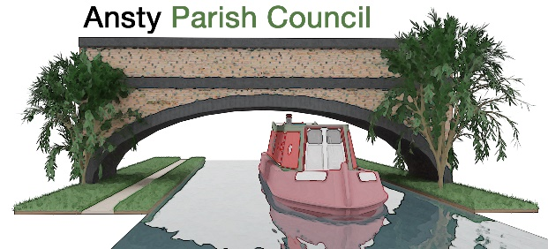

NOTICE OF A PARISH COUNCIL MEETING

You are hereby summoned to attend the Meeting of Ansty Parish Council at 7.00pm on 16th December 2025 at Ansty Club Grove Road, Ansty.

Photographing, reporting, filming, or transmitting the proceedings of the meeting may occur, and therefore all persons participating in the meeting should be aware that such recording, reporting, or filming may take place.

Signed
L Foster
Lindsay Foster Dated: 10th December 2025
Clerk to Ansty Parish Council
Email: clerk.anstypc@gmail.com

THE PUBLIC AND PRESS ARE WELCOME TO ATTEND

A G E N D A

- Apologies

To receive apologies for absence from the meeting.

- Declarations of Interest
To receive any declarations of interest and approve the grant of dispensations in respect of any item to be discussed at the meeting.

- To discuss and approve Co-option

- Minutes
To approve the minutes of the meeting held on 18th November 2025.

- Parishioners’ Time
Members of the public are invited to raise issues and ask questions.

- Warwickshire County Council and Rugby Borough Council Update

To receive updates from Warwickshire County Councillor Warwick and Rugby Borough Councillor Gillias.

- Finance Matters
- To approve and pay invoices and accounts as required
- To discuss tree works quote
- To discuss ditch works quote
- To approve Draft budget 2026-27
- To approve precept 2026-27

Ongoing Project updates
- To discuss bin issues

Planning Applications and Matters
To consider any planning applications and matters.
- Local plan update

- Bridge Works
To receive an update on the bridge repairs.

- Village maintenance updates
Maintenance issues around the village including drains, footpaths, double yellow lines and parking issues

- Correspondence

- Items for next Meeting

- To approve meeting dates 2026

- Dates of Next Meetings

20th January 2026

