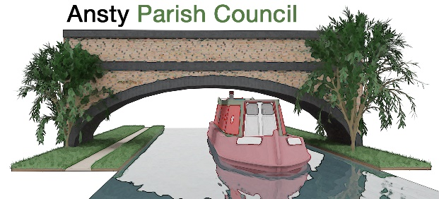

NOTICE OF A PARISH COUNCIL MEETING

You are hereby summoned to attend the Meeting of Ansty Parish Council at 7.00pm on 21st April 2026 at Ansty Club Grove Road, Ansty.

Photographing, reporting, filming, or transmitting the proceedings of the meeting may occur, and therefore all persons participating in the meeting should be aware that such recording, reporting, or filming may take place.

Signed
L Foster
Lindsay Foster Dated: 15th April 2026
Clerk to Ansty Parish Council
Email: clerk.anstypc@gmail.com

THE PUBLIC AND PRESS ARE WELCOME TO ATTEND

A G E N D A

- Apologies

To receive apologies for absence from the meeting.

- Declarations of Interest
To receive any declarations of interest and approve the grant of dispensations in respect of any item to be discussed at the meeting.

- Minutes
To approve the minutes of the meeting held on 17th March 2026.

- Parishioners’ Time
Members of the public are invited to raise issues and ask questions.

- Warwickshire County Council and Rugby Borough Council Update

To receive updates from Warwickshire County Councillor Warwick and Rugby Borough Councillor Gillias.

- Finance Matters
- To approve and pay invoices and accounts as required
- To discuss tree works quote
- To discuss ditch works quote
- To discuss email hosting and new email set up for councillors

Ongoing Project updates
- To discuss bin issues

Planning Applications and Matters
To consider any planning applications and matters.

- Bridge Works
To receive an update on the bridge repairs.

- Village maintenance updates
Maintenance issues around the village including drains, footpaths, double yellow lines and parking issues

- Correspondence

- Items for next Meeting

- Dates of Next Meetings

19th May 2026- Annual Parish meeting followed by Annual Parish Council meeting.

