GALLERY FUMI presents
NOMAD Hamptons
25 – 28 June 2026 | The Watermill Center, Water Mill, New York
London, United Kingdom – Gallery FUMI is pleased to announce its participation in the inaugural edition of NOMAD Hamptons, taking place 25 – 28 June 2026 at the Watermill Center, Water Mill, New York.
The gallery has long been a participant in NOMAD's international programme, including its debut in Abu Dhabi in 2025. Each edition of NOMAD presents new opportunity to bring our artists to venues that are emblematic of the regions they belong to. The Hamptons' tradition of considered domestic life, of architecture and nature held in close dialogue, speaks directly to the kind of work Gallery FUMI champions.
The presentation also marks the close of an extended residency in the United States for Gallery FUMI, following the gallery's New York residency at Galerie56 in Tribeca. NOMAD Hamptons brings that chapter to a natural conclusion with an exhibition of works made with the commitment to material rigour and artistic ambition that the gallery has platformed both in New York and throughout the history of its international programme.
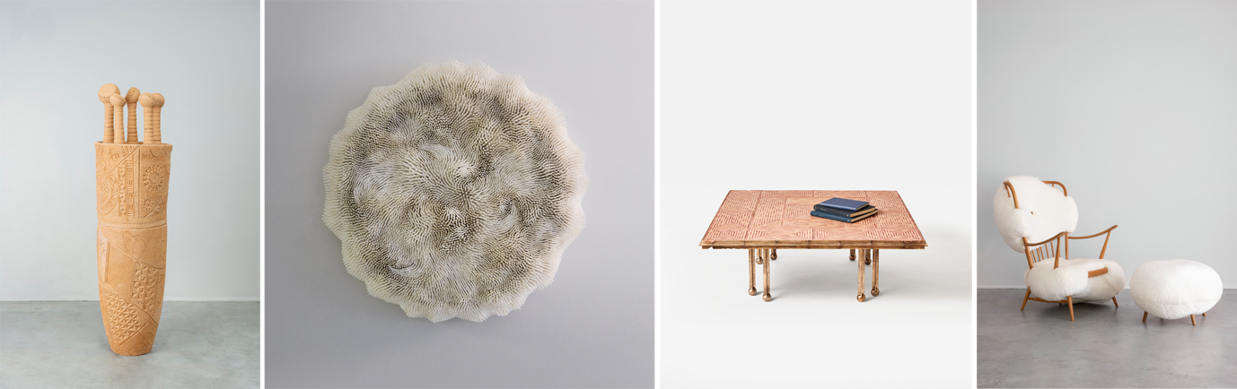
ABOUT THE WORKS
Kobina Adusah Living Signal and Vessel of Echoes are large-scale ceramic sculptures inscribed with a contemporary pattern language singular to the artist’s practice. These expressive marks operate as symbols and signals, evoking ancestry, spiritual knowledge, and oral traditions while resisting fixed interpretation. Bearing a deep connection to his material, the artist works the clay through each phase from its raw state, to shaping, carving, firing, and assembly.
Rowan Mersh's Pithvava Mini is a wall-mounted work built entirely from tubular dentalium shells, a primary material of the artist’s practice. Each one is individually placed and angled to build a surface of extraordinary density and movement. Organic in feeling yet obsessively constructed, the work resolves as a flowing, coral-like form that seems to shift with the light.
Jeremy Anderson’s Coffee Table (Square) combines a top of hand-painted terracotta tile with a cast bronze base of clustered, ball-footed legs, all made by hand onsite in Anderson’s Brooklyn studio. The result is a table that is significant in presence yet intimate in detail.
Charlotte Kingsnorth's Wuzzy Hi!breed Armchair and Ottoman takes a salvaged mid-century armchair frame and re-bodies it entirely in cloud-like faux fur upholstery, the original structure still legible through the softness. Tender, slightly absurd, and uniquely inviting, the pair embodies Kingsnorth's belief that furniture should have a soul.
ABOUT GALLERY FUMI
Established in 2008 by Sam Pratt and Valerio Capo, Gallery FUMI presents conceptually and aesthetically ambitious designers and artists whose work values craftsmanship, traditional techniques, and innovative technologies. Many pieces are handmade in small workshops, using processes such as carving, glassblowing, cabinetry, lacquering, and hand assemblage.
The gallery has built lasting relationships with institutions, interior designers, and collectors, earning a reputation for a personal and original curatorial approach. Combining close knowledge of their designers with insight into the market, they commission exclusive, low-volume, limited-edition works.
The gallery runs an ambitious exhibition programme and participates in leading international design fairs.
an ambitious programme of exhibitions alongside a presence at international design fairs.
GENERAL CONTACT
2–3 Hay Hill, London W1J 6AS
020 7490 2366
galleryfumi.com
@gallery_fumi
PRESS CONTACT
Reiber PR
Danielle Reiber
danielle@reiberpr.com
+44 7776 218 683

