Social Media Kit Spin-off Austria Konferenz 2025

Vielen Dank, dass Sie die Spin-off Austria Konferenz in Ihrem Netzwerk teilen!

In diesem Dokument finden Sie Vorschläge zu einem Newsletter-Text sowie LinkedIn Post. Sie können diese Vorschläge gerne verändern oder auch einen eigenen Text schreiben.

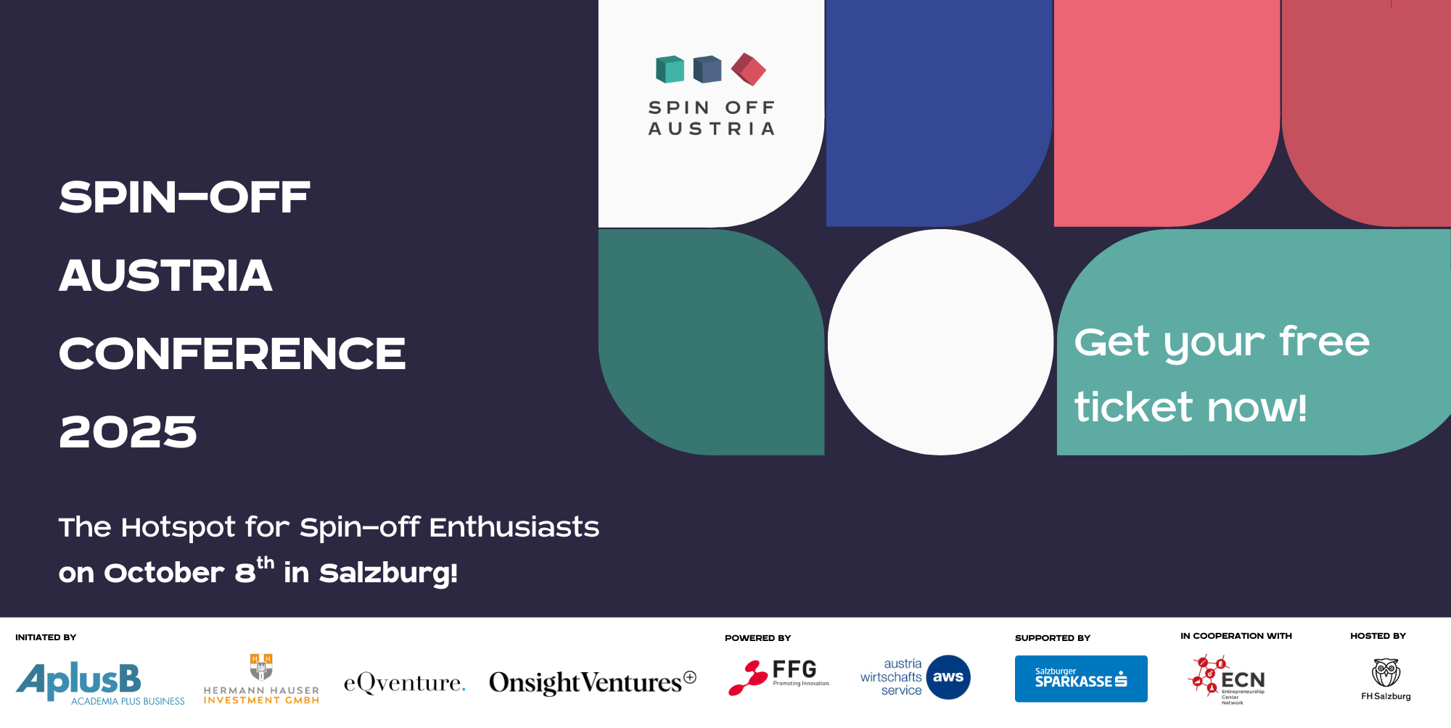

Invitation

Newsletter
Subject: Invitation | Spin-off Austria Conference – Austria’s spin-off scene is gaining remarkable momentum!
Dear Spin-off Community,
An increasing number of universities are launching dedicated programmes for aspiring entrepreneurs and establishing investment vehicles to support spin-offs. Reflecting this dynamic development, this year’s Spin-off Austria Conference will spotlight the processes and tools that help transfer organisations work more efficiently and effectively.
As in previous years, Spin-off Austria will showcase inspiring international best practices. This time, we’re especially excited to introduce live workshops designed to immediately turn input into actionable outcomes.

Join us on 8th October in Salzburg and help shape the future of Austria’s spin-off ecosystem!

More Information and registration: https://www.spin-off-austria.at/conferences/conference-8-oct-2025

Social Media

🚀 Austria’s spin-off scene is gaining remarkable momentum.
More and more universities are launching structured programmes for entrepreneurial talent and founding investment vehicles to support spin-offs. A strong signal that innovation is becoming a key strategic pillar in Austria’s academic landscape.

🎯 At this year’s Spin-off Austria Conference, we’ll focus on processes and tools that make the work of transfer organisations more effective, scalable, and future-ready.

🌍 As always, we’ll bring international best practices to the stage – but this year, we’re taking it one step further:
💡 Live workshops will turn expert input into actionable results – on the spot.

📅 Join us on 8th October in Salzburg to connect, learn, and actively shape the next phase of Austria’s spin-off ecosystem.

👉 Register now: https://www.spin-off-austria.at/conferences/conference-8-oct-2025

#spinoff #innovation #austriainnovation #academicentrepreneurship #spinoffaustria #spinoffaustria2025 #networking #startupsaustria #techtransfer #knowledgetransfer

