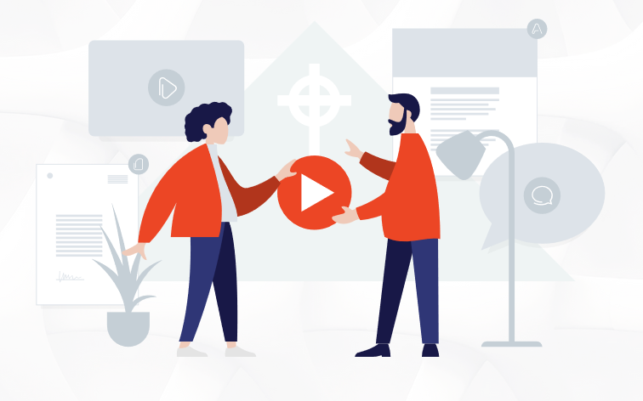
Easter Preparation Resources Pack
Easter Preparation Resources
Easter is a celebration which requires a lot of planning for a church. It provides a lot of footfall for our churches which means we prepare lots of resources to help bless the children’s ministries and those who are volunteering in them.
A lot of these resources are aimed at Children’s Ministry simply because they can be less church-specific, but we do have some song suggestions included at the end for songs to use in your service! We hope this resource will bless you and make your Easter plans a little easier.

Kids
1) Helpful teaching material for Kids Ministry
Our first recommended resource is the Gospel Project. It has free Easter session materials for all age groups from nursery aged children up to adults. The sessions normally include Leader resources as well. https://www.gospelproject.com/weekly-leader-training-for-preschool-kids-easter-bonus-sessions-2026/
Another resource we found that is made up of a range of activities is on the Faith in Kids site. They have advice for setting up a family activity session, suggested Easter events for Easter weekend and lots of craft ideas
https://www.faithinkids.org/resources/sunday-school/easter-explained/

Younger Children
- Children’s Ministry Deals is offering some free resources including Easter colouring pages (which could prove to be very handy for younger children); Easter programs and skits and Easter Sunday Children’s Ministry Curriculum. https://www.childrens-ministry-deals.com/collections/10-free-resources-for-easter

Older Children
- Crossroads Kids Club did a tour of the locations of Israel mentioned in the Easter story and told the Easter story with relevant Bible verses as they went. We found this an encouraging look at the gospel story that really pushed home the truth of Jesus’ life, death and resurrection. https://www.youtube.com/watch?v=HyuqfUxdOH8

2) Easter Songs (Kids)
Here are a few song ideas for your Easter children’s ministry:
- Happy Day – This song is very upbeat, bound to get the children dancing and we’ve linked a video with some dance moves you could try! (https://www.youtube.com/watch?v=BL_vqA94Xls)

- O Taste and See (Bethel Kids)- This is another good one to get the children dancing to (although we wouldn’t recommend the dancing on the chairs!) (https://www.youtube.com/watch?v=kyzXnbBI5LQ)

- My Lighthouse (Rend. Co. Kids)- This song is a much-loved favourite. The video has a brightly coloured background, clear and easy actions and lyrics on screen. (https://www.youtube.com/watch?v=JeJvKkBV6rY)

- We Believe (Easter song)- This song is slower than the others but talks directly about Jesus coming to save us. Although there are actions, they are in the corner of the screen and not easy to see, so they may need to be learnt beforehand. (https://www.youtube.com/watch?v=So1853BcwMg)

- He’s Alive, He’s Alive- This song celebrates the resurrection and talks about God’s plan to rescue us. It’s an upbeat song that hopefully will get the children dancing and singing along in no time. (https://www.youtube.com/watch?v=N29pfecIiYE)

3) Crafts ideas
Here’s some pages with handy ideas:
- Although perhaps a more unconventional source, this photo gallery of ideas in Country Living for crafts based off of the Easter story has a variety of ideas, with different levels of materials required: https://www.countryliving.com/diy-crafts/g30928377/religious-easter-crafts-ideas/

- This blog that we found starts off with a range of picture ideas from Pinterest and further down the page, categorises crafts into different types e.g. handprint crafts, decorating a cross, etc. Many of them have instructions too! https://www.redtedart.com/religious-easter-crafts-for-sunday-school-or-at-home/

- Here is another blog that has a lot of good craft ideas for Easter Sunday but also for Holy Week. Some of the crafts here are even food based (which could be pointed out to parents as a possible extra to do after church, or at some point in the holidays). https://www.icanteachmychild.com/christ-centered-easter-activities-and-crafts/

- This webpage is quite old-school and has crafts ranging from easier to more challenging which could be helpful in planning for a class with a wide age-range amongst the children. https://ministry-to-children.com/childrens-easter-crafts-resource-page/

- This website holds a few craft ideas for a wide-range of children. It also contains a craft list and instructions too!
https://capuk.org/news-and-blog/ten-religious-easter-crafts-for-kids-and-families

4) Games
- Relay Race- Split the children into teams. Have a chosen child in each team who needs to get from A to B but can only stand on leaves (big palm leaf shapes cut out from paper). The rest of the team’s job is to create the path by moving the leaves so that the team leader can keep moving. The first team to get their leader to point B wins. (The idea is to remind children of Jesus riding a donkey over palms in the triumphal entry).

- Hard Boiled Egg and Spoon Race

- Bible Verse Easter Egg Hunt-
  - Get hollow eggs and fill them with one word from a Bible verse. Get the children to go on an Easter egg hunt and figure out the verse. The fastest team to figure out the verse wins a prize.
  - Get hollow eggs and fill them with half a memory verse. Get the children to go on an Easter egg hunt and match the verses together The fastest team to put the verses in the right order wins a prize.

- Hard Boiled Egg Rolling Race- Get the children to decorate an egg and have a competition to see who can roll theirs the furthest with the least damage.

- Charades- Act out the words to the Bible verse like charades for the children and make them guess the words of the verse.

- Act it out- Give the children one minute to act out one bit of the Easter story or to do a freeze frame of how they think different people would have reacted in the moment e.g. the disciples faces when they heard Jesus was alive/when Jesus was arrested/etc.

- Bible Race- Split the children into groups and give them a bible verse to find. The first to 10 wins.

- Race- send the children to look for different things around the room e.g. ‘hunt for something yellow/something you can drink from/etc.’ and the first one back wins.

For your Easter Service
It was difficult thinking of ways we could help support you in preparing your services but one area that did spring to mind was the music. Here are some suggestions of songs that you could include in your Easter service this year:
- Glorious Day (Living He loved me)- Casting Crowns (https://www.youtube.com/watch?v=CoGvGvhjD68)

- In Christ Alone- Stuart Townend
(https://www.youtube.com/watch?v=ENtL_li4GbE)

- Man of Sorrows- Shane and Shane
(https://www.youtube.com/watch?v=6E5Ux9PXjso)

- How Deep the Father’s Love for Us- Stuart Townend
(https://www.youtube.com/watch?v=pmzudzkGS-Q)

- Nothing but the Blood of Jesus
(https://www.youtube.com/watch?v=j-J8PPbIdHc)

- King of Kings
(https://www.youtube.com/watch?v=dQl4izxPeNU)

- Living Hope
(https://www.youtube.com/watch?v=u-1fwZtKJSM)

- Christ Our Hope in Life and Death
(https://www.youtube.com/watch?v=OibIi1rz7mw)

If you would like a full playlist, FIEC have created a playlist to celebrate Easter- have a listen on spotify here: https://open.spotify.com/playlist/78UhFHiIAKDeJGTbAkeiOG?go=1&sp_cid=8a2f03ff729f2dbe03596e739301e71b&utm_source=embed_player_p&utm_medium=desktop&nd=1&dlsi=f0c03b52b5a34b93
We hope that this has been a help in your preparations for your Easter service and if you have any other useful ideas or crafts that you’d like to share, let us know on our social media! Equally if you think we’ve missed something email us at info@thechurchoffice.co.uk.
We pray that your Easter services are a blessing to your church and communities and that through our preparations now, people will come to know Jesus.

