
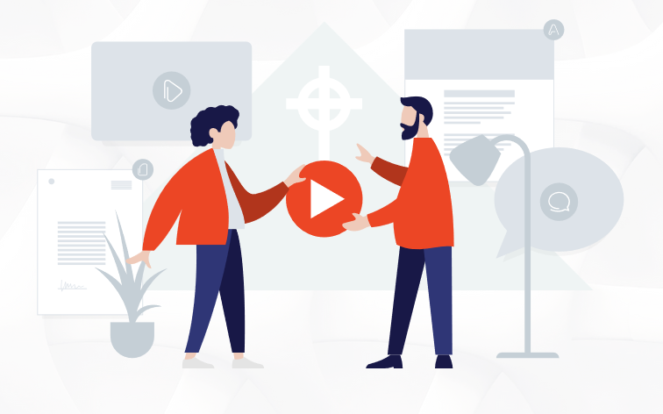
Event Booking Form

Event Planning
We have put this form together for members of [Your Church Name Here] who would like to use the facilities at the [Your Church Name Here] to host private parties and weddings. We hope this form is helpful in assisting members plan their event at the church building. Our priority as a pastoral team is to ensure that the [Your Church Name Here] is ready for a Sunday morning meeting and other church events. Typically, parties and weddings take place across a weekend, which has an impact on the facility being ready and organised for a Sunday morning. Within this booking form you will find information provided about event set up, equipment that is available for you to use, clear up team, alcohol policy, price list and opening and locking up times etc.
The pastoral team agrees to all events and requires the booking form to be completed. For clarification or assistance, please email [Church Administrator’s Name Here] on [Church Administrator’s Email Address] or telephone [Church Administrator’s Contact Number].
Details required to book an event
Contact name
Address

Post code
Phone number
E-mail address
Proposed Event Date(s)
About the event
Please give the following details about who will be attending your event.

No. of 0-17yrs: ___ No. of 18-30yrs: ___ No. of 30+yrs: ___

What is the purpose of the event? (e.g. birthday party, wedding etc.)

___________________________________
Any other information which you think may be relevant:

________________________________________________________________________________________________________________________________________________________________________________________________________________________________________________________________________________________________________________________________________________________________________________________________________________________________________________________________________________________________________________________________________

Equipment Information
What Equipment Can I Use?

*EXAMPLE LAYOUT AND EQUIPMENT*
The following equipment is generally available for use:
- Any Kitchen Equipment found in the kitchen area and cupboards
- Plates, glasses, and cutlery found within the kitchen
- Hot water urns and coffee machines
- Fridge / Freezer in the Baby Crèche
- Round tables - Quantity 20
- Trestle tables- Quantity 15
- Children’s Tables and Chairs
- Bar tables – Quantity 2
- Bar Stools- Quantity 6
- Main Hall Chairs- Quantity 700
- Coat Hanger- Quantity 1 (30 Coats)
- Extension Leads- Quantity 4
- BBQ Equipment
What Equipment Can’t I Use?

*EXAMPLE LAYOUT*
The following is not available for use:
- AV and Camera Equipment
- Conference tables and chair
Chargeable Equipment available for Hire?

*EXAMPLE LAYOUT*
- Projectors - Quantity 2
- Projector Screens - Quantity 2
- Flip Charts - Quantity 4
- Bouncy Castles- Quantity 2
- Laptop- Quantity 1
- Table cloths
- Pipe and Drape System

Please contact [church administrator’s name] for a price list if you would like to hire any of these items.

Planning your layout
For our event, we require the following tick / fill in all that apply
Rooms:  *EXAMPLE*  ⬜ The foyer  ⬜ The kitchen  ⬜ The main hall  ⬜ Toddler Crèche | Equipment Request: | Furniture:  *EXAMPLE*  ⬜ round tables number _______.  ⬜ trestle tables number _______.  ⬜ bar tables number _______.  ⬜ bar stools number _______.  ⬜ chairs number _______.
Our event will start at ____am/pm and finish at ____am/pm. (Main Hall Events are to end no later than [insert time here] pm)

What are my responsibilities?
Before the Event -

  - Finding a key holder to open and lock up before and after the event.
If you are unable to find someone, please speak to the office. There is a charge for calling out a key holder
  - Set up and prepare the event room, equipment and furniture required for your event.
  - Organising the external Hire of equipment, liaison with [Your Church Name Here] staff regarding storing any hired equipment in the [Your Church Name Here] office. (Hire equipment may only be stored in the church office area over a Sunday morning).
  - Organise a clear up team who are experienced and familiar with the building and where our equipment and furniture are stored. (When using the main hall, a team of 8-10 people is required.)
  - In addition to the clear up team, when organising an event in the main hall we would ask that you provide us with a team of church members who can organise the room and chair layout for a Sunday morning. If you do not have a team of people who have experience in this area, then please let us know and we will organise a team from the office. There will be a charge in this instance in order that the church can pay a team to come in and set this up on your behalf.

During the Event -

- Reporting and rectifying / paying for repair of any breakages, damage or staining to carpets / upholstery.
- Supervising children, at all times.
- Supervised tours of the building for guests are allowed, but we request you do not bring guests into any of the office areas.

After the Event -

The following must be cleaned and set back after the event:

Any rooms or equipment used must be set back as they were found (i.e. ready for the next church event) including the following:

    - Kitchen
Surfaces must be cleared and cleaned with all kitchen equipment returned. The fridge and kitchen surfaces must be emptied of any food / drink from the event. Bins must be emptied at the end of the event.

    - Toilets
All toilets must be cleaned, restocked with toilet paper / soap / hand towels, and checked for damage or blockages. Toilet bins must be emptied at the end of the event. Please ask a member of [Your Church Name Here] staff for details of where supplies are kept.

- [Your Church Name Here] staff are in no way liable for the following:

  - First Aid provision
It is your responsibility to provide adequate first aiders for your event

  - Food hygiene
Any food / drink prepared on the premises, eaten on the premises, or removed from the premises is done so entirely at the risk of the individual consuming / preparing the food / drink.

  - Alcohol consumption
It is your responsibility to manage any alcohol consumption, including over- indulgence and under- age drinking. Alcohol may not be sold on the premises.

Agreement to terms and conditions
Please tick the following and sign below:

⬜ I have read, understood, and agree to the terms and conditions on page 4.
⬜ I am aware of the fire procedure and first aid procedure and take full responsibility for the event described above.

Signed:  Print Name:  Date: | Thank you!  We hope you have an enjoyable event.

