Session #1
Hand-on experience: Each participant develops Story of self, us, now and several participants will share with the group
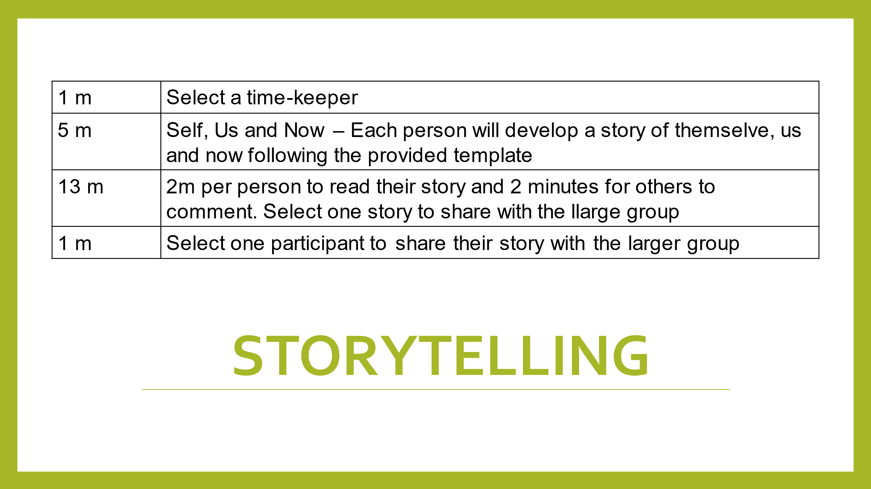
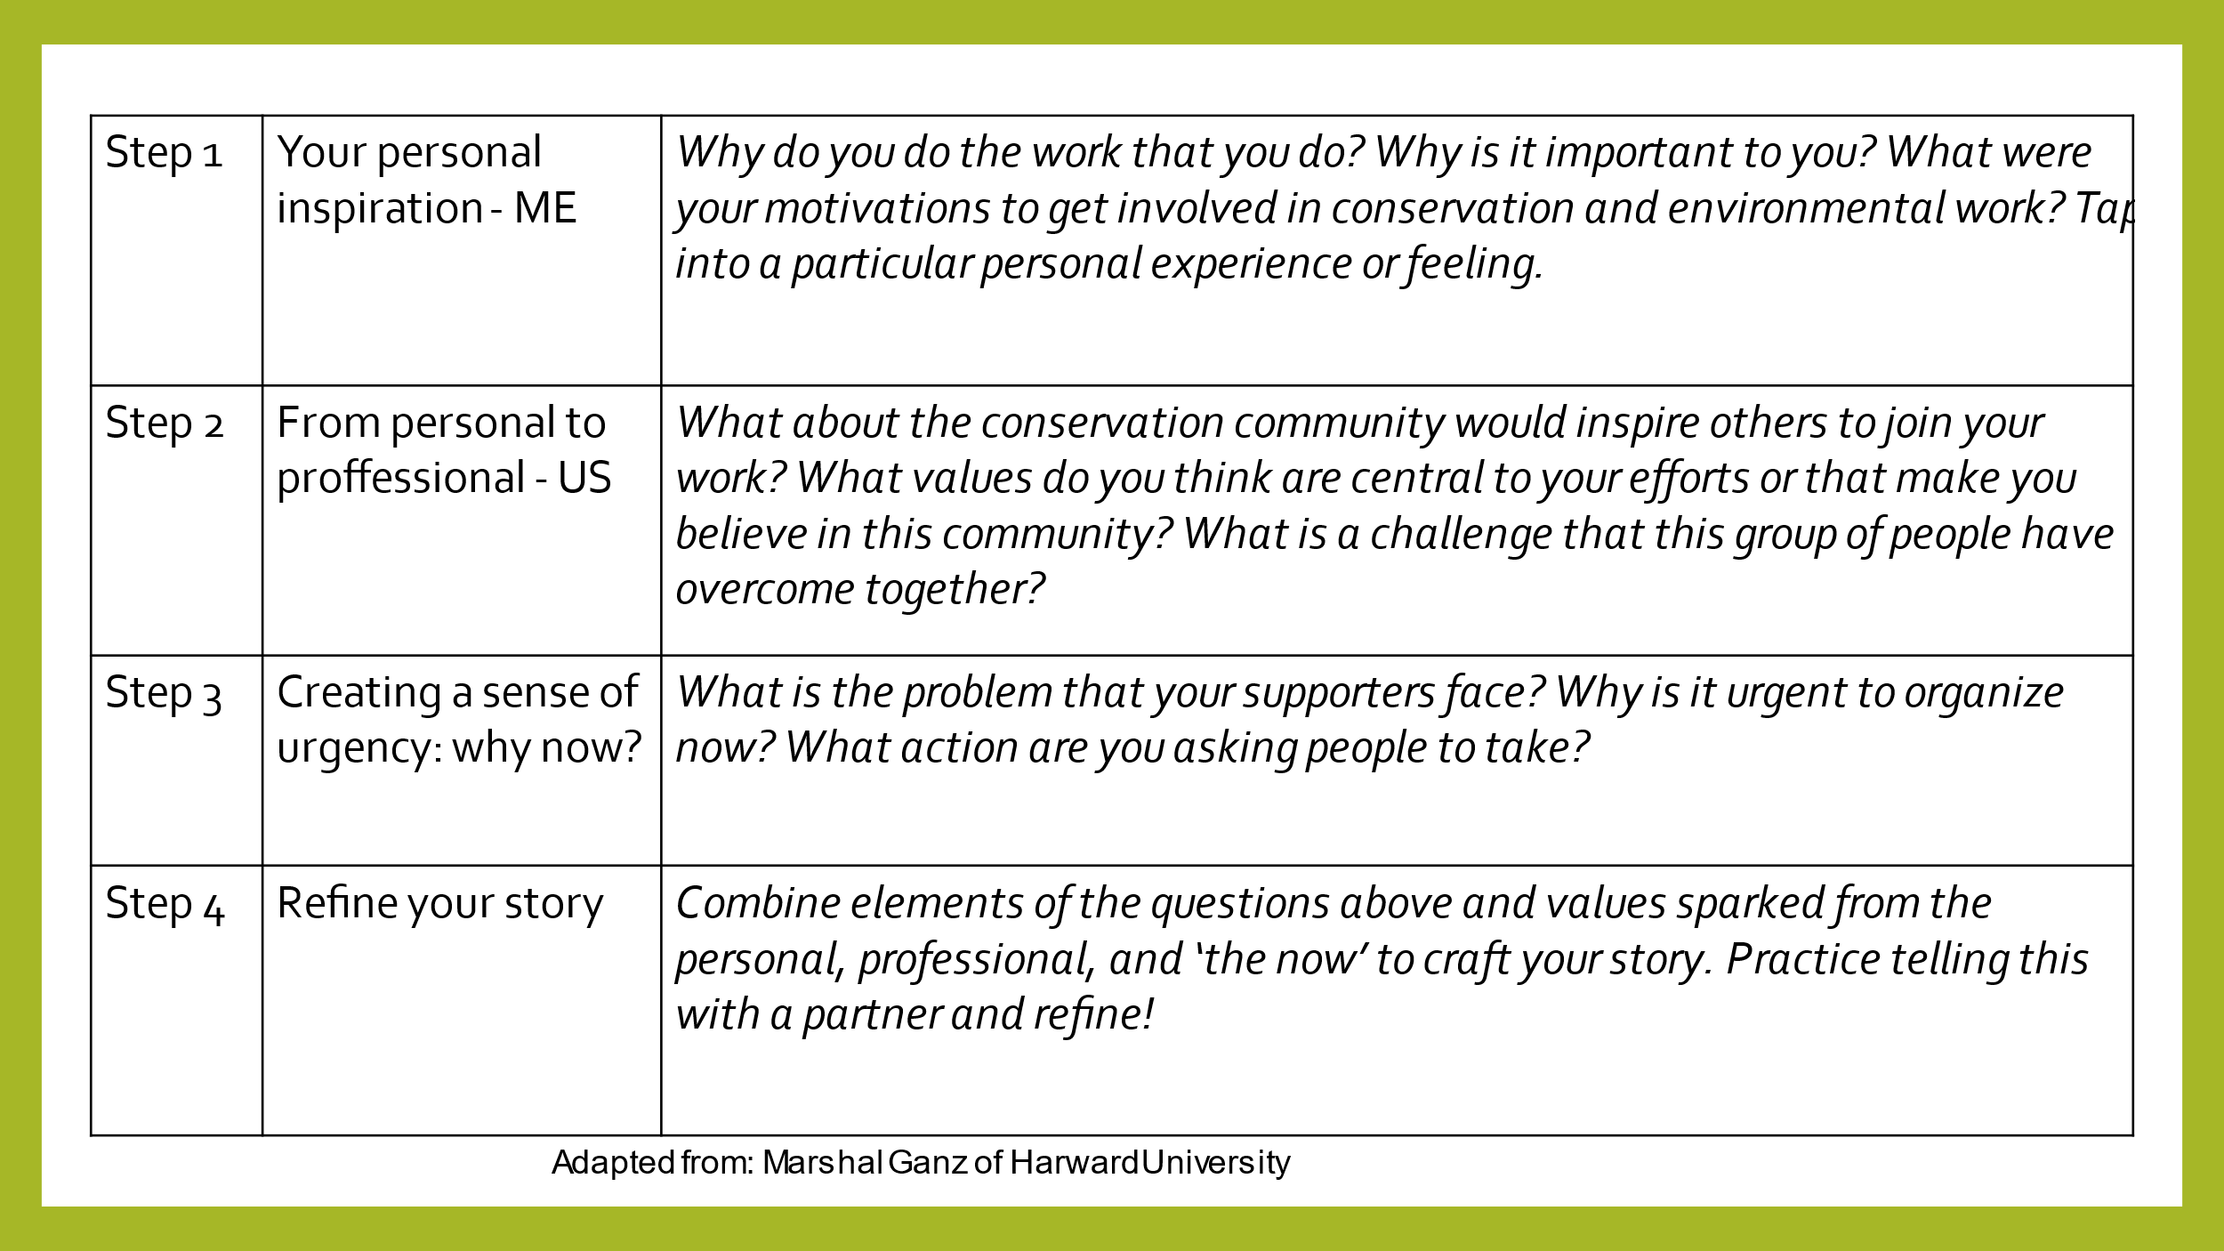

For those who want to work in the word document
Step 1: Your personal inspiration
Why do you do the work that you do? Why is it important to you? What were your motivations to get involved in conservation and environmental work? Tap into a particular personal experience or feeling.
Step 2: From personal to professional
What about the conservation community would inspire others to join your work? What values do you think are central to your efforts or that make you believe in this community? What is a challenge that this group of people have overcome together?
Step 3: Creating a sense of urgency: why now?
What is the problem that your supporters face? Why is it urgent to organize now? What action are you asking people to take?
Step 4: Refine your story
Combine elements of the questions above and values sparked from the personal, professional, and ‘the now’ to craft your story. Practice telling this with a partner and refine!

