Exercise #1 – Theory of Change
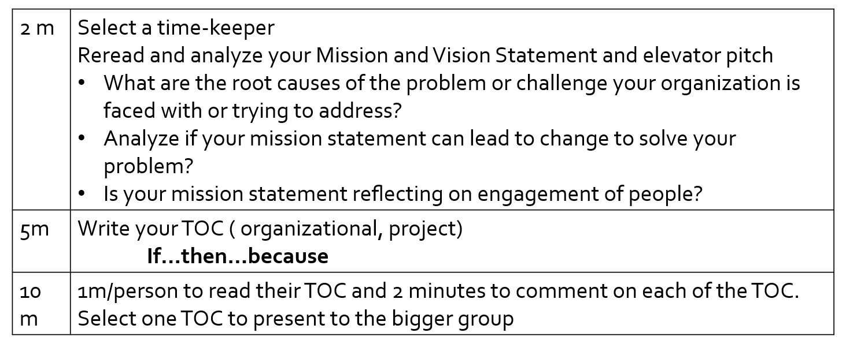 Example– Bruce Trail Conservancy
Vision
The Bruce Trail secured within a permanently protected natural corridor along the Niagara Escarpment
Mission
Preserving a ribbon of wilderness, for everyone, forever.
Theory of change
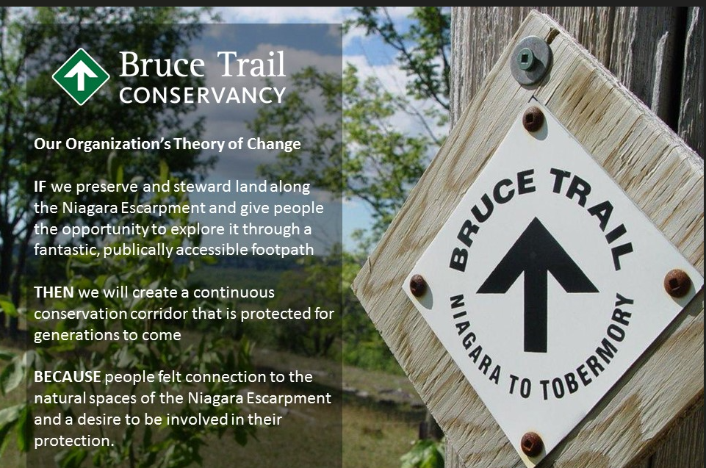
Template:
If
Then
Because

Exercise #2 – Organizing Sentence
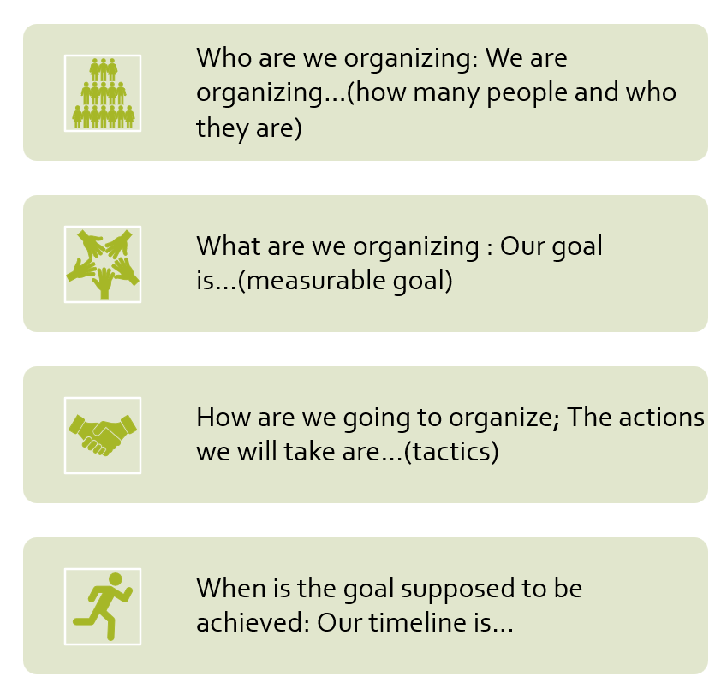
Example
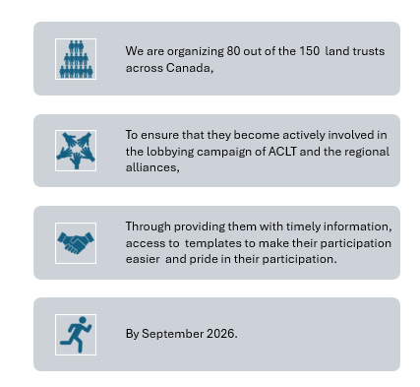
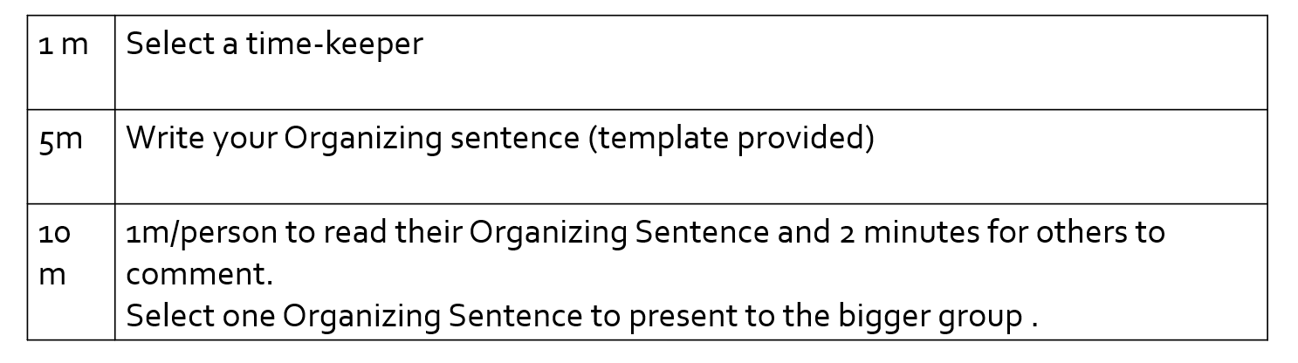
Template
WHO are you organizing? | I am organizing:
WHAT is your goal? | Our goal is:
HOW do you plan to achieve it? | The actions we will take are:
WHEN does change need to happen | Our timeline is:

