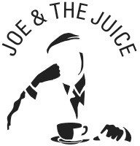

AGREEMENT/ CONTRACT REPORT

Explanatory note:

  - This document must be filled out when any Joe and the Juice entity enters a contract with a supplier, buys a service, sign up for a subscription, accepts any terms and conditions or in any other way enter into a business relationship with a third party service provider.

General information
Contract title:
Information about contracting partner
Name of the Joe & the Juice entity entering agreement
Responsible department
Responsible employee
Contract/agreement terms etc.
What is purchased
Contract description
Contract amount
What are the payment terms?
What is the duration of the contract?
Signing date
Who signed the agreement on behalf of Joe and the Juice A/S?
Have any terms & conditions been accepted – if yes. What version of the T&C?

What are the termination terms?
This report was prepared by:
Date:

