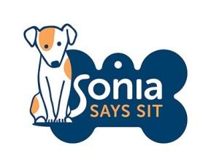 English as a second language
Verbal Cue (word) | Visual Cue  (hand signal) | Meaning | Tick when your dog understands it
 |  | Marker
All gone |  | I have nothing for you  Training is finished
 |  | Relax – calm on cue
 |  | Sit to say please
 |  | Your dog’s name = Look at me
 |  | Interrupter or attention noise
Gentle |  | Be slow & gentle  no teeth contact
Sit |  | Put your bottom on the ground
 |  | Lie Down
Come |  | Return to me
 |  | Give me the toy open your mouth
Leave it |  | You can’t have that
Get it |  | Take the item
 |  | Go to your bed
Collar/Harness |  | Sit still while I touch your collar/harness
Let’s go |  | Walk on a loose lead
 |  | Go to the toilet
Wait or Stay |  | pause
Ok |  | Release Cue
 |  | Search or sniff on cue
Up |  | Get up on something
Enough |  | Stop barking

