

Food Policy Forum
Washington State
Food Policy Forum

Meeting Summary

Thursday, October 2, 2025 l 1:00–4:00 PM

Key Takeaways
- The Diversifying Voices Team has developed guidance to bring new voices to the Forum by broadening engagement through topical small team activities and serving as an internal, ad hoc technical support team.
- Forum members were reminded of the work planning process and the next steps for advancing priorities.
- Forum members were introduced to the progress report section of the 2025 Legislative Report and reviewed and finalized the background summaries and proposed priorities developed by the five topical small teams for inclusion in the report.

Welcome & Opening Remarks
Chris Elder, King County Natural Resources and Parks (KCNRP), the Forum Administrative Chair, opened the meeting by welcoming Forum members and noted that his employment has shifted from Whatcom County Public Works to KCNRP.
Petra Vallila-Buchman, Ross Strategic facilitator, reviewed the agenda and emphasized that the focus of the Forum meeting was to review and finalize the Forum’s 2025 Legislative Report to ensure the Forum’s topical priorities for the next two years are accurately captured.

Small Team Update: Diversifying Voices
Piper Casey, Ross Strategic, provided an update on the Diversifying Voices Team by noting that the team has met four times in 2025 to continue discussing needs and opportunities around bringing new voices to the Forum.
Laura Raymond, WA State Department of Agriculture (WSDA), highlighted the Food Policy Forum’s long-standing dedication to recognizing the importance of engaging diverse voices in its work which the Diversifying Voices Team will continue to support through guidance that the small team has developed. Diversifying Voices Team members will take on a liaison role between the small teams and the Diversifying Voices Team to ensure diverse voices are reflected in topical small team priorities. Laura noted the iterative and adaptive nature of the Diversifying Voices work, offering both structured guidance and flexible, ad hoc technical support to help small teams integrate equity-focused practices, such as integrating consistent use of the Forum’s equity filter.

Two-Year Work Planning Process Update
Petra provided an overview of the Forum’s multi-step work planning process, which began in April 2025 with a member survey and four topical opt-in calls. These initial steps surfaced key issues warranting the Forum’s attention. Insights from these activities informed Forum-wide breakout discussions during the May 8 meeting, which in turn led to five “State of the State” presentations each one led by a Forum member and state agency representative and focused on a component of the Forum’s Food System Lens to assess the food system landscape and existing consensus recommendations. Following this, small teams met throughout July and August to further develop and refine proposed priorities, culminating in topical small team presentations at the August 7 Forum meeting (see Appendix A).
To reiterate the relevance of the Forum’s five food system components in the work planning process, Petra shared the Food System Lens (pictured below) which is rooted in the Forum’s 2019 framework. It’s important to note that important refinements were made to some of the food system components as priorities evolved throughout the process. During this process, each team explored specific challenges, gaps, and opportunities which have culminated into either one or two timely actionable priority topics and a background summary of challenges discussed for each small team. Priorities are still in progress and may take shape as formal recommendations, stakeholder convenings, facilitation of learning sessions, analyzing data and documenting findings, proposing new policies or program investments, or updating existing recommendations with current context.
Forum’s Food System Lens
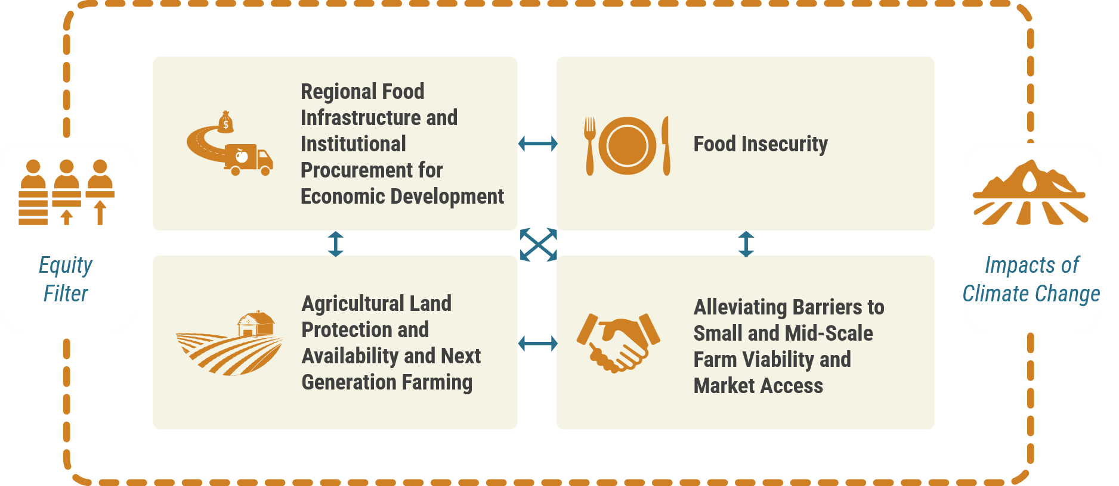

Topical Small Team Report Content Review and Finalization
To confirm small team content for the 2025 Legislative Report, the following questions were raised to each of the five topical small teams:
- Small teams were asked: Does the problem summary clearly and concisely describe the key dimensions of the issues the team explored?
- Forum members were asked: Are there any major red flags or fatal flaws in the section that need to be addressed before finalizing?

When reporting proposed edits, small teams provided no major changes. Their edits included clarifying language, improving accuracy, and ensuring faithful representation of team discussions. Specific adjustments involved refining terminology (e.g., replacing “property tax relief” with “tax relief”), ensuring accurate descriptions of technical assistance needs across farm scales, and adding context to infrastructure and climate-related priorities. Teams also suggested clearer formatting to distinguish multiple ideas within topical priorities. Overall, the edits aimed to enhance clarity and alignment with prior recommendations without altering the report’s core direction.

Legislative Report: Progress Report Section
Petra introduced the progress report section of the Legislative Report which provides detailed accounts of activities, policy issues, and projects the Forum has made progress on from November 2023 to October 2025. These activities are listed in the table below.
2023–2025 Milestones
 | Increase Irrigated Agricultural Lands  Reached consensus on three policy recommendations to improve water access and management; convened learning sessions with farmers and experts; transmitted recommendations to legislative committees; a legislator expressed interest in a 2026 committee meeting.
 | Advance Agriculture’s Participation in the Climate Commitment Act  Submitted a letter to legislative leadership highlighting unimplemented fuel tax exemptions; helped prompt short-term financial relief and 2025 legislation clarifying exemption access.
 | Identify Mechanisms for Diversifying Voices in the Forum  Launched Diversifying Voices Team; developed guidance for small team composition and engagement; published member biographies; positioned team as a technical support resource for equity-related decisions.
 | Local Food Policy Entity Engagement  Supported UW-led study on local food policy entities (FPE); hosted statewide webinar with 14 FPEs; added FPEs to Forum communications; created and circulated a statewide FPE roster.
 | Washington Food System Snapshot  While not formally advanced due to capacity constraints, the snapshot concept informed the Forum’s planning process and “State of the State” presentations, reinforcing its value as a strategic framing tool.
 | Progress on Existing Forum Recommendations  Labeling and Promotion Program: Forum served as advisory body for WSDA’s location-based promotion program; hosted input sessions; submitted a letter of support for implementation funding; program was not funded in the 2025–27 budget.  Urban Agriculture Research: Forum named in HB 1552 directing SCC to lead a study; Forum members participated in focused discussions; insights informed the final report, which aligned with Forum priorities on land, water, and market access.
 | Administrative Updates  Administrative Chair and Vice Chair: At the June 2024 Forum meeting, the Forum voted to confirm a series of appointments for administrative chair and vice chair for the period of June 2024 through June 2026. The administrative chair serves a 12-month term alongside a vice chair, who may transition to administrative chair at the end of the term.

Next Steps & Closing
After confirming and finalizing content for the 2025 Legislative Report, it will be sent to the Office of Financial Management (OFM) on October 8 for review before distributing to the Washington State Legislature. The Forum will reconvene the same small teams in November to continue refining topical priorities for the Forum’s two-year work plan which will be discussed at the next Forum meeting on December 4.
Petra Vallila-Buchman invited Jon DeVaney, WA State Tree Fruit Association, to share closing reflections as the new Forum Vice Chair. Jon recognized the Forum’s contributions to the Legislative Report by providing a clear snapshot of the Forum’s accomplishments and future endeavors. Jon concluded his remarks by inviting members to provide any final edits to the report before October 8.

Appendix A. Topical Small Team Participants
Below is a list of members associated with each topical small team. Some members were unable to contribute to this process due to scheduling conflicts.
Agricultural Land Protection and Availability and Next Generation Farming Team
- Addie Candib, American Farmland Trust
- Chris Elder, King County Natural Resources and Parks
- Dan Wood, WA State Dairy Federation
- Hilary Aten, on behalf of the Director of the WA State Conservation Commission
- Heather Wendt, WA Association of Conservation Districts
- KayDee Gilkey, WA Association of Wheat Growers
- Rep. Mary Dye, WA State Legislature
- Mary Embleton, King Conservation District
- Nate Lewis, WA Farmland Trust

Food Insecurity Team
- Aaron Czyzewski, Food Lifeline
- Brice Montgomery, WA Dept. of Social and Health Services
- Brittany Tybo, WA State Dept. of Health (guest participant)
- Chris Voigt, WA State Potato Commission
- Claire Lane, Anti-Hunger & Nutrition Coalition
- Diane Dempster, Clark County Food System Council
- Jennifer Otten, UW Food Systems, Nutrition, and Health
- Katie Rains, on behalf of the Director of the WA State Dept. of Agriculture
- Kyle Unland, WA Dept. of Health
- Leanne Eko, Office of Superintendent of Public Instruction

Impacts of Climate Change Team
- Caleb Gwerder, WA Farm Bureau
- Chad Kruger, WSU-CSANR
- Chris Voigt, WA State Potato Commission
- Chris Elder, King County Natural Resources and Parks
- Dani Gelardi, on behalf of the Director of the WA State Dept. of Agriculture
- Jon DeVaney, WA State Tree Fruit Association
- Sen. Judy Warnick, WA State Legislature
- Laura Raymond, on behalf of the Director of the WA State Dept. of Agriculture
- Linda Neunzig, Snohomish County
- Melissa Spear, Tilth Alliance
- Sen. Rebecca Saldaña, WA State Legislature
- Richard Conlin, Conlin Columbia Partnership for Cities

Alleviating Barriers to Small and Mid-Scale Farm Viability and Market Access Team
- Addie Candib, American Farmland Trust
- Brian Estes, LINC Foods
- Caleb Gwerder, WA Farm Bureau
- Diane Dempster, Clark County Food Systems Council
- Jon DeVaney, WA State Tree Fruit Association
- Kate Smith, WSU Food Systems Program
- Laura Raymond, on behalf of the Director of the WA State Dept. of Agriculture
- Mary Embleton, King Conservation District
- Melissa Spear, Tilth Alliance
- Nate Lewis, WA Farmland Trust

Regional Food Infrastructure and Institutional Procurement for Economic Development Team
- Aslan Meade, Thurston Economic Development Council
- Brian Estes, LINC Foods
- Jennifer Otten, UW Food Systems, Nutrition, and Health
- Laura Raymond, on behalf of the Director of the WA State Dept. of Agriculture
- Leanne Eko, Office of Superintendent of Public Instruction
- Linda Neunzig, Snohomish County
- Marie Spiker, UW Food Systems, Nutrition, and Health
- Mary Embleton, King Conservation District
- P.J. Cawley, Charlie’s Produce
- Sen. Rebecca Saldaña, WA State Legislature
- Tim Crosby, Thread Fund

