

Dairy nutrient management plan approval checklist

Click or tap here to enter text. Conservation District Approval

Dairy nutrient management plan for:

Operator: Click or tap here to enter text.

Facility name: Click or tap here to enter text.

Physical address: Click or tap here to enter text.

The Board of Supervisors of the conservation district name ☐approved ☐ did not approve this dairy nutrient management plan on Click or tap to enter a date.

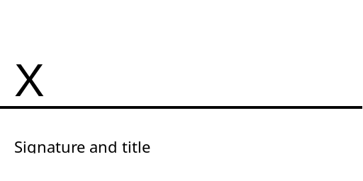

Checklist begins on next page.

Approval checklist:
If all answers to the below statements are “yes,” the district’s Board of Supervisors must approve the plan. If any answer is “no,” the board cannot approve the plan.

When approval is denied, the district must explain the changes required to obtain plan approval. The explanation must be in writing and delivered to the applicant within 90 days of the date the plan was received by the district.

Approved | Plan element
☐ Yes ☐ No | All standard practices meet the standards, specifications and methods described in the NRCS Field Office Technical Guide and the NRCS Agricultural Waste Management Field Handbook. If alternative practices are utilized, practices have been approved by the Washington Conservation Commission.
☐ Yes ☐ No | A summary of the operation includes: name, location, acres available for nutrient management, herd size, existing nutrient management facilities.
☐ Yes ☐ No | The dairy nutrient management plan follows the planning format adopted by the Washington Conservation Commission.
☐ Yes ☐ No | The following have been inventoried and evaluated to identify potential pollution sources and to determine water quality protection needs:  - All fields used in the dairy operation  - Cattle confinement areas, barns and milking facilities  - Water collection, handling and storage facilities  - Feed storage and mixing areas  - Riparian areas  - Irrigation systems  - Drainage systems
☐ Yes ☐ No | If the plan has not been fully implemented, there is a schedule of planned practices listing the location, what will be done, how much will be done and when it will be completed.
☐ Yes ☐ No | Forage and crop fields are identified and their acreage is shown on an aerial photo, topographic map, or a plan map drawn to scale.
☐ Yes ☐ No | A month-by-month nutrient application schedule is included, with a nutrient balance sheet that includes nutrient requirements of crops receiving dairy wastes.
☐ Yes ☐ No | Crop yield values or estimates are supported in the plan or in the dairy producer’s case file.
Approved | Plan element
☐ Yes ☐ No | If manure is utilized elsewhere, off-site manure management agreements are included in the plan.
☐ Yes ☐ No | An operation plan is included for the waste management system.
☐ Yes ☐ No | Major factors influencing the quantity of manure and wastewater are described (e.g., herd size and composition, climatic data, existing runoff controls, etc.)
☐ Yes ☐ No | Existing manure and wastewater collection systems have been evaluated, and needed improvements are described.
☐ Yes ☐ No | Storage needs and facilities for solid and liquid manure are described. Calculations and worksheets used to determine storage needs are included.
☐ Yes ☐ No | Transfer facilities and systems are described.
☐ Yes ☐ No | Manure or wastewater treatment is described.
☐ Yes ☐ No | Soils are described, including their physical capacity to accept nutrient applications.
☐ Yes ☐ No | If nutrient testing of soils and manure is required, testing procedures are described.
☐ Yes ☐ No | A recordkeeping system is included that addresses:  - Soil and manure tests  - Application of solid and liquid components of manure  - Cropping  - Other significant factors and practices
☐ Yes ☐ No | Time periods and conditions are clearly described when dairy nutrients can be safely and agronomically applied.
☐ Yes ☐ No | Time periods and conditions are clearly described when dairy nutrients should not be applied.
Checklist continues.

Send a copy to
When the approval checklist has been completed, signed and dated by the district, the district should send a copy each to:

Washington Department of Agriculture  Mailing address:  Nutrient Management Technical Services  PO Box 42560  Olympia, WA 98504-2560  Email: NMTS.admin@agr.wa.gov  Phone: 360-972-5767 | Washington State Conservation Commission  Mailing address:  PO Box 47721  Olympia, WA 98504-7721  Attn: Karen Hills  Email: khills@scc.wa.gov  Phone: 360-407-6200

