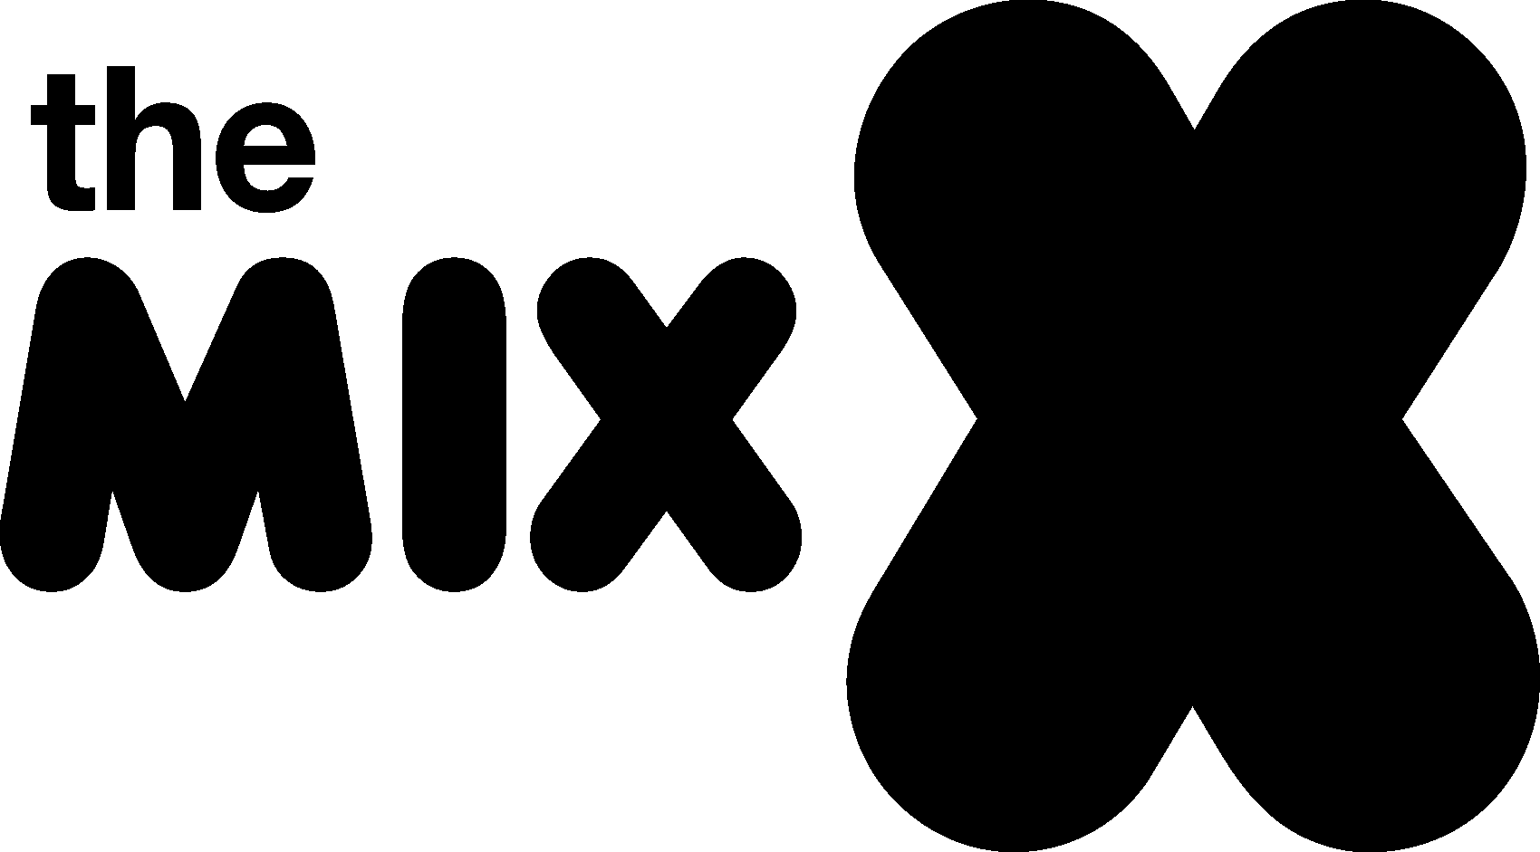

The Mix Code of Conduct 2025

Introduction
At The Mix including colleagues in 127 Trading, we are committed to creating a safe, respectful, and inclusive environment for everyone we work with and support.

Our Code of Conduct sets out the standards of behaviour we expect from all staff, volunteers, Trustees, Directors, partners, and representatives.

It reflects our values of empathy, integrity, and accountability, and serves as a guide for how we treat one another, how we represent The Mix and 127 Trading, and how we uphold the trust placed in us by young people and the wider community.

By following this Code, we ensure that The Mix remains a positive space where everyone can feel valued, heard, and supported.

Our Values
Our work at The Mix is guided by a set of values that shape the way we act, speak, and make decisions.

These values are at the heart of our Code of Conduct and help us build trust, foster inclusion, and ensure our actions reflect the spirit of our organisation.

- Respect – We value each person’s dignity, perspective, and boundaries, treating others with kindness and understanding at all times.
We do not use offensive or threating language or behaviours, and we do not tolerate bullying.
We show respect and care within the building, taking due care of any equipment used and take responsibility for own belongings within The Mix.

- Integrity – We act honestly, responsibly, and in a way that reflects well on The Mix, even when no one is watching.

- Inclusivity – We embrace diversity and create space where everyone feels welcome, safe, and represented.

- Empathy – We listen without judgment, offer support with compassion, and aim to understand before being understood.

- Accountability – We take responsibility for our words and actions, learning from mistakes and working to make things right.

