
Bonneville County, Idaho
Request for Proposal #2602
Innovation Center
Facility Lease
PROPOSALS DUE:
June 29, 2026, at 5 PM MDT
TABLE OF CONTENTS
INTRODUCTION 2
SITE DESCRIPTION 3
PROJECT BACKGROUND 4
BOARD OF COUNTY COMMISSIONERS 11
KEY PERSONNEL & THIRD PARTIES 11
NEEDED and/or TENANT IMPROVEMENTS 12
LEASE TERMS 13
RESPONSE CONTENT 13
SUBMISSION AND PROCUREMENT PROCESS 14
SCORING CRITERIA 17
DISCLOSURES 18
APPENDICES 19

INTRODUCTION
Bonneville County, Idaho (“County”) is a growing regional hub in eastern Idaho, with a population of approximately 130,000 residents and anchored by the City of Idaho Falls. The County serves as a center for commerce, advanced energy research, and regional economic activity.
The County is issuing a Request for Proposals (“RFP”) to identify a qualified tenant or tenant team to lease and operate the North Yellowstone Innovation Center, located at 2300 North Yellowstone Highway (U.S. Highway 26) in Idaho Falls, Idaho.
The County’s primary objective is to secure stable, long-term lease revenue while maintaining the property as a productive commercial asset. The County is open to a range of viable commercial uses and occupancy models, provided proposals demonstrate financial capacity, operational stability, and compatibility with surrounding land uses.
Bonneville County is seeking proposals from qualified parties interested in leasing and operating all or a portion of the Innovation Center facilities. The County will consider a variety of approaches, including single-tenant occupancy, multi-tenant configurations, or continued incubator-style operations.
Proposals should clearly demonstrate:
- Financial capacity and ability to meet lease obligations
- A viable long-term occupancy and operational plan
- Ability to manage and maintain the property

Owner: | Bonneville County, Idaho (The County)
Project: | Lease of Innovation Centers A, B, & C
Site Location | All three buildings are located at 2300 N. Yellowstone Highway (Hwy 26) in Idaho Falls, Idaho 83401
Project Consultant | Clearwater Financial, LLC
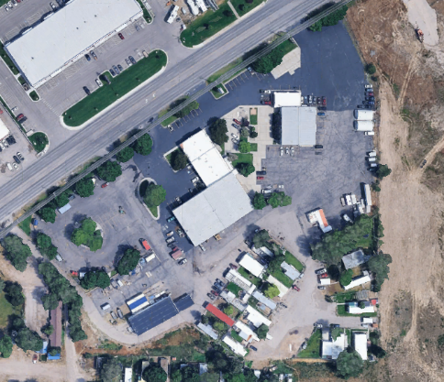

Site map source: Google Earth 2026

Proposals are to be submitted electronically by 5:00 PM MST on June 29, 2026. See: Submission Instructions.

Questions: Questions regarding this RFP must be emailed to info@clearwaterfinancial.biz by 5:00 pm MST on Monday June 15, 2026. On June 19, 2026, written responses, including any addenda, will be posted on the County webpage and/or distributed to all parties that have registered as interested parties.

An optional, pre-proposal virtual meeting will be held on June 10, 2026, at 10:00 AM MST. The virtual meeting can be accessed via this LINK or connecting to Microsoft Teams using Meeting ID: 296 464 169 903 717 and Passcode: Gp379jp2.

Public Records: Proposals are subject to the Idaho Public Records Law (Idaho Code Title 74, Chapter 1). The County will make reasonable efforts to maintain the confidentiality of materials properly identified as exempt from disclosure; however, the County cannot guarantee that such materials will be withheld from disclosure. See: Public Records.
Bonneville County RFP webpage: https://www.bonnevilleCountyidaho.gov/requests-for-proposal

SCHEDULE
Tuesday, May 26, 2026 |  | 1st Notice of RFP published in Post Register
Tuesday, June 2, 2026 |  | 2nd notice of RFP Published in Post Register
Tuesday, June 9, 2026 |  | Optional site walkthrough at 10:00 AM
Wednesday, June 10, 2026 |  | Optional virtual pre-proposal meeting at 10:00 AM
Monday, June 15, 2026 |  | Questions regarding RFP due
Friday, June 19, 2026 |  | Answers to submitted RFP questions to all interested parties
Monday, June 29, 2026 |  | RFP responses due by 5:00 pm MDT
Tuesday, July 7, 2026 |  | Board consideration of recommendation; selection of preferred developer; Agreement to Negotiate Exclusively (“ANE”)

SITE DESCRIPTION
The North Yellowstone Innovation Center is located at 2300 North Yellowstone Highway (U.S. Highway 26) in Idaho Falls, Idaho, along a primary commercial corridor with strong visibility and access to regional transportation routes.
The property consists of approximately 5.6 acres and includes three buildings totaling approximately 32,000 square feet. The buildings are currently configured to support multi-tenant occupancy, with individual suites that have historically been leased to small businesses and startup companies.
The site includes:
- On-site surface parking
- Vehicular access from North Yellowstone Highway and adjacent local roadways
- Proximity to established commercial, retail, and service uses
The property is located within the City of Idaho Falls and is zoned Highway Commercial, with a Comprehensive Plan designation of Mixed Use Centers and Corridors, allowing for a range of commercial uses subject to applicable city approvals.
The County is open to continued multi-tenant use, single-tenant occupancy, or alternative configurations, depending on the proposer’s approach.
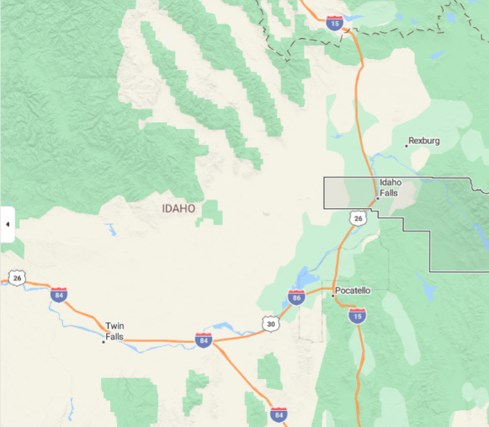
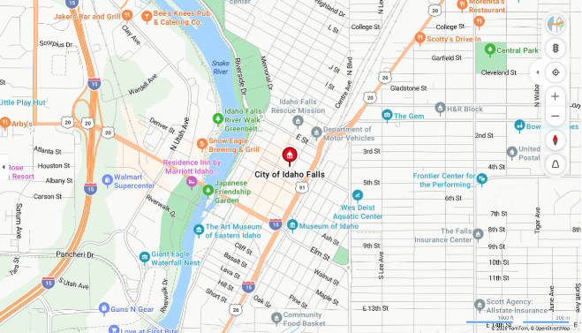
Regional Map Idaho Falls Map

Site Map
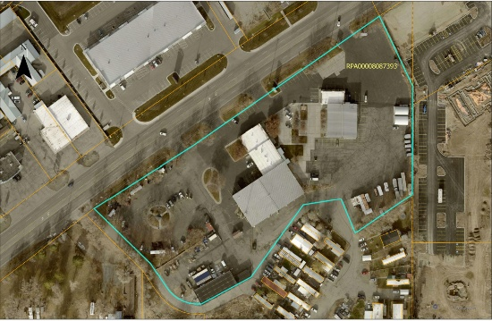

PROJECT BACKGROUND
The North Yellowstone Innovation Center was originally developed to support small business development and local economic growth within Bonneville County.
Historically, the facility has been operated in coordination with the Idaho Innovation Center as a multi-tenant incubator space. Under this model, individual suites were subleased to small and emerging businesses at below-market rates, typically for one- to two-year terms. The intent of this approach was to support business formation and growth, with tenants transitioning into larger commercial spaces within the community as they expanded.
Bonneville County is now evaluating long-term strategies for the continued use and operation of the facility. Through this RFP process, the County is seeking a tenant or operator that can provide:
- Stable and predictable lease revenue
- Effective management and maintenance of the property
- A viable long-term occupancy strategy
The County remains open to a range of operational approaches, provided proposals demonstrate financial viability and alignment with applicable land use regulations.

BOARD OF COUNTY COMMISSIONERS
The following is a list of current Board of County Commissioners, their positions, and their terms of office.

Name | Position | Office Term Began | Office Term End
Karl T. Casperson | District 1 | 2025 | 2027
Jonathan D. Walker | District 2 | 2021 | 2027
Michelle Mallard | District 3 | 2025 | 2029
Source: Commissioners | Bonneville County

KEY PERSONNEL & THIRD PARTIES
Austin Black, Chief Operations Officer, Bonneville County
Clearwater Financial, LLC, Municipal Advisor & Owner’s Representative
Bonneville County has engaged Clearwater Financial LLC as its Owner’s representative for the RFP process. Clearwater also serves as the County’s municipal advisor regarding this RFP acting as a fiduciary to the County.
Other County staff and advisors as assigned.
DESIRED USE AND OPERATIONAL CONSIDERATIONS
The County’s purpose in issuing this RFP is to select a tenant or tenant team that will provide stable, long-term lease revenue while maintaining the property as a productive commercial asset. Proposals should demonstrate:
- The ability to generate reliable lease income to Bonneville County
- Compatibility with surrounding land uses and the general character of the area
- A viable operational approach that supports long-term occupancy and effective property management
- Potential to contribute to local economic activity and business development, where feasible
The County does not prescribe a specific use for the site and is open to a range of commercial uses and occupancy models, provided they are financially and operationally viable and comply with applicable zoning and land use regulations.
LAND USE & REGULATORY CONTEXT
The Site is located within the jurisdiction of the City of Idaho Falls and is currently zoned Highway Commercial. The Comprehensive Plan designation for the property is Mixed Use Centers and Corridors. All proposed uses must comply with applicable City of Idaho Falls zoning, land use, and development regulations.
For additional information, respondents are encouraged to review the following resources:
- Zoning Map: https://experience.arcgis.com/experience/67629e080ea74cd19de61240b8760d55
- Zoning Code: https://www.idahofallsidaho.gov/DocumentCenter/View/7031
- Comprehensive Plan (Imagine IF): https://www.idahofallsidaho.gov/1609/Imagine-IF
The selected respondent will be solely responsible for obtaining all required entitlements, permits, and approvals necessary for its proposed use of the Site. Such approvals may include, but are not limited to:
- Site plan approval
- Special use permits (if applicable)
- Building permits, encroachment permits, and right-of-way permits
- Applicable business or operational licenses, including alcohol beverage licensing (if applicable)
Respondents are responsible for independently verifying all zoning, land use, and regulatory requirements and should not rely solely on the information provided in this RFP.

NEEDED and/or TENANT IMPROVEMENTS
The North Yellowstone Innovation Center will be made available in its current condition. The County does not intend to perform significant improvements to the property prior to lease commencement.
Respondents should assume that any improvements required to support their proposed use of the Site, including tenant improvements, repairs, or modifications, will be the responsibility of the selected tenant.
Proposals should clearly describe:
- Any anticipated tenant improvements or modifications to the property
- The scope and general cost of such improvements
- The proposed timeline for completion
- Any requested participation by the County, if applicable
The County will consider, but is not obligated to accept, proposals that include requests for County participation in improvements or capital investments. Any such request should be clearly identified and justified within the proposal.
All improvements and modifications must comply with applicable codes, ordinances, and permitting requirements and will be subject to review and approval by the appropriate regulatory authorities.
The selected tenant will be solely responsible for obtaining all required entitlements, permits, and approvals necessary to implement its proposed use of the Site.
Such approvals may include, but are not limited to:
- Site plan approval (if applicable)
- Special use permits (if required)
- Building permits, encroachment permits, and right-of-way permits
- Any other required local, state, or federal approvals
Respondents are responsible for independently verifying all permitting and entitlement requirements associated with their proposed use.

LEASE TERMS
The term of this lease shall be:
A. The term of the lease shall commence on October 1, 2026, and shall be in effect for a period of one (1) year.
B. This lease shall be automatically renewed for an additional one (1) year term at the end of the initial term of this lease or any renewal thereof on the same terms and conditions as set forth herein unless Bonneville County - Lessor and/or Perspective Lessee shall give the other party notice of its intention to terminate said lease at least sixty (60) days prior to the end of said term.
C. Irrespective of the term provisions above, either Prospective Lessee or Bonneville County - Landlord shall have the right to terminate this agreement in its entirety upon sixty (60) days written notice.

RESPONSE CONTENT
Interested parties may obtain the RFP 2602 Innovation Center Facility Lease Request for Proposals package free of charge from the Bonneville County website at https://www.bonnevilleCountyidaho.gov/rfp/2602.

1.1 Cover Letter
- A letter signed by an authorized representative of the lead developer summarizing the team’s interest, commitment, and key points of the proposal.
- Identification of the primary contact person (name, title, email, phone, mailing address).
1.2 Lessee Information
- Description of the lessee organization
- Relevant experience leasing, operating, or managing similar properties
- Records demonstrating history of on-time lease payments or financial obligations
- Disclosure of any conflicts of interest
- Description of any previous work with the County (if applicable)
1.3 Proposed Use and Operations Plan
- Description of proposed use(s) of the property
- Operational plan, including tenant mix (if multi-tenant) or business operations
- Any plans to sublease the property
- Description of how the proposed use aligns with surrounding land uses
- Discussion of anticipated community or economic benefits
1.4 Operations & Management Plan
- Description of property management approach
- Maintenance and upkeep plan
- Staffing (if applicable)
- Approach to long-term asset care
1.5 Financial Capacity
- Summary of the lessee’s team’s financial capacity to undertake the lease, including:
- Evidence of equity capacity (e.g., representative balance sheet summary or letters from equity partners);
- If selected, proof of funds will be required during the Agreement to Negotiate Exclusively (“ANE”) process.

1.6 Financial Proposal
- Proposed rent
- Lease term requested
- Any proposed financial structure (if applicable)

SUBMISSION AND PROCUREMENT PROCESS
Submission Instructions
Proposals must be received by 5:00 PM MST on June 29, 2026. Received proposals will be electronically dated and time stamped as they are submitted. Proposals received after the deadline will not be considered.
Email PDFs or links to the Proposal to info@clearwaterfinancial.biz, Subject Line: “Innovation Center Lease - [Firm Name]”.
Questions & Addenda
All questions must be submitted in writing via email to the RFP Contact identified above no later than 5:00 PM MST on June 15, 2026. Responses to all timely submitted questions, and any RFP addenda, will be issued by June 19, 2026, and distributed to all registered interested parties.
Evaluation Committee
An Evaluation Committee (Committee) composed of County representatives and consultants will review and evaluate proposals for compliance with this RFP and alignment with the County’s objectives. The Committee may, at its discretion:
- Shortlist respondents;
- Conduct interviews and/or request clarifications or additional information;
- Request refined financial scenarios.
Negotiation and Disposition Process
Following evaluation, the County Chief Operations Officer will present findings and recommended ranking to the Board of County Commissioners. The Board is the ultimate decision-making authority. The County may enter into:
- An Agreement to Negotiate Exclusively (“ANE”) with the top-ranked proposer, setting forth a defined period to negotiate deal terms, and prepare a proposed DDA Design progression and evidence of financial capacity is required during this stage;
- If the County is unable to reach agreement on an ANE with the top-ranked proposer, it may terminate negotiations and proceed to the next-ranked proposer or take any other action deemed in its best interest, including re-issuing or canceling this RFP.
Public Nature of RFP Submissions
Bonneville County is a public agency. All documents in its possession are public records subject to inspection and copying under the Idaho Public Records Act, Chapter 1, Title 74, Idaho Code. The Public Records Act contains certain exemptions – one of which that is potentially applicable to part of your response is an exemption for trade secrets. Trade secrets include a formula, pattern, compilation, program, computer program, device, method, technique or process that derives economic value, actual or potential, from not being generally known to, and not being readily ascertainable by proper means by other persons and is subject to the efforts that are reasonable under the circumstances to maintain its secrecy. Prices quoted in a proposal are not trade secrets.

If any Respondent claims any part of a submittal is exempt from disclosure under the Idaho Public Records Act, the Respondent must: 1.) Indicate by marking the pertinent document “CONFIDENTIAL”; and 2.) Include the specific basis for the position that it be treated as exempt from disclosure. Marking the entire proposal as “Confidential” is not in accordance with Idaho Public Records Act and will not be honored.

Bonneville County, to the extent allowed by law and in accordance with these Instructions, will honor a nondisclosure designation. By claiming materials to be exempt from disclosure under the Idaho Public Records Act, Respondent expressly agrees to defend, indemnify, and hold Bonneville County harmless from any claim or suit arising from Bonneville County’s refusal to disclose such materials pursuant to the Respondent’s designation. Any questions regarding the applicability of the Public Records Act should be addressed to your own legal counsel prior to submission.

SCORING CRITERIA
Completeness and clarity of responses will influence the RFP Compliance score. The following scoring matrix is provided as a guide; the County reserves the right to adjust weighting as needed.
Evaluation Areas | Points Possible | Raw Score | Weight | Weighted Score
Compatibility with County vision for the site | 5 |  | 10%
Financial capacity and proposed rent | 20 |  | 40%
Rental history | 10 |  | 20%
Ability to Maintain | 5 |  | 10%
Community benefit | 5 |  | 10%
Compliance with City of IF | 5 |  | 10%
Total Points | 50 |  | 100%

POINTS
5.0 – Excellent
4.0 – Good
3.0 – Meets Minimum Expectations
2.0 – Unsatisfactory
1.0 – Poor
0.0 – No Information Provided

DISCLOSURES

- Right to Reject / Modify. The County reserves the right to accept or reject, in whole or in part, any or all proposals received in response to this RFP, and/or to waive any formality or technicality. This RFP is issued for planning and information-gathering purposes and shall not obligate the County to accept any proposal or to enter into any agreement.

- No Property Interest. This RFP is not an invitation for bids, and the submission and/or acceptance of any proposal does not create any property interest or contractual rights in favor of any respondent.

- No Lease to own. This RFP is not a lease to own contract, and in no way can be construed as such.

- Costs. Respondents are solely responsible for all costs incurred in the preparation and submission of proposals and participation in this process.

- No Lobbying. During the RFP process, respondents shall not contact the County Commissioners about this RFP except through the designated RFP Contact. Violation of this provision may result in disqualification.

- Compliance with Law. The selected developer must comply with all applicable federal, state, and local laws, including ethics and conflict-of-interest statutes.

- Equal Opportunity. The County does not discriminate based on race, color, religion, sex, national origin, age, disability, or any other protected status in its selection of development partners or in the disposition of property.

APPENDICES

- Appendix A: First Document in Proposal Packet (Cover Sheet)
- Appendix B: Site Map & Legal Description
- Appendix C: Sample Agreement to Negotiate Exclusively (ANE)
- Appendix D: Release, Waiver and Indemnity Agreement

Appendix A
First Document in Proposal Packet
PROPOSAL RESPONSE COVER SHEET
RFP 2602
INNOVATION CENTER FACILITY LEASE

Name of Proposer:
Address:
Contact Name:
Email:
Phone number(s):

TO: THE BOARD OF COMMISSIONERS OF BONNEVILLE COUNTY
- Scope of Work. The undersigned having familiarized itself with the cost of work, and with all criteria included within or referenced by RFP 2602 Innovation Center Facility Lease. Including the instructions to proposers, Proposal Response Cover Sheet, and any addenda and exhibits issued and attached thereto (‘RFP 2602’), on file in the office of Bonneville County Procurement located at 605 N Capital Ave, Idaho Falls, Idaho 83402, does hereby propose to lease and take all required maintenance responsibility required by RFP 2602 as provided in the written proposal enclosed with this sealed proposal submission.

- Addenda. Proposer hereby expressly acknowledges receipt of the following addendum (addenda) to the Agreement Documents:
#1 Dated___________
#2 Dated___________
#3 Dated___________
- Right to Reject Proposals. In submitting this proposal, it is understood that the right is reserved by Bonneville County to reject any and all proposals, including any and all options.

- Compliance with Instructions to Proposers. Proposer has read and understand the Instructions.

- Certification and Signature. This response to RFP 2602 Innovation Center Facility Lease is submitted in accordance with all documents and provisions of RFP 2602. By my signature, I accept and agree to the terms, conditions and requirements contained in this solicitation, including but not limited to, the stated contract requirements and solicitation instructions. As the undersigned, I certify that I am authorized to sign and submit this proposal. I further acknowledge that I am responsible for reviewing and acknowledging any addenda that have bene issued in connection with RFP 2602.
The selected proposer may be requested to provide appropriate documentation that demonstrates the signatory to any agreement with the County has authorization to bind the selected proposer.
Before submission to Bonneville County, the proposal form must be properly completed and signed in ink or contain an electronic signature as defined in Section 28-50-102, Idaho Code.

Date
Signature
Printed Name
Title
Email
Phone

Appendix B
Site Map:
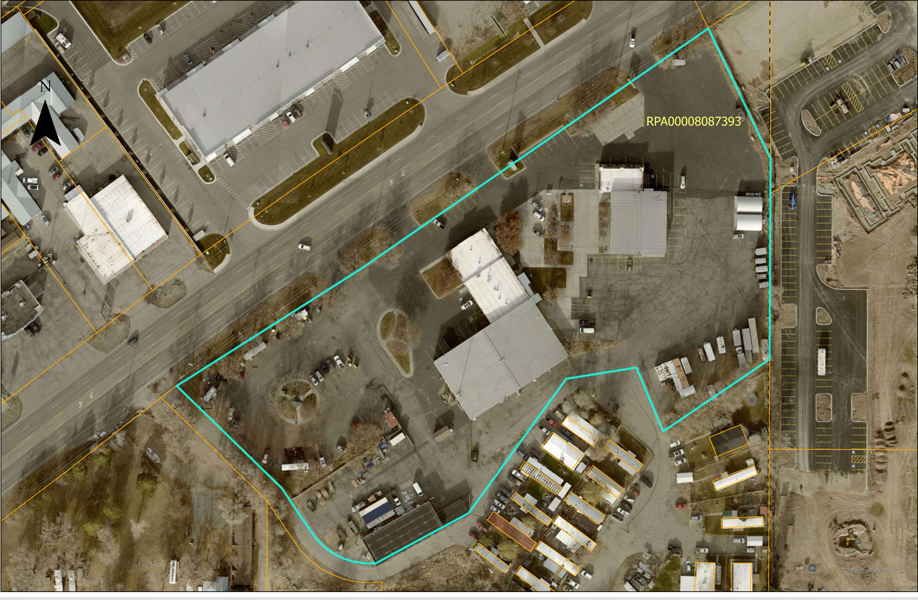
Legal Description: 6.08 A NE1/4 SE1/4 S RD, SEC 8, T 2N, R 38

Appendix C Agreement to Negotiate Exclusively (ANE)

AGREEMENT TO NEGOTIATE EXCLUSIVELY
THIS AGREEMENT TO NEGOTIATE EXCLUSIVELY (“Agreement”) is entered into by and between Bonneville County, Idaho, a political subdivision of the State of Idaho (hereinafter referred to as the "Lessor,” or “County”), and <Name of Prospective Lessee/ Prospective Lessee Company>, or its assigns as provided for herein (“Prospective Lessee”), collectively referred to as the “Parties” and each individually as “Party,” on the terms and provisions set forth below.
RECITALS
WHEREAS, Lessor is a political subdivision of the State of Idaho and owns certain real property addressed as 2300 N Yellowstone Avenue, Idaho Falls, Idaho 83401 (the "Site") as described on Exhibit A; and
WHEREAS, Lessor seeks to enter into a lease agreement with an outside party to revitalize the site and surrounding area in compliance with the City of Idaho Falls comprehensive plan and zoning requirements, which could also serve as a catalyst for improvement of other properties in the vicinity; and
WHEREAS, following the publication of a Request for Proposal (“RFP”) in the Post Register newspaper on May 12th and May 19th, 2026, Lessor received <XX> proposals to lease the Site; and
WHEREAS, at a public meeting on Monday, June 15th, 2026 the Lessor Board selected Prospective Lessee's proposal to lease, attached hereto as Exhibit B; and
WHEREAS, Lessor and Prospective Lessee intend to pursue the negotiation and execution of a Lease Agreement, and by doing so, comply with the required notice provisions concerning the lease of property by Lessor as set forth in the Law.
AGREEMENT
NOW, THEREFORE, in consideration of the foregoing recitals, which are hereby incorporated into this Agreement as an integral part hereof and not mere recitals hereto, and the mutual rights and obligations set forth below, the parties hereby agree as follows:
Section 100 DEFINITIONS
“Effective Date” shall be the date this Agreement is signed by both Parties, or if signed by both Parties on different dates, the date this Agreement is signed by the last Party.
“Lease Agreement” shall be the mutual agreement of written lease terms that shall be negotiated under this Agreement.
“Lessor” shall be Bonneville County, Idaho, a political subdivision of the State of Idaho.
“Lessor Board” shall be the members of the Lessor’s Board of Commissioners, as duly and legally elected or appointed.
“Lessor Staff” shall be the staff of Lessor, understood to be separate and distinct from the members of the Lessor Board.
“Prospective Lessee” shall be <Name of Prospective Lessee>, or its assigns.
“Negotiation Period” shall begin on the Effective Date and end one hundred fifty (150) days after the Effective Date, unless extended by Lessor as provided in Section 202 below.
“Schedule of Performance” shall mean the attached Exhibit C.
“Scope of Lease” shall mean Prospective Lessee’s proposed lease of the Site included in the proposal and attached hereto as Exhibit B, plus any mutually agreed upon changes negotiated by Lessor and Prospective Lessee during the Negotiation Period.
“Site” shall mean the real property owned by Lessor and more particularly described in Exhibit A, attached hereto and incorporated herein by reference.
Section 200 NEGOTIATIONS
Section 201 Good-Faith Exclusive Negotiations
Lessor and Prospective Lessee agree for the Negotiation Period to negotiate diligently and in good faith to prepare a Lease Agreement to be considered for execution between Lessor and Prospective Lessee, in the manner set forth herein, with respect to the lease of the Site. During the Negotiation Period Lessor shall not directly or indirectly negotiate with any person or entity other than Prospective Lessee with respect to the disposition or lease of the Site.
Section 202 Negotiation Period
The duration of this Agreement (the "Negotiation Period") shall commence on the Effective Date and shall terminate one hundred fifty (150) days thereafter (the “Termination Date”). Notwithstanding the foregoing, Lessor may, in its sole discretion, extend the Negotiation Period for an additional thirty (30) days beyond the Termination Date. If such extension is at the sole instigation of Lessor, no extension fee shall be due. If Prospective Lessee requests an extension and Lessor grants such request, Lessor may, in its sole discretion, require Prospective Lessee to pay an extension fee of Five Thousand Dollars ($5,000.00). In the event an extension fee has been paid, and a Lease agreement has been executed by both Parties, such extension fee shall be credited towards the first payable lease payment.
If upon expiration of the Negotiation Period Prospective Lessee has not executed a Lease agreement approved by the Lessor Board, then this Agreement shall terminate, unless extended in writing by Lessor. Once a Lease agreement is signed by both Lessor and Prospective Lessee, then the terms of the Lease agreement shall prevail and this Agreement shall automatically terminate.
If the negotiations do not result in an executed Lease agreement, Prospective Lessee shall submit to Lessor a summary of its findings and determinations regarding the proposed lease, excluding any confidential or privileged information. If this Agreement is terminated per this Section 102, Prospective Lessee shall not seek reimbursement for costs and expenses from Lessor and Lessor shall not seek reimbursement for costs and expenses from Prospective Lessee, except that Lessor shall retain any extension fee paid by Prospective Lessee, and Lessor shall be entitled to retain the Deposit (defined below) subject to Section 203.
Section 203 Deposit
Prospective Lessee’s Submission of Deposit:
Prospective Lessee shall submit to Lessor a deposit ("Deposit") in an amount of Ten Thousand Dollars ($10,000) in the form of cash or cashier's check to ensure that Prospective Lessee will proceed diligently and in good faith to negotiate and perform all of Prospective Lessee's obligations under this Agreement. In the instance of a fully executed lease agreement, the Deposit shall be applied to the first payable lease payment. Provided, if the Parties terminate this Agreement before Lessor incurs any costs as defined below, the Deposit shall be refunded in its entirety to Prospective Lessee. After Lessor incurs any third-party costs in preparing lease negotiations, such costs shall be deducted from the amount of the Deposit refunded to Prospective Lessee if such a refund occurs as otherwise provided herein.
Submission of the Deposit must occur within fifteen (15) days of the Effective Date. If Prospective Lessee fails to submit said Deposit within the fifteen (15) day period, Lessor may terminate this Agreement, with neither Party having any further rights against nor liability to the other under this Agreement, unless as agreed to in writing by Lessor.
Lessor shall be under no obligation to pay or earn interest on Prospective Lessee 's Deposit, but if interest shall accrue or be payable thereon, such interest (when received by Lessor) shall become part of the Deposit.
Section 300 LEASE PROPOSAL
Section 301 Scope of Lease
Lessor and Prospective Lessee acknowledge Prospective Lessee's proposal, as submitted to Lessor on <Enter date submitted> (the “Proposal”), is attached as Exhibit B.
Section 301.01 Lease Plan
Prospective Lessee shall refine and supplement their Proposal to produce a second submittal to Lessor Staff and Board under this Agreement (the “Lease Plan”). Prior to the submittal of the Lease Plan to Lessor Staff, Prospective Lessee, and Lessor Staff shall engage in a lease refinement process to address lease-related issues identified by Lessor Following this lease refinement and within sixty (60) days of the Effective Date, Prospective Lessee shall submit the Lease Plan to Lessor Staff which shall include:
A clear chart showing changes from the Proposal including:
- square footage of each proposed lease use
- number of required parking spaces, if any
- renderings
- floor plans
- site plan
- elevations/sections listing exterior finishes
The Lease Plan shall also include a brief use summary Prospective Lessee shall submit the Lease Plan to Lessor Staff and Lessor Staff shall review and consider the Lease Plan as set forth in Section 302.02 of this Agreement and the Schedule of Performance.
Section 302.02 Approval of the Lease Plan
Within fifteen (15) days of Lessor Staff’s receipt of the Lease Plan, Lessor shall either approve or disapprove the Lease Plan in writing to Prospective Lessee. In the event the Lease Plan is initially disapproved by Lessor Staff, within fifteen (15) days of Lessor’s receipt of the Lease Plan Lessor Staff shall set forth the reasons for disapproval and options that address Lessor's reasons for disapproval. Prospective Lessee shall then have ten (10) days to resubmit information to address the reasons for disapproval. Within five (5) days of Lessor Staff’s receipt of the resubmittal, Lessor Staff shall meet with Prospective Lessee to discuss the resubmittal (the “Resubmittal Meeting”) and shall identify issues that have not been resolved to Lessor Staff's satisfaction, if any, and shall provide an additional period of fifteen (15) days for Prospective Lessee to resubmit information to address Lessor Staff’s issues. Lessor and Prospective Lessee agree that the purpose of this process is to reach a mutually satisfactory resolution of differences on lease contract with the understanding that Lessor retains the right to approve the Lease Plan. In the event the Lease Plan, as applicable, is again disapproved based on issues identified by Lessor Staff in its discussions with Prospective Lessee, Lessor may terminate this Agreement and the Deposit, less any costs incurred per Section 203, shall be refunded to Prospective Lessee.
Section 303 Assessment of Project Feasibility; Notification
In the event at any time during the Negotiation Period Prospective Lessee determines that it is not feasible to proceed with the Project, this Agreement shall be terminated upon ten (10) days' written notice to Lessor. In the event of such termination, Lessor shall refund the Deposit subject to Section 203 of this Agreement. In the event of such termination neither Party shall have any further rights against or liability to the other under this Agreement. Prospective Lessee acknowledges and consents that in the event this Agreement is terminated, Lessor has the right and authority to enter into an exclusive right to negotiation agreement concerning the Site with any other interested Prospective Lessee.
Section 400 LEASE PRICE
The Initial lease Price for the Site shall be <lease price > Dollars per mo/year ($000,000). During the Negotiation Period, Lessor and Prospective Lessee shall negotiate the schedule and conditions for lease payments, which schedule and conditions will be included in the lease agreement.
Section 500 PROSPECTIVE LESSEE AND PROSPECTIVE LESSEE’S OBLIGATIONS
Section 501 Nature of Prospective Lessee
Prospective Lessee is <Name of Prospective Lessee>, or its assigns. Wherever the term "Prospective Lessee" is used herein, such term shall include any permitted nominee or assignee as herein provided.
Section 502 Prospective Lessee's Principal
Prospective Lessee’s Principal Office is located at: <Insert complete address of Prospective Lessee’s office>
Section 503 Full Disclosure
Prospective Lessee is required to make full disclosure to Lessor of its officers, key managerial employees, and lease agents involved in this Project.
Section 504 Compliance with Applicable Laws
Prospective Lessee recognizes it will be required to comply with all applicable laws, including all applicable current and future Federal and State standards, antidiscrimination standards, affirmative action standards, and nondiscrimination and non-segregation standards, laws, and regulations in rental of the Site.
Section 600 EXECUTION OF THIS AGREEMENT NOT A DISPOSITION OF PROPERTY
By its execution of this Agreement, Lessor is not committing itself to or agreeing to undertake: (a) lease of land to Prospective Lessee; or (b) any other acts or activities requiring the subsequent independent exercise of discretion by Lessor, or any agency or department thereof.
Section 700 ISSUES OF NEGOTIATION
Prospective Lessee recognizes that the following items are matters Lessor desires be addressed during the Negotiation Period, but both Parties understand that there is no present agreement as to the manner or degree to which they or any particular one can or will be included in the lease agreement.
Section 701 Lease Refinement
Prior to submission of the Lease Plan, Lessor, Prospective Lessee shall engage in lease discussions to address lease issues related to the Lease Plan identified by Lessor, which Lessor desires to resolve prior to submittal of the Lease Plan to Lessor by Prospective Lessee. Lessor shall prepare a list of the issues to be addressed in the Lease Plan, and the process shall be conducted as provided in the Schedule of Performance. Lessor and Prospective Lessee shall reach mutual agreement on how to proceed regarding the lease issues.
Section 800 GENERAL PROVISIONS
Section 801 Notices
Formal notices, demands, and communications between Lessor and Prospective Lessee shall be sufficiently given if sent by registered or certified mail, postage prepaid and return receipt requested, to the principal offices of Lessor and Prospective Lessee as set forth below. Routine communication may be by first class mail, e-mail, facsimile, or telephone.

Lessor
Austin Black, Chief Operations Officer
Bonneville County
605 N. Capital Ave
Idaho Falls, Idaho 83402
208-529-1350 ext 1686 (voice)
ablack@bonnevillecountyidaho.gov
Prospective Lessee
First Name, Initial, Last Name
Name of Prospective Lessee
Street Address
City, State, Zip
Phone Number
Fax Number
Email Address
With a copy to:
First Name, Initial, Last Name
Name of Prospective Lessee Attorney
Street Address
City, State, Zip
Phone Number
Fax Number
Email Address
Section 902 REMEDIES AND DAMAGES
Notwithstanding anything to the contrary contained in this Agreement, Prospective Lessee's obligations hereunder are nonrecourse. Lessor's only recourse and security for Prospective Lessee's obligations shall be retention of the Deposit and any extension fee. In the event of any legal proceeding described in this Section 902 between the Parties to this Agreement to enforce any provision of this Agreement or to protect or establish any right or remedy of either Party hereunder, the prevailing Party shall recover its reasonable attorney fees, at trial and upon appeal, in addition to all other costs and damages allowed, as determined by the Court.

Section 903 NO RECORDATION

In no event shall any Party record this Agreement or any memorandum hereof or otherwise encumber the Site by reason of this Agreement or the negotiations contemplated hereby.

Section 904 SUCCESSORS AND ASSIGNS

No Party may assign or delegate its obligations under this Agreement without the consent of each other Party hereto, which consent may not be unreasonably withheld or delayed. Lessor shall not withhold consent to any assignment of this Agreement by Prospective Lessee to an entity managed by Prospective Lessee, directly or indirectly. Except as otherwise set forth in this Agreement, the terms, covenants, conditions, and agreements contained herein shall be binding upon and inure to the benefit of the heirs, personal representatives, successors, and assigns of the Parties hereto.

Section 905 COUNTERPARTS

This Agreement may be executed in counterparts, and each counterpart shall then be deemed for all purposes to be an original, executed agreement with respect to the Parties whose signatures appear thereon.

Section 906 LOCAL PROPERTY MANAGER

<Enter complete name of Property Manager>, an employee of <an affiliated entity of> Prospective Lessee, shall serve as the local property manager who will be available to Lessor.

Section 1000 TERMINATION

Section 1001 TERMINATION BY MUTUAL AGREEMENT

This Agreement may be terminated at any time by the written consent of either Party. In the event of such termination, Deposit shall be refundable as set forth in Section 203 and neither Party shall have any further rights against or liability to the other under this Agreement.

Section 1002 TERMINATION DUE TO INABILITY TO AGREE TO LEASE TERMS

Upon termination of this Agreement at the expiration of the Negotiation Period, or such extension thereof, neither Party shall have any further rights against nor liability to the other under this Agreement. If this Agreement is terminated for the Parties' failure to negotiate a lease acceptable to both Parties, Prospective Lessee shall not seek reimbursement for costs and expenses from Lessor, and Lessor shall not seek reimbursement for costs and expenses from Prospective Lessee, except to retain from Prospective Lessee's Deposit and extension fee, if any, any third-party costs actually incurred by Lessor in preparing the Reuse Appraisal, as provided in Section 203.

Exhibits
Exhibit A Legal Description of the Site
Exhibit B Prospective Lessee’s Proposal
Exhibit C Schedule of Performance
End of Agreement | Signatures appear on the following page.

IN WITNESS WHEREOF, the Parties hereto have executed this Agreement as of the dates set forth below.

Lessor
Bonneville County, Idaho
a political subdivision of the State of Idaho

By:
<Name of signatory>

Its:

Date:

Acknowledgement
State of Idaho
County of
This record was acknowledged before me on
by .

Signature of Notary Public

(Stamp)

My commission expires .

Prospective Lessee
<Name of Prospective Lesee>
<Entity type, etc>

By:
<Name of signatory>

Its:

Date:

Acknowledgement
State of Idaho
County of
This record was acknowledged before me on
by .

Signature of Notary Public

(Stamp)

My commission expires

Appendix D Release, Waiver and Indemnity Agreement
The undersigned has read and fully accepts the discretion and non-liability of Bonneville County, Idaho, (hereinafter “County”) as stipulated herein.
A. Discretion of County
County reserves the right in its sole discretion and judgment for whatever reasons it deems appropriate to, at any time:
1. Modify or suspend any and all aspects of the process for the Request for Proposals (hereinafter “RFP”) seeking interested responders to provide requested lease proposals, as defined in the RFP.
2. Obtain further information from any person, entity, or group, including, but not limited to, any person, entity, or group responding to County’s RFP (any such person, entity, or group so responding is, for convenience, hereinafter referred to as “Responder”), and to ascertain the depth of Responder’s capability and desire to lease, and in any and all other respects, to meet with and consult with Responder or any other person, entity, or group;
3. Waive any formalities or defects as to form, procedure, or content with respect to its RFP and any responses by any Responder thereto;
4. Accept or reject any proposal or statement of interest received in response to the RFP including any proposal or statement of interest submitted by the undersigned, or select one Responder over another;
5. Accept or reject all or any part of any materials, implementation programs, schedules, phasing’s, and proposals or statements, including, but not limited to, the nature of the lease.
B. Non-Liability of County
The undersigned agrees:
(1) that County shall have any liability whatsoever of any kind or character, directly or indirectly, by reason of all or any of the following; and
(2) that the undersigned has not obtained and shall not obtain at any time, whether before or after acceptance or rejection of any statement of interest or proposal, any claim or claims against County or County property (all as hereinafter defined), directly or indirectly, by reason of all or any of the following:
1. Any aspect of the RFP, including any information or material set forth therein or referred to therein;
2. Any modification or suspension of the RFP for informalities or defects therein;
3. Any modification of or criteria or selection or defects in the selection procedure or any act or omission with respect thereto, including, but not limited to obtaining information from any Responder contacts or consultations with Responders who have submitted statements of interest or proposals as to any matters or any release or dissemination of any information submitted to County;
4. The rejection of any statement of interest or proposal, including any statement of interest or proposal by the undersigned, or the selection of one Responder over another;
5. The acceptance by County of any statement of interest or proposal;
6. Entering into and thereafter engaging in negotiations;
7. The expiration of negotiations;
8. Entering into any lease agreement, other agreement, relating to the statement of interest or proposal, or as a result thereof;
9. Any statement, representations, acts, or omissions of County in connection with all or any of the foregoing;
10. The exercise of County discretion and judgment set forth herein or with respect to all or any of the foregoing; and
11. Any and all other matters arising out of or directly or indirectly connected with all or any of the foregoing.
The undersigned further, by its execution of this Release, expressly and absolutely waives any and all claim or claims against County and County property, directly or indirectly, arising out of or in any way connected with all or any of the foregoing.
For purposes of this section, the term “County” includes their respective commissioners, appointed and elected officials, members, officers, employees, agents, selection committee, volunteers, successors, and assigns; the terms “County property” and all property of County, real, personal, or of any other kind or character; the terms “claim or claims” include any and all protests, rights, remedies, interest, objections, claims, demands, actions, or causes of actions, of every kind or character whatsoever, in law or equity, for money or otherwise including, but not limited to, claims for injury, loss, expense, or damage, claims to property, real or personal accounts or funds, or rights or interests therein, and claims to contract interests of any kind or character, in any County property, accounts, or funds, or claims which might be asserted against to cloud title to County property, accounts, or funds. The words “Responder or Responders” shall include any person, entity, or group responding to County’s RFP.
C. Hold Harmless and Indemnity
The undersigned shall defend, hold harmless, and indemnify County, and each of them, from and against any and all claims, directly or indirectly, arising out of the Undersigned’s responses to the RFP, including, but not limited to, claims, if any, made by Undersigned or by anyone connected or associated with Undersigned or by anyone claiming directly or indirectly through Undersigned.
__________________________________________
Interested Responder
BY:______________________________________
Its:_______________________________________
Date: _____________________________________
ACKNOWLEDGMENT
STATE OF ____________
COUNTY OF __________
On this ____ day of _______________, 2026, before me, ______________________, a Notary Public in and for said State, personally appeared _______________________, known or identified to me (or proved to me on the oath of ________________) to be the ____________________________ of ____________________________________, an ________________________________, the entity that executed the instrument or the person who executed the instrument on behalf of said entity and acknowledged to me that such entity executed the same.
____________________________________
Notary Public for
State of: _____________________________
My commission expires___________

