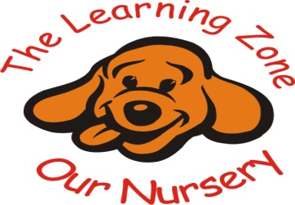

Sun Safety Policy

The nursery is committed to ensuring that all children are fully protected from the dangers of too much sun. Severe sunburn in childhood can lead to the development of malignant melanoma (the most dangerous type of skin cancer) in later life.

Clothing

• Children must have a clearly named sun hat which will be worn at all times whilst outside in sunny weather. This hat will preferably be of legionaries design to provide additional protection (that is with an extended back and side to shield children’s neck and ears from sun) to provide additional protection.
• Children are allowed to wear named UV protection sunglasses

Shade and Hydration

• Children are offered drinking water more frequently throughout sunny or warm days, water is accessible to children and staff indoors, drinking water is provided in the nursery garden.
• Children are made aware of the need for sun hats, sun cream and the need to drink more fluids during their time in the sun.
• Shade will be provided to ensure children are able to cool down or escape the sun should they wish or need to
• Parents/carers of children are made aware that any skin types can burn in the sun and that this is very important to remember

Sun cream must be applied at home using a high UV protection as the nursery do not apply sun cream to the children.

Timetabling

• Staff will make day-to-day decisions about the length of time spent outside dependant on the strength of the sun. On hotter days a 20 min limit is put in place.
• Children will not be out in the sun between 11.45am – 2.15pm on very hot days.

Drinking water:

- Children are encouraged to increase their water intake in hot weather and are encouraged to drink water throughout the nursery session.

If we suspect that any children are particularly struggling with the heat, we will contact parents/carers and ask them to come and collect their child(ren).

https://www.nhs.uk/conditions/dehydration/

https://www.nhs.uk/conditions/heat-exhaustion-heatstroke/

Review Date: 03/10/2025

