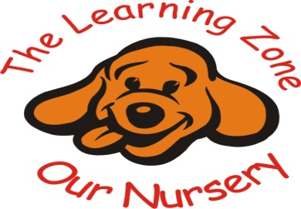

Nappy changing
Policy statement
At The Learning Zone we provide nappy changing facilities and exercise good hygiene practices in order to accommodate children who are not yet toilet trained.
We see toilet training as a self-care skill that children have the opportunity to learn with the full support and non-judgemental concern of adults. Any change of clothing that is carried out by a member of staff will be added to the ‘change of clothes’ book and the parent/carer will be asked to sign it. Children’s privacy is always considered and balanced with safeguarding and support needs when changing nappies and toileting.

Procedures
- Changing areas are warm with safe areas to lay children, we have a changing station which is 10cm off of the floor.
- Each child should have their own named bag to include their own changing items.
- Gloves and aprons are put on by staff before changing starts and the areas are prepared. Mats are cleaned after each change.
- All staff are familiar with the hygiene procedures and carry these out when changing nappies.
- In addition, key persons ensure that nappy changing is relaxed and a time to promote independence in young children.
- Children are encouraged to take an interest in using the toilet; they may just want to sit on it and talk to a friend who is also using the toilet.
- Children are encouraged to wash their hands and have soap and towels to hand. They should be allowed time for some play as they explore the water and the soap.
- Barred soap should not be used for young children; young skin is quite delicate and anti-bacterial products kill off certain good bacteria that children need to develop their own natural resistance to infection.
- Key persons are gentle when changing; they avoid pulling faces and making negative comments about ‘nappy contents’.
- Key persons do not make inappropriate comments about children’s genitals when changing their nappies.
- Older children access the toilet when they have the need to and are encouraged to be independent.
- Nappies and pull ups are disposed of hygienically. Any soil (faeces) in nappies or pull ups is flushed down the toilet and the nappy or pull up is bagged and put in the bin. Cloth nappies, trainer pants and ordinary pants that have been wet or soiled are bagged for the parent to take home and the member of staff will also fill out the ‘change of clothes’ book and will ask the parent/carer to sign.
- We have a ‘duty of care’ towards children’s personal needs. If children are left in wet or soiled nappies/pull ups in the setting this may constitute neglect and will be a disciplinary matter.

Amendments to ensure that children’s privacy during nappy changing and toileting is considered and balanced with all safeguarding considerations (see Safeguarding Children – Child Protection Policy).

References: Statutory framework for Early Years foundation stage Review Date: 10/10/2025

