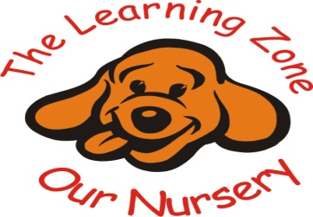

First aid

Policy statement
In our setting, staff are able to take action to apply first aid treatment in the event of an accident involving a child or adult. At least one member of staff with a current Paediatric first aid certificate is on the premises, or on an outing at any one time. The Paediatric first aid qualification includes first aid training for infants and young children. Our Paediatric first aid training is local authority approved and is relevant to staff caring for young children.
All our members of staff have received Paediatric first aid training.
We regularly liaise with other health care professionals and will always introduce new training if and when required.
Please refer to HSE’s guidance about choosing a first aid training provider, which can be found at: www.hse.gov.uk/pubns/geis3.htm

Procedures
The first aid kit:
Our first aid kits are accessible at all times, contains all the necessary supplies and comply with the Health and Safety (First Aid) Regulations 1981

- The first aid boxes are easily accessible to adults and are kept out of the reach of children.
- No un-prescribed medication is given to children, parents/carers or staff.
- At the time of each child’s admission to the setting, parents/carers' written permission for obtaining emergency medical advice or treatment is sought. Parents sign and date their written approval.
- Parents/carers sign a consent form at registration allowing staff to take their child to the nearest Accident and Emergency unit to be examined, treated or admitted as necessary on the understanding that parents/carers have been informed and are on their way to the hospital.

We keep a written record of accidents, injuries and first aid treatment given. We inform parents and/or carers of any accident or injury sustained by the child on the same day as, or as soon as reasonably practicable after, and of any first aid treatment given. The parent/carer will be asked to sign the relevant form(s).

Individual Care Plan
Each child that attends the nursery with specific medical needs must bring with them an individual care plan, it must include all the relevant information about their medical condition/History, including signs/symptoms, medication etc...
Medication Record
The staff must ensure that a medication record is filled out and signed by the key staff and the parent/carer(s) when administering medication to one of our children.

Example: Page 1
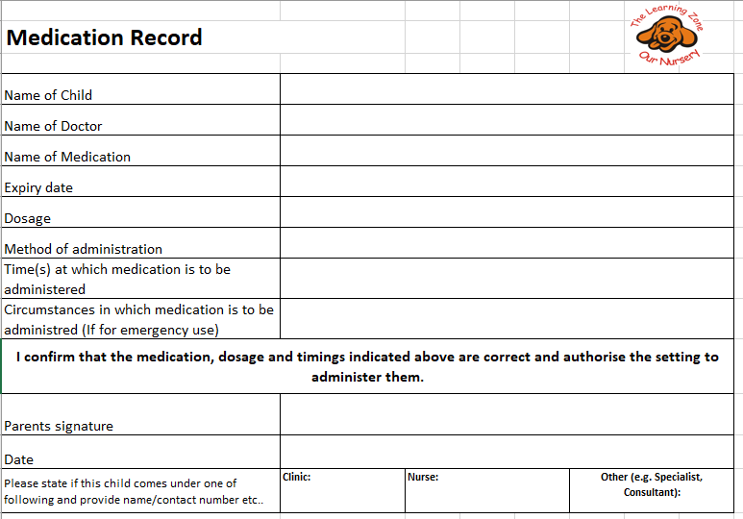
Example: Page 2
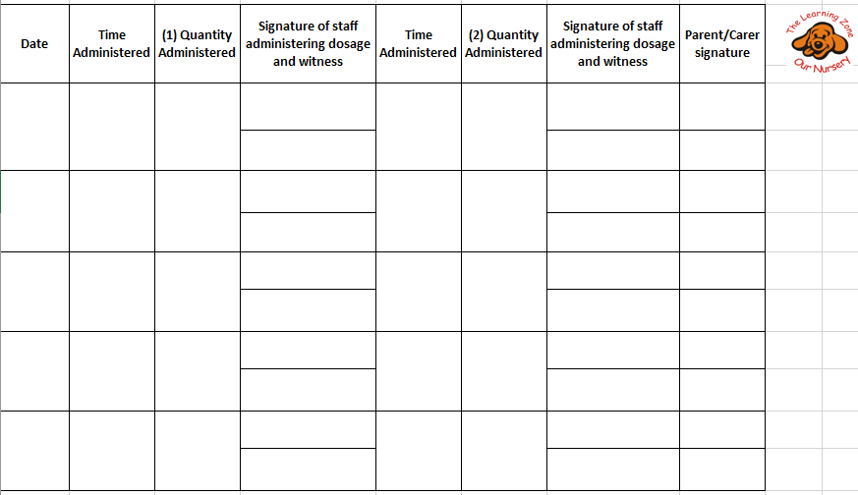

Legal framework

- Health and Safety (First Aid) Regulations (1981)
- Statutory Framework for the Early Years foundation stage

Further guidance

- First Aid at Work: Your questions answered (HSE )
- Basic Advice on First Aid at Work (HSE)
- Guidance on First Aid for Schools (DfEE)
Other useful Pre-school Learning Alliance publications

- Medication Record

Review Date: 03/10/2025

