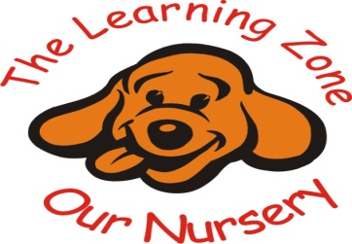

Allergies and Allergic Reactions
At the Learning Zone Nursery we are aware that children can have allergies and that coming into contact with their allergens can cause a reaction, in most cases this will be a mild reaction but in some it can be so serious that it becomes life threatening.

We will always follow this policy to take every possible step to prevent the child coming into contact with their allergen.

Managing allergic reactions

• All our staff have a paediatric first aid qualification which includes signs and symptoms that a child is having an allergic reaction which may include a rash or hives, nausea, stomach pain, diarrhoea, itchy skin, runny eyes, shortness of breath, chest pain, swelling of the mouth or tongue, swelling to the airways to the lungs, wheezing and anaphylaxis.
• Some members of staff have been trained on how to administer an epi-pen (if this has been prescribed for use in the case of an anaphylactic shock or severe reaction). If necessary, we will seek further training from the child’s health visitor as the child starts nursery to be able meet the child’s particular needs.
• In the case of an unknown or first reaction in a child we will closely monitor the child and if needed use our first aid training to manage the symptoms until medical help arrives. Parents will always be given a courtesy phone call as soon as possible to inform them of any reaction noticed.
• If the allergic reaction is severe a member of staff will telephone for an ambulance immediately. We will not attempt to transport the sick child in our own vehicles
• Whilst waiting for the ambulance, we will telephone the child’s parents or their emergency contact and arrange to meet them at the hospital
• A member of staff must accompany the child ensuring that the child’s registration form, health care plan, medication and child’s comforter are taken with the child.
• Staff must remain calm at all times; children who witness an allergic reaction may well be affected by it and may need lots of cuddles and reassurance. All incidents will be recorded, shared and signed by parents at the earliest opportunity.

Documentation

• The nursery manager will be involved in discussions with the parents before the child starts to discuss the best way to manage the child’s allergy and dietary needs. This information will be shared with all of the staff. If a child’s needs are complex then a meeting will be arranged with the nursery manager, and the child’s parents so that strategies to meet the child’s individual dietary needs can be agreed.
• Each child with a known allergy will have a health care plan which is completed by the child’s keycarer and parents and reviewed every three months. The health care plan will include the child’s name, date of birth, emergency contacts, details about the allergy, child’s individual symptoms and treatment. All staff are made aware of the plan.
• A copy of the health care plan and the child’s clearly named medication will be kept either in the office or fridge in the kitchen near the main office.
• Information gathered from parents via the registration form or child’s routine form regarding allergic reactions and allergies and must be shared with all staff in the nursery
• Each term the list of children with dietary requirements is updated and a copy is displayed in the main room.

To be reviewed: 03/10/2026

