# **G-L 2 3Q 2020 Quarterly Review**

*December 7, 2020*

**Index Performance**

* **Total return for 3Q 2020 came in at 0.54%** compared with 2Q 2020’s 1.72%. Results reflect performance fully netted for use of leverage to “manufacture mezz” from senior whole loans.[1]
  + Income return was 1.68%, roughly matching the prior quarter’s 1.70%
  + Capital value return was -1.14% due to credit effects, which are discussed below.
  + Year-to-date 2020 total return as of September 30 is 2.94%.
  + Trailing twelve-month total return as of September 30 is 4.50%.
* Monthly returns:
  + Jul. 2020 0.62%
  + Aug. 2020 0.57%
  + Sep. 2020 -0.65%
* Revisions to historical data typically have had minor effects on index results. However, in 3Q revised data for some months of 2019, 1Q and 2Q 2020 were received. Resultant changes were larger than those we typically see. In particular, **the revised return for 1Q 2020 shows a greater effect from the COVID pandemic than had previously been calculated** (see Table 1).

**Table 1. Revisions to G-L 2 Reported Total Returns**



CY Calendar Year

Source: Giliberto-Levy

* **Credit effects now are systemic rather than anecdotal.** The onset of the long economic expansion after the global financial crisis roughly coincided with G-L 2’s inception date. Consequently, very few credit events occurred in the index before 2020. Those that did were asset-specific events, and they had minimal effect on index performance.

The abruptness and severity of the economic collapse due to COVID was expected to change this benign pattern, and it has. The chart below shows capital value return for each month in 2020. Large write-downs from defaults in March and September had dramatic effects.

**Chart 1. G-L 2 Capital Value Return**

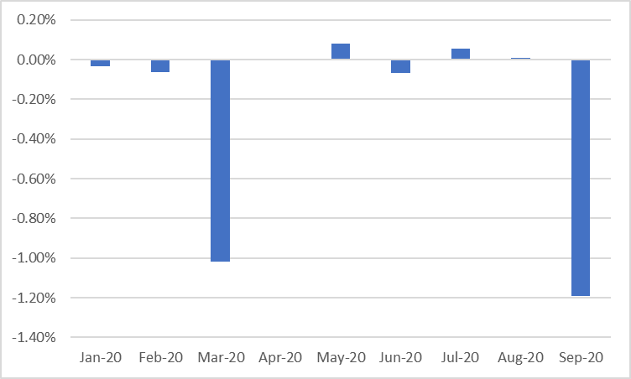

Source: Giliberto-Levy

We measured the incidence of various types of credit events using unpaid principal balances (UPB). Percentage incidence is the sum of UPB for a particulate event type divided by the total UPB reported for the index (see Table 2).

**Table 2. G-L 2 Credit Event Incidence 3Q 2020**



UPB Unpaid Principal Balance

Source: Giliberto-Levy

Credit event incidence overall declined in 3Q due to a reduction in the amount of loans having interest deferrals. (Note: loans that receive interest deferrals are not considered delinquent.) However, **delinquency and defaults increased**, which was not a surprise. Delinquency and default incidence remains modest. For comparison, Trepp data showed an average 4% CMBS delinquency (60 days or more) rate for 3Q 2020.

Loss severity is a different story. Year to date, defaulted loans registered an average severity of 91%. **Defaults have been concentrated in mezzanine loans on lodging and retail sector assets.** As income and collateral values have plummeted, several investments sustained 100% losses.

* For comparisons of fixed versus floating-rate loan performance, G-L 2 and G-L 1 results and so forth, please see the expanded report package, which is described below.

**Expanded G-L 2 Report Package**

We recently introduced an expanded package of reports.

The package includes:

* Segment overview (shows composition of index and availability of sub-indices)
* Rolling 12-month Total Return: data and graph
* Index Performance
  + G-L 2
  + G-L 1 senior loan index
  + Investment-grade CMBS
  + High-yield Corporate Bonds
* G-L 2 Broad Categories
  + Overall index
  + All subordinate debt
  + Senior loans (note: leveraged whole loans are part of subordinate debt)
* Payment Type
  + Floating
  + Fixed
* Subordinate Debt Details
  + Mezzanine
  + Leveraged Whole Loans
  + Other (includes B Notes, Second Mortgages, Preferred Equity)
* Property Type
  + Office
  + Multifamily
  + Retail
  + Lodging
  + All others (includes industrial, which cannot be reported separately due to confidentiality restrictions)
* Asset Strategy Type
  + Stabilized
  + Bridge and Transitional
  + Value-add
  + Value-add plus Bridge and Transitional (Broad Value-add)
* Performance of Investments Held in Open-end Funds
* G-L 2 Index Profile
* Historical Return Component Detail (for the overall G-L 2)

We are studying additions, such as an equal-weighted index. Let us know what additional exhibits and data might be useful to see as part of the standard package. (Information such as loan count, net asset value (NAV), and total principal balance is available in the G-L 2 Dashboard, which is sent to all participants. Its anticipated release date is December 11, 2020.)

**If you have not received the new report package, please contact us.**

1. Reported components may not sum to reported totals due to rounding.