# **Second Quarter 2020**



**The Giliberto-Levy Commercial Mortgage Performance Index (G-L 1) rebounded strongly in 2Q 2020, generating 4.27% total return.** [1]Total return consisted of 1.04% income return and 3.24% capital value return, which incudes price changes and other factors. (The sum of the components may not equal the total due to rounding.) The **surge in capital value was mainly caused by declining commercial mortgage spreads,** which came down 60 to 65 basis points (bp) after peaking at the end of March (see Chart 1).

Chart 1. Spreads over Treasuries for Ten-year Commercial Mortgages

In basis points, reflecting 30/360-day count convention

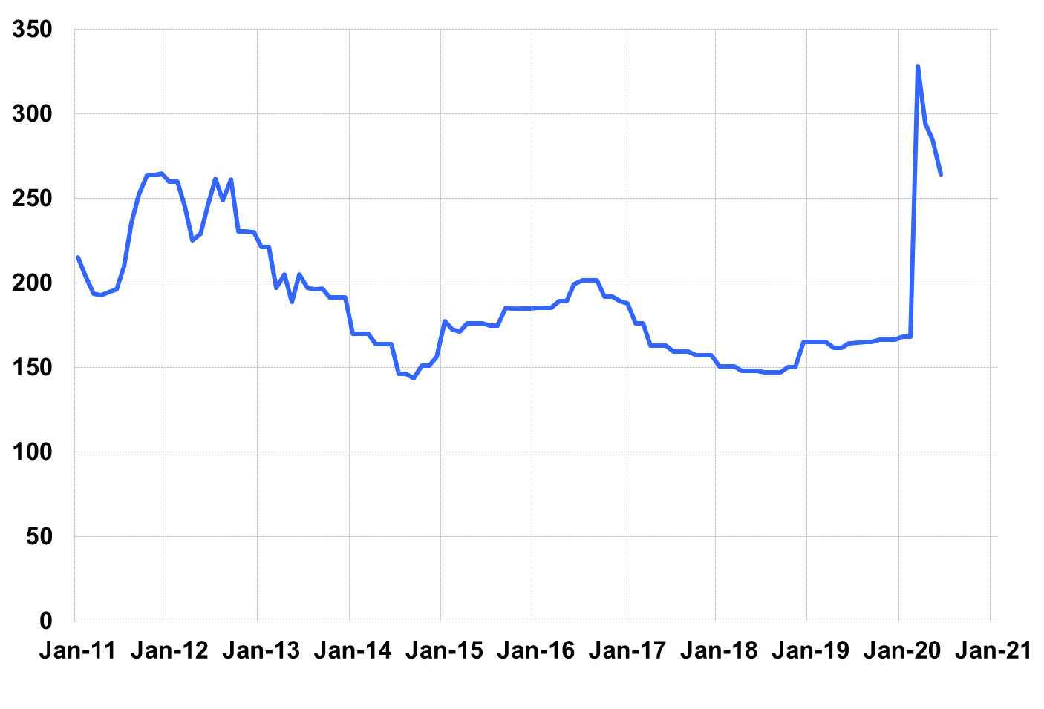

Source: Giliberto-Levy. Chart data are averages of office, apartment, retail and industrial property loans.

In contrast, U.S. Treasury yields barely moved during 2Q. The benchmark ten-year yield fell 4 bp from 0.70% on March 31 to 0.66% on June 30, for example.

**The mortgage spread movement in Chart 1 represents about a 40% “retracing” of the increase that occurred during March**. (A 65-bp decline from March 31 to June 30 is 40% of the 161-bp increase registered from February 28 to March 31.)

**Public market fixed-income sectors exhibited significantly larger retracing**. As of June 30, the investment-grade CMBS index spread had retraced 62% of its increase from February 28 to a March 25 peak, according to data from Bloomberg Barclays Indices. The majority of CMBS is AAA-rated, and those top-rated securities are eligible for the Federal Reserve’s TALF program. Intermediate-term Baa-rated corporate bonds had an even stronger rebound, gaining back nearly 90% of the spread increase sustained in March. The Fed’s stated willingness to purchase investment-grade corporate bonds likely propelled this recovery.

Market Trends: 2Q 2020

Observations below are based on data received at the time we prepared this report. Results are subject to change as we receive additional information.

* **2Q origination of loans eligible for the Index came in at $3.6 billion**, compared with 1Q 2020's $5.8 billion, revised from the previously reported $4.9 billion. The significant drop-off was expected: quite a few lenders stayed out of the market in April, and several remained on the sidelines through June.
* **The “floor” on coupon rates appeared to be 2.75%, although there were a few loans with slightly lower coupons.** It is possible that some lenders imposed higher floors, particularly on smaller loans. However, we were unable to determine that size premiums generally prevailed.
* **Average loan size was about $26 million**, slightly above last quarter’s $23 million. Loan sizes ranged from $1.6 million to well over $200 million. Loans above $25 million made up roughly two-thirds of dollar volume but accounted for only 32% of the number of loans. Despite 2Q’s lower volume, these statistics were almost identical to those posted in 1Q.
* **The average LTV on new loans eligible for inclusion in the Index was 63%**. This was an increase from last quarter’s 61%. Reported DSC was 2.3 times, up from last quarter’s 2.2 times. Neither change seems meaningful. That said, we believe many lenders are re-underwriting property values and expectations about stabilized operating income in light of COVID-19’s economic effects.
* The t**en-year segment’s market share by volume was a whopping 58%**, well above its recent average, although not unprecedented.Twenty-year loans took second place with 13% of reported volume.
* **New loan production was 37% full-term interest-only loans, 60% loans with partial amortization, and 3% fully amortizing loans.** Partially amortizing loans often include an interest-only period up front.
* **Except for industrial, values for all property sectors in the National Council of Real Estate Investment Fiduciaries (NCREIF) Property Index declined.** Not surprisingly, retail and lodging were especially hard hit.
* **After a long period of essentially zero credit-related effects, the G-L 1 registered a slight uptick in 2Q on this metric.** The annualized rate increased from under 2 bp to about 5 bp. That is still low, but we would be surprised if this is just a blip: it is more likely a first step down in the credit cycle.

Added detail and analysis will appear in the 2Q 2020 *Giliberto-Levy Monitor*.

1. The Index's components are fixed-rate commercial mortgage loans held on balance sheets of institutions such as life insurance companies and pension funds. Index returns are a market-value-weighted blend of office, apartment, retail, industrial, lodging, mixed-use and other miscellaneous property types. Index performance tracks senior loans only; it does not include construction loans, mezzanine and other subordinate instruments and bridge loans made by such institutions.