# **Third Quarter 2020**



**The Giliberto-Levy Commercial Mortgage Performance Index (G-L 1) produced 1.74% total return for 3Q 2020.** [1]Total return consisted of 0.99% income return and 0.76% capital value return, which incudes price changes and other factors. (The sum of the components may not equal the total due to rounding.) As was the case in 2Q, declining commercial mortgage spreads caused most of the capital value increase. **Third quarter spreads declined about 20 to 25 basis points (bp)** **for major sectors,** compared with 60-to-65 bp declines in 2Q (see Chart 1).

G-L 1 total return year to date through September 30 was 5.11%. Trailing four-quarter total return was 5.02%

Chart 1. Spreads over Treasuries for Ten-year Commercial Mortgages

In basis points, reflecting 30/360-day count convention

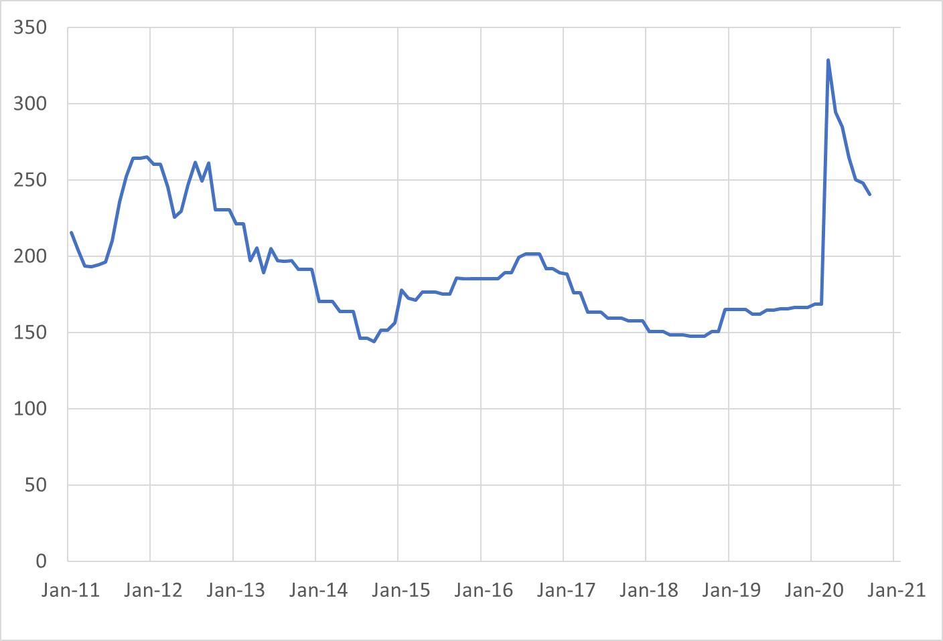

Source: Giliberto-Levy. Chart data are averages of office, apartment, retail and industrial property loans at 60% to 65% LTV.

Even with back-to-back quarterly spread declines, commercial mortgage spreads remained about 75 bp higher than pre-COVID levels. U.S. Treasury yields moved a few bp up or down, with down moves for maturities less than ten years and increases from ten years out. The benchmark ten-year yield was 0.69% on September 30, up 3 bp from its June 30 value, for example.

CMBS turned in similar performance results. According to Bloomberg Barclays Indices, investment-grade CMBS generated 1.90% total return. Baa-rated corporate bonds, adjusted to match G-L 1 duration, coincidentally also came in at 1.90%.

Market Trends: 3Q 2020

Observations below are based on data received at the time we prepared this report. Results are subject to change as we receive additional information.

* **The 3% coupon rate floor that life insurance company and pension fund lenders largely maintained during 2Q collapsed in 3Q**. In 2Q, only 7% of loans made by these entities had coupons below 3%; in 3Q nearly 40% of their loans had sub-4% coupons. As noted above, Treasury yields did not change much, so the result most likely reflects a behavioral shift in the market.
* **3Q origination of loans eligible for the Index increased to $5.1 billion**, compared with 2Q 2020's $4.0 billion, revised from the previously reported $3.6 billion. The rebound will, in fact, be greater when additional loans made in 3Q are reported as part of 4Q data collection.
* We detected 25-bp small loan (under $5 million) premiums for most sectors. Not all small-balance loans have such premiums.
* **Average loan size was about $24 million**, slightly below last quarter’s $26 million. Loan sizes ranged from under $1.0 million to nearly $300 million. Loans above $25 million made up roughly two-thirds of dollar volume but accounted for about 26% of the number of loans. These statistics are comparable to those posted in 2Q.
* **The average LTV on new loans eligible for inclusion in the G-L 1 was 60%**. This is down from last quarter’s 63%. Reported DSC was 2.4 times, up from last quarter’s 2.3 times. Neither change seems meaningful.
* The **ten-year segment’s market share by volume was 44%,** reverting to a more typical result compared with 2Q’s outsized 58%. **Seven-year loans experienced an uptick in popularity**, coming in with 21% of volume. Loan with 15 years or more to maturity had about 20% of reported volume.
* **New loan production was 32% full-term interest-only loans, 58% loans with partial amortization, and 10% fully amortizing loans.** Partially amortizing loans often include an interest-only period up front.
* Except for industrial, values for all property sectors reported in the National Council of Real Estate Investment Fiduciaries (NCREIF) Property Index continued to decline.
* **Credit effects continued to show a run rate of 5 bp annually.** The3Q result was slightly higher than 2Q’s. We anticipate the rate will continue to increase, but we do not have an estimate of the magnitude.

Added detail and analysis will appear in the 3Q 2020 *Giliberto-Levy Monitor*.

1. The Index's components are fixed-rate commercial mortgage loans held on balance sheets of institutions such as life insurance companies and pension funds. Index returns are a market-value-weighted blend of office, apartment, retail, industrial, lodging, mixed-use and other miscellaneous property types. Index performance tracks senior loans only; it does not include construction loans, mezzanine and other subordinate instruments and bridge loans made by such institutions.