# **Fourth Quarter 2020**



**The Giliberto-Levy Commercial Mortgage Performance Index (G-L 1) generated 1.16% total return for 4Q 2020.** [1]Total return consisted of 0.97% income return and 0.19% capital value return, which includes price changes and other factors. (The sum of the components may not equal the total due to rounding.) The modest capital value increase reflected a combination of increases in intermediate- and long-term Treasury yields and decreases in commercial mortgage spreads. **Fourth quarter spreads declined about 25 basis points (bp)** **for major sectors** (see Chart 1).

Chart 1. Spreads over Treasuries for Ten-year Commercial Mortgages

In basis points, reflecting 30/360-day count convention

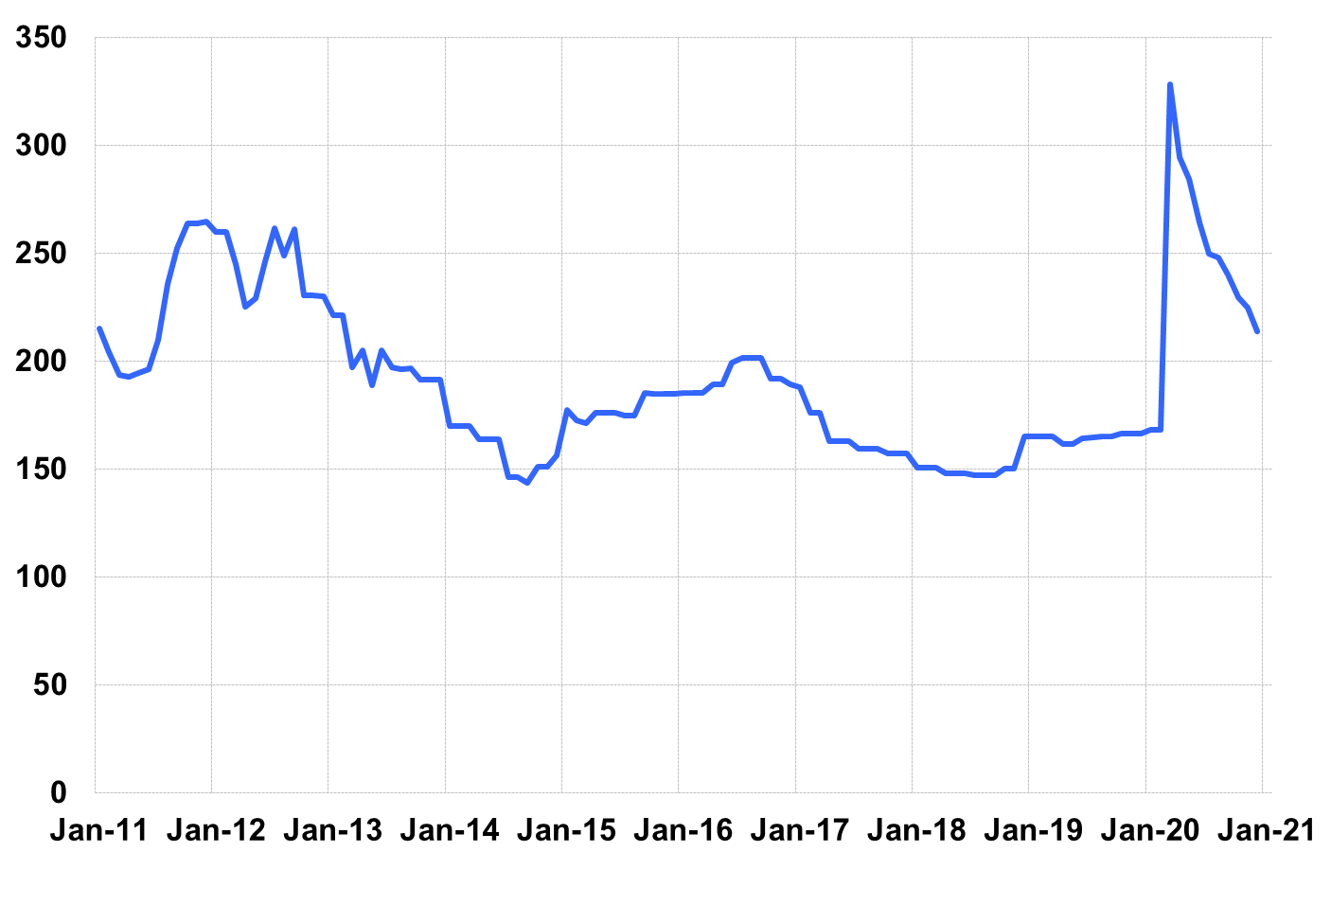

Source: Giliberto-Levy. Chart data are averages of office, apartment, retail and industrial property loans at 60% to 65% LTV.

Chart 1 shows how volatile spreads were in 2020. Our G-L major-sector composite, which equally weights spreads on office, retail, multifamily and industrial, went from 166 bp on December 31, 2019 to 214 bp on December 31, 2020, after peaking at 329 bp in March 2020.Treasury yields also moved considerably. At year-end 2019, the ten-year yield was 1.92%. A year later it stood at 0.93%, which was up from its 2020 low of 0.52%. For the year, the decline in Treasury yields (-99 bp) outpaced the year-on-year spread increase (48 bp). As a result, the ten-year commercial mortgage coupon rate (Treasury yield plus G-L standardized spread) fell about 50 bp for 60% to 65% LTV deals.

**G-L 1 total return for calendar year 2020 was 6.33%**, compared with 8.39% for 2019. Both years had “coupon plus” returns, i.e., total return exceeded income return due to favorable movements in index yields.

Investment-grade CMBS produced 1.25% total return, according to Bloomberg Barclays Indices. As was the case in 3Q, this result was quite comparable to G-L 1 performance. However, CMBS delivered higher total return (7.61%) for all of 2020. The reason is that the CMBS spread retraced almost all its 2020 increase, ending 2020 about 10 bp above its December 31, 2019 level. As noted above, the G-L spread was about 50 bp higher its year-end 2019 level.

Market Trends: 4Q 2020

Observations below are based on data received at the time we prepared this report. Results are subject to change as we receive additional information.

* **Origination of loans with coupon rates below 3% continued in 4Q.** About 46% of ten-year loans had coupon rates under 3%. This was during a quarter when the ten-year Treasury yield moved up about 25 bp. The percentage of sub-3% coupons was almost identical when all loans, both under and over ten-year term to maturity, were analyzed.
* **4Q origination of loans eligible for the Index increased to $6.6 billion**, compared with 3Q 2020's $6.1 billion, revised from the previously reported $5.1 billion. As usual, we expect the most recent quarter’s volume will increase when additional loans made in 4Q 2020 are reported as part of 1Q 2021 data collection.
* We continued to see a 20-bp to 30-bp small loan (under $5 million) premiums for most sectors. Not all small-balance loans have such premiums.
* **Average loan size moved up to $25.7 million** fromquarter’s $24 million. Loan sizes ranged from $1.0 million to over $400 million. Loans above $25 million made up roughly 70% of dollar volume but accounted for about 29% of the number of loans. These statistics are comparable to those posted in prior quarters.
* **The average LTV on new loans eligible for inclusion in the G-L 1 was 62%**. This is a slight increase from last quarter’s 60%. Reported DSC held steady at 2.4 times.
* The **ten-year segment’s market share by volume was 48%,** which is near the norm.Other segments also showed typical shares. Five- and seven-year loans jointly got 26% of volume, and loans with 15 years or more to maturity had about 20%.
* **New loan production was 25% full-term interest-only loans, 66% loans with partial amortization, and 9% fully amortizing loans.** Partially amortizing loans often include an interest-only period up front: 63% of all loans, by volume, had at least some period of interest-only.
* For calendar year 2020 the National Council of Real Estate Investment Fiduciaries (NCREIF) Property Index reported price changes of -1.1% for apartments, -2.5% for office, +8.4% for industrial, -10.2% for retail and -18.9% for hotels. These changes reflect a combination of property sales and appraisals. The hotel sample is small and may not be representative of the market.
* **Credit effects for 2020 came in at 4 bp, up from 2 bp in 2019.** The annualized quarterly run rate dipped slightly from 5 bp in 3Q to 4 bp. This is a statistic we will be watching in 2021. Its direction will be dictated by the pace of economic recovery, which is contingent on factors such as progress with COVID vaccinations and the size and delivery of fiscal stimulus.

Added detail and analysis will appear in the 4Q 2020 *Giliberto-Levy Monitor*.

1. The Index's components are fixed-rate commercial mortgage loans held on balance sheets of institutions such as life insurance companies and pension funds. Index returns are a market-value-weighted blend of office, apartment, retail, industrial, lodging, mixed-use and other miscellaneous property types. Index performance tracks senior loans only; it does not include construction loans, mezzanine and other subordinate instruments and bridge loans made by such institutions.