# **First Quarter 2021**



**The Giliberto-Levy Commercial Mortgage Performance Index (G-L 1) posted a -1.22% total return for 1Q 2021.** [1]Total return consisted of 0.95% income return and -2.17% capital value return, which includes price changes and other factors. (The sum of the components may not equal the total due to rounding.) Sharp increases in Treasury yields caused the capital value hit. The full potential effect of increased Treasury yields was blunted by declining commercial mortgage spreads. Replicating 4Q 2020 moves, **spreads declined about 30 basis points** (bp) for major sectors(see Chart 1**). That move puts spreads about 15 basis points (bp) above their average level in February 2020**, just prior to the COVID-driven market disruption.

Chart 1. Spreads over Treasuries for Ten-year Commercial Mortgages

In basis points, reflecting 30/360-day count convention

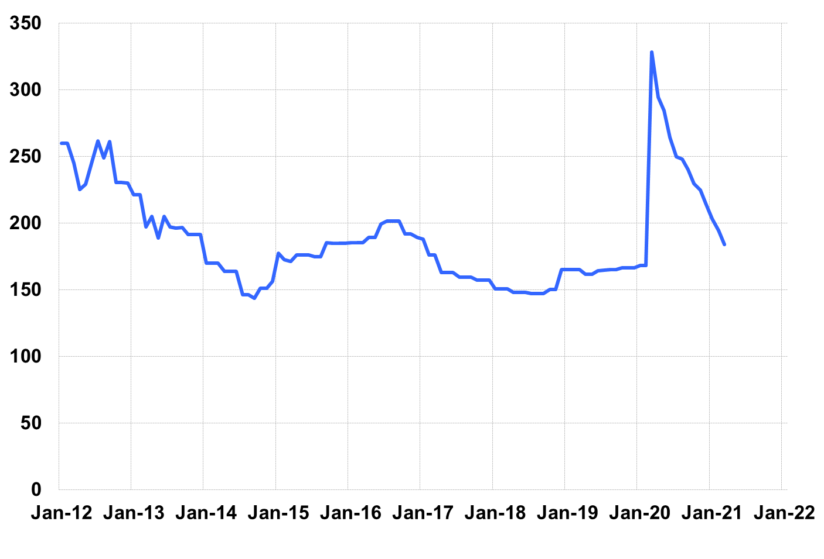

Source: Giliberto-Levy. Chart data are averages of office, apartment, retail and industrial property loans at 60% to 65% LTV for a term of ten years.

The rise in Treasury yields was accompanied by a marked steepening of the yield curve slope. To illustrate, on December 31, 2020 the two-year yield was 0.13% and the ten-year yield was 0.93%; the 80-bp difference measures the slope. On March 31, 2021, the two-year yield had barely moved, coming in at 0.16%. In contrast, the ten-year yield had reached 1.74%, implying a 158-bp slope, an increase of 78 bp. Similar results were repeated across intermediate and long-term notes and bonds.

Importantly, **slope increases appeared to prompt a return of term premiums as a component of commercial mortgage spreads** for new loans with five or fewer years to maturity. As a reminder, we measure “term premium” as the spread difference between, say, a five-year and a ten-year mortgage that have identical characteristics, other than term. We estimated the term premium to be about 60 bp at the three-year mark and 25 bp for five-year deals. In the past, term premiums, when present, have ranged from 40 bp to 150 bp for three-year loans and 10 to 90 bp for five-year loans. Even with term premiums, coupon rates on new shorter-term loans were below those on longer loans, on average

Investment-grade CMBS produced -2.10% total return, according to Bloomberg Barclays Indices. As we often note, CMBS and G-L 1 do not move in lockstep, and this quarter demonstrated that. However, looking back over the last five quarters, reaching back to pre-COVID days, cumulative returns are similar: 5.04% for G-L 1 and 5.36% for CMBS.

Market Trends: 1Q 2021

Observations below are based on data received at the time we prepared this report. Results are subject to change as we receive additional information.

* **Origination of loans with coupon rates below 3% abated somewhat in 1Q as rising Treasury yields put upward pressure on coupon rates.** About 37% of ten-year loans had coupon rates under 3%, compared with 46% in 4Q 2020. The percentage of sub-3% coupons was almost identical when all loans, both under and over ten-year term to maturity, were analyzed.
* **The typical first-quarter seasonal drop in lending volume occurred. 1Q origination of loans eligible for the Index decreased to $4.8 billion**, compared with 4Q 2020's $7.4 billion, revised from the previously reported $6.1 billion. As usual, we expect the most recent quarter’s volume will increase when additional loans made in 1Q 2021 are reported as part of 2Q 2021 data collection.
* We continued to see a 20-bp to 30-bp small loan (under $5 million) premiums for most sectors. Not all small-balance loans have such premiums.
* **Average loan size came down quite a bit from $25.7 million to about $19 million.** Loan sizes ranged from $1.5 million to over $200 million. However, in 4Q 2020 there were more mega-loans. Reduced volume in that segment in 1Q 2021 explains most of the decline in average size. Loans above $25 million made up roughly 55% of dollar volume but accounted for about 22% of the number of loans. These statistics are roughly comparable to those posted in prior quarters.
* **The average LTV on new loans eligible for inclusion in the G-L 1 was 60%**. This is a slight decline from last quarter’s 62%. Reported DSC held steady at 2.4 times.
* The **ten-year segment’s market share by volume was 43%,** which is near its historical average and near the prior quarter’s 48%.Other segments also showed typical shares. Five- and seven-year loans jointly got 20% of volume, and loans with 15 years or more to maturity also had about 20%.
* **New loan production was 22% full-term interest-only loans, 65% loans with partial amortization, and 13% fully amortizing loans.** Partially amortizing loans often include an interest-only period up front: about half these loans, by volume, had at least some period of interest-only.
* The National Council of Real Estate Investment Fiduciaries (NCREIF) Property Index reported about a 1% price increase, with all major sectors other than retail posting positive changes. As expected, industrial assets had the largest increase. Apartments were well below that, and offices were just slightly positive. These changes reflect a combination of property sales and appraisals.
* **Annualized quarterly credit effects increased to 6 bp after having dipped to 4 bp in 4Q 2020.** This reflects ongoing, albeit perhaps moderating, stress in office and retail. This is a statistic we will continue watching in 2021. As economic recovery seems likely to strengthen, this number – low by historical standards – should improve, probably with a lag.

Added detail and analysis will appear in the 1Q 2021 *Giliberto-Levy Monitor*.

1. The Index's components are fixed-rate commercial mortgage loans held on balance sheets of institutions such as life insurance companies and pension funds. Index returns are a market-value-weighted blend of office, apartment, retail, industrial, lodging, mixed-use and other miscellaneous property types. Index performance tracks senior loans only; it does not include construction loans, mezzanine and other subordinate instruments and bridge loans made by such institutions.