# **Second Quarter 2021**



**The Giliberto-Levy Commercial Mortgage Performance Index (G-L 1) generated 2.45% total return for 2Q 2021.** [1]Total return consisted of 0.97% income return and 1.47% capital value return, which includes price changes and other factors. (The sum of the components may not equal the total due to rounding.) Declining Treasury yields produced most of the capital value return. Modest reductions in commercial mortgage credit spreads enhanced the capital value increase. **Spreads declined about 8 basis points** (bp) for major sectors(see Chart 1**).** This was muted compared with the 25 to 30 bp drops that occurred in the prior two quarters. **Spreads have now retraced all but about 10 bp of the surge that occurred in the wake of the onset of the COVID pandemic.**

Chart 1. Spreads over Treasuries for Ten-year Commercial Mortgages

In basis points, reflecting 30/360-day count convention

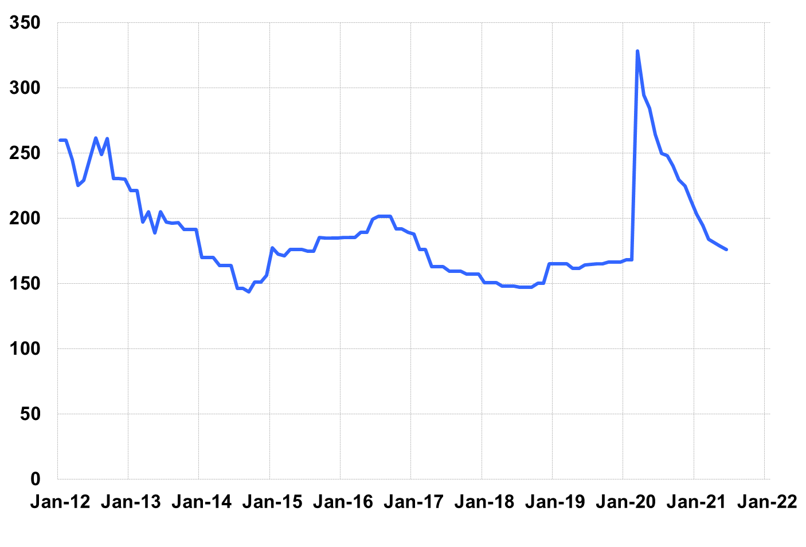

Source: Giliberto-Levy. Chart data are averages of office, apartment, retail and industrial property loans at 60% to 65% LTV for a term of ten years.

Coincidentally, the benchmark ten-year Treasury yield was 1.45% on June 30, 2021, not much different from 1.51% on January 31, 2020. To be sure, there was considerable volatility in both Treasury yields and mortgage spreads over the period.

Investment-grade CMBS posted 1.92% total return, according to Bloomberg Barclays Indices. G-L 1’s higher return mainly reflected (1) a 20-bp higher income return for the quarter and (2) slightly longer duration, which produced higher capital value increases from Treasury yield movements for G-L 1 compared with CMBS.

The table below summarizes G-L 1 results and statistics. Added detail and analysis will appear in the 2Q 2021 *Giliberto-Levy Monitor*.

|  |  |  |  |  |  |  |  |
| --- | --- | --- | --- | --- | --- | --- | --- |
|  | **G-L 1 Summary** |  |  |  |  |  |  |
|  |  | **Most Recent Period** |  | **Prior Period** |  | **Year Ago Comp. Period** |  |
|  |  | **2Q 2021** |  | **1Q 2021** |  | **2Q 2020** |  |
|  |  |  |  |  |  |  |  |
|  | **Index Results:** |  |  |  |  |  |  |
|  |  |  |  |  |  |  |  |
|  | Total Return | 2.45% |  | -1.22% |  | 4.27% |  |
|  | Income Return | 0.97% |  | 0.95% |  | 1.04% |  |
|  | Capital Value Return | 1.47% |  | -2.17% |  | 3.24% |  |
|  | Credit Effect (bp; annualized) | 6 |  | 6 |  | 5 |  |
|  |  |  |  |  |  |  |  |
|  | **Index-eligible Lending Activity** [Note 1]**:** | |  |  |  |  |  |
|  |  |  |  |  |  |  |  |
|  | Loan Volume ($ billions) | 8.0 |  | 6.0 |  | 4.0 |  |
|  | Weighted Average: |  |  |  |  |  |  |
|  | LTV | 59.7% |  | 59.9% |  | 62.5% |  |
|  | DSCR | 2.24 |  | 2.38 |  | 2.29 |  |
|  | Coupon Rate | 3.12% |  | 3.03% |  | 3.27% |  |
|  | Spread (basis points) [Note 2] | 159 |  | 168 |  | 257 |  |
|  | Term to Maturity (years) | 10.3 |  | 11.0 |  | 10.6 |  |
|  | Loan Size ($ millions) | 27.9 |  | 20.0 |  | 25.4 |  |
|  |  |  |  |  |  |  |  |
|  | Notes: |  |  |  |  |  |  |
|  | 1. Lending activity statistics are subject to revision as additional data are received. | | | | | | |
|  | 2. Spread is measured with respect to comparable maturity U.S. Treasury yield. | | | | | |  |
|  |  |  |  |  |  |  |  |
|  | Source: Giliberto-Levy |  |  |  |  |  |  |

1. The Index's components are fixed-rate commercial mortgage loans held on balance sheets of institutions such as life insurance companies and pension funds. Index returns are a market-value-weighted blend of office, apartment, retail, industrial, lodging, mixed-use and other miscellaneous property types. Index performance tracks senior loans only; it does not include construction loans, mezzanine and other subordinate instruments and bridge loans made by such institutions.