# **Third Quarter 2021**



**The Giliberto-Levy Commercial Mortgage Performance Index (G-L 1) posted a 0.42% total return for 3Q 2021.** [1]Total return consisted of 0.94% income return and -0.52% capital value return, which includes price changes and other factors. (The sum of the components may not equal the total due to rounding.) Rising Treasury yields caused most of the capital value return. Commercial mortgage credit spreads were mostly unchanged from June 30, 2021 levels (see Chart 1**).** High LTV loans, which are a small component of the index, did experience spread reductions.

All segments of the U.S. Treasury yield curve showed higher yields. The largest increases were for issues with five to ten years of remaining term. For example, the benchmark ten-year yield was up 16 basis points, ending the quarter at 1.61%.

Investment-grade CMBS posted -0.03% total return, according to Bloomberg Barclays Indices. G-L 1’s higher return reflected (1) 21 bp higher income return for the quarter and (2) 23 bp less decline in capital value (-52 bp for G-L 1 versus -75 bp for CMBS).

Chart 1. Spreads over Treasuries for Ten-year Commercial Mortgages

In basis points, reflecting 30/360-day count convention

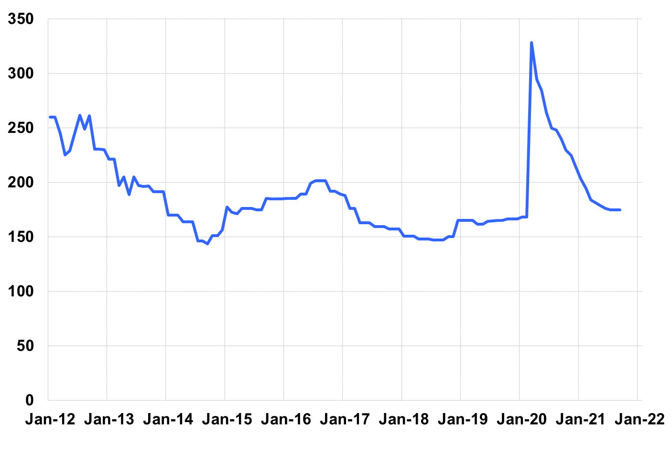

Source: Giliberto-Levy. Chart data are averages of office, apartment, retail and industrial property loans at 60% to 65% LTV for a term of ten years.

The table below summarizes G-L 1 results and statistics. Added detail and analysis will appear in the 3Q 2021 *Giliberto-Levy Monitor*.

|  |  |  |  |  |  |  |  |
| --- | --- | --- | --- | --- | --- | --- | --- |
|  | **G-L 1 Summary** |  |  |  |  |  |  |
|  |  | **Most Recent Period** |  | **Prior Period** |  | **Year Ago Comp. Period** |  |
|  |  | **3Q 2021** |  | **2Q 2021** |  | **3Q 2020** |  |
|  |  |  |  |  |  |  |  |
|  | **Index Results:** |  |  |  |  |  |  |
|  |  |  |  |  |  |  |  |
|  | Total Return | 0.42% |  | 2.45% |  | 1.74% |  |
|  | Income Return | 0.94% |  | 0.97% |  | 0.99% |  |
|  | Capital Value Return | -0.52% |  | 1.47% |  | 0.76% |  |
|  | Credit Effect (bp; annualized) | 3 |  | 6 |  | 5 |  |
|  |  |  |  |  |  |  |  |
|  | **Index-eligible Lending Activity** [Note 1]**:** | |  |  |  |  |  |
|  |  |  |  |  |  |  |  |
|  | Loan Volume ($ billions) | 9.3 |  | 8.9 |  | 6.1 |  |
|  | Weighted Average: |  |  |  |  |  |  |
|  | LTV | 62.2% |  | 59.6% |  | 62.5% |  |
|  | DSCR | 2.32 |  | 2.29 |  | 2.42 |  |
|  | Coupon Rate | 2.97% |  | 3.11% |  | 3.01% |  |
|  | Spread (basis points) [Note 2] | 168 |  | 157 |  | 235 |  |
|  | Term to Maturity (years) | 10.4 |  | 10.5 |  | 10.7 |  |
|  | Loan Size ($ millions) | 29.0 |  | 28.2 |  | 24.0 |  |
|  |  |  |  |  |  |  |  |
|  | Notes: |  |  |  |  |  |  |
|  | 1. Lending activity statistics are subject to revision as additional data are received. | | | | | | |
|  | 2. Spread is measured with respect to comparable maturity U.S. Treasury yield. | | | | | | |
|  |  |  |  |  |  |  |  |
|  | Source: Giliberto-Levy |  |  |  |  |  |  |

1. The Index's components are fixed-rate commercial mortgage loans held on balance sheets of institutions such as life insurance companies and pension funds. Index returns are a market-value-weighted blend of office, apartment, retail, industrial, lodging, mixed-use and other miscellaneous property types. Index performance tracks senior loans only; it does not include construction loans, mezzanine and other subordinate instruments and bridge loans made by such institutions.