# **Fourth Quarter 2021**



**The Giliberto-Levy Commercial Mortgage Performance Index (G-L 1) generated 0.28% total return for 4Q 2021.** [1]Total return consisted of 0.94% income return and

–0.66% capital value return, which includes price changes and other factors. (The sum of components may not equal the total due to rounding.) Shifting Treasury yields caused most of the capital value return. Commercial mortgage credit spreads drifted, ending the quarter slightly lower; the difference was almost imperceptible (see Chart 1**).**

Changes in the U.S. Treasury yield curve were not uniform in size and direction. The average yield on issues with one to five years of remaining term *increased* by more than 30 basis points (bp) on average, compared with September 30, 2021. In contrast, the benchmark ten-year yield *dropped* 9 bp, and the 30-year yield was down 26 bp.

Investment-grade CMBS posted -0.65% total return, according to Bloomberg Barclays Indices. As noted in earlier reports, G-L 1’s income return is higher, coming in 19 bp above CMBS for 4Q. CMBS reported a capital value decline of -1.37%. It appears spreads on seasoned CMBS rose, which explains some of the difference. Additionally, the maturity distribution of CMBS differs from that of G-L 1. CMBS loans rarely have initial terms to maturity greater than ten years. As a result, CMBS is mainly concentrated in maturities of ten years and lower and therefore has different exposure to Treasury yield curve movements than G-L 1. In our index those (ten years and under) maturity segments all showed negative capital value returns, while longer-term loans showed increases in capital values.

Chart 1. Spreads over Treasuries for Ten-year Commercial Mortgages

In basis points, reflecting 30/360-day count convention

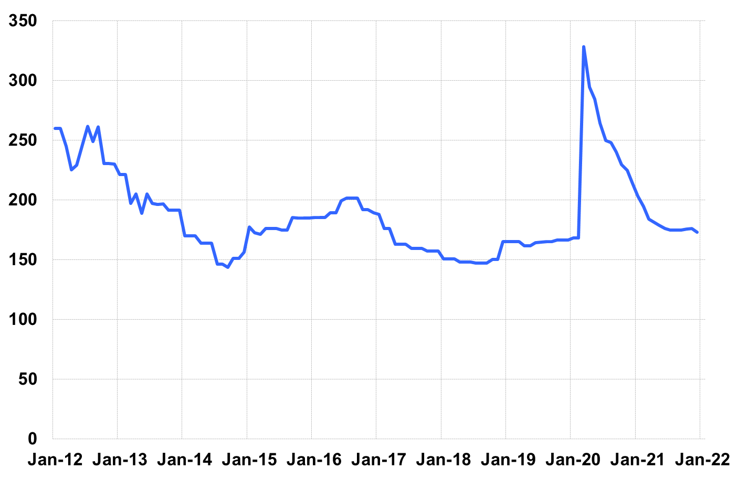

Source: Giliberto-Levy. Chart data are averages of office, apartment, retail and industrial property loans at 60% to 65% LTV for a term of ten years.

The table below summarizes G-L 1 results and statistics. Added detail and analysis will appear in the 4Q 2021 *Giliberto-Levy Monitor*.

|  |  |  |  |  |  |  |  |
| --- | --- | --- | --- | --- | --- | --- | --- |
|  | **G-L 1 Summary** |  |  |  |  |  |  |
|  |  | **Most Recent Period** |  | **Prior Period** |  | **Year Ago Comp. Period** |  |
|  |  | **4Q 2021** |  | **3Q 2021** |  | **4Q 2020** |  |
|  |  |  |  |  |  |  |  |
|  | **Index Results:** |  |  |  |  |  |  |
|  |  |  |  |  |  |  |  |
|  | Total Return | 0.28% |  | 0.42% |  | 1.16% |  |
|  | Income Return | 0.94% |  | 0.94% |  | 0.97% |  |
|  | Capital Value Return | -0.66% |  | -0.52% |  | 0.19% |  |
|  | Credit Effect (bp; annualized) | 4 |  | 3 |  | 4 |  |
|  |  |  |  |  |  |  |  |
|  | **Index-eligible Lending Activity** [Note 1]**:** | |  |  |  |  |  |
|  |  |  |  |  |  |  |  |
|  | Loan Volume ($ billions) | 10.3 |  | 11.0 |  | 7.4 |  |
|  | Weighted Average: |  |  |  |  |  |  |
|  | LTV | 60.7% |  | 61.9% |  | 61.8% |  |
|  | DSCR | 2.17 |  | 2.37 |  | 2.4 |  |
|  | Coupon Rate | 3.09% |  | 2.93% |  | 2.93% |  |
|  | Spread (basis points) [Note 2] | 159 |  | 166 |  | 210 |  |
|  | Term to Maturity (years) | 9.4 |  | 10.2 |  | 10.5 |  |
|  | Loan Size ($ millions) | 34.2 |  | 31.1 |  | 25.5 |  |
|  |  |  |  |  |  |  |  |
|  | Notes: |  |  |  |  |  |  |
|  | 1. Lending activity statistics are subject to revision as more data are received. | | | | | | |
|  | 2. Spread is measured with respect to comparable maturity U.S. Treasury yield. | | | | | | |
|  |  |  |  |  |  |  |  |
|  | Source: Giliberto-Levy |  |  |  |  |  |  |

1. The Index's components are fixed-rate commercial mortgage loans held on balance sheets of institutions such as life insurance companies and pension funds. Index returns are a market-value-weighted blend of office, apartment, retail, industrial, lodging, mixed-use and other miscellaneous property types. Index performance tracks senior loans only; it does not include construction loans, mezzanine and other subordinate instruments and bridge loans made by such institutions.