First Quarter 2022

 | Giliberto-Levy Commercial Mortgage Performance Index
 | First Quarter 2022 Summary
 | Total Return: | Total (all sectors) |  | -4.41
 | (in %) | Office |  | -3.87
 |  | Multi-family |  | -4.68
 |  | Retail |  | -3.96
 |  | Industrial |  | -4.70
 | Index Statistics: | Capitalization ($ billion) |  | 291.03
 | (as of 3/31/2021) | Duration (years) |  | 5.18
 |  | Coupon (%) |  | 3.89
 |  | Maturity (years) |  | 7.11
 |  | Book LTV (%) |  | 45.32
 | Source: Giliberto-Levy

The Giliberto-Levy Commercial Mortgage Performance Index (G-L 1) posted a -4.41% total return for 1Q 2022. Treasury yields rose at all points on the yield curve, leading to a –5.32% capital value decline in the index. Commercial mortgage credit spreads compressed slightly early in the quarter but shot up in March (see Chart 1). We have pointed out in the past that about two-thirds of the time a change in Treasury yields is accompanied by a credit-spread move in the opposite direction. 1Q 2022 fell into the one-third of instances in which Treasury yields and mortgage spreads move in the same direction.

Investment-grade CMBS generated -5.56% total return, according to Bloomberg Barclays Indices. As noted in earlier reports, G-L 1’s income return is higher, coming in 16 bp above CMBS for 1Q. CMBS capital values declined about 100 basis points (bp) more than G-L 1. Most of the difference in the capital value effect arose from the shorter weighted-average maturity for CMBS: about five years for CMBS versus a bit more than seven years for G-L 1. Treasury yield increases averaged 136 bp for issues with one to five years of remaining term, while the average increase for seven years and greater was 74 bp.

We estimate that the “double whammy” of Treasury yield and spread increases caused coupon rates on ten-year loans to rise by more than 90 bp from December 31, 2021 to March 31, 2022. This is likely to dampen the pace of lending in 2Q 2022.

Chart 1. Spreads over Treasuries for Ten-year Commercial Mortgages
In basis points, reflecting 30/360-day count convention

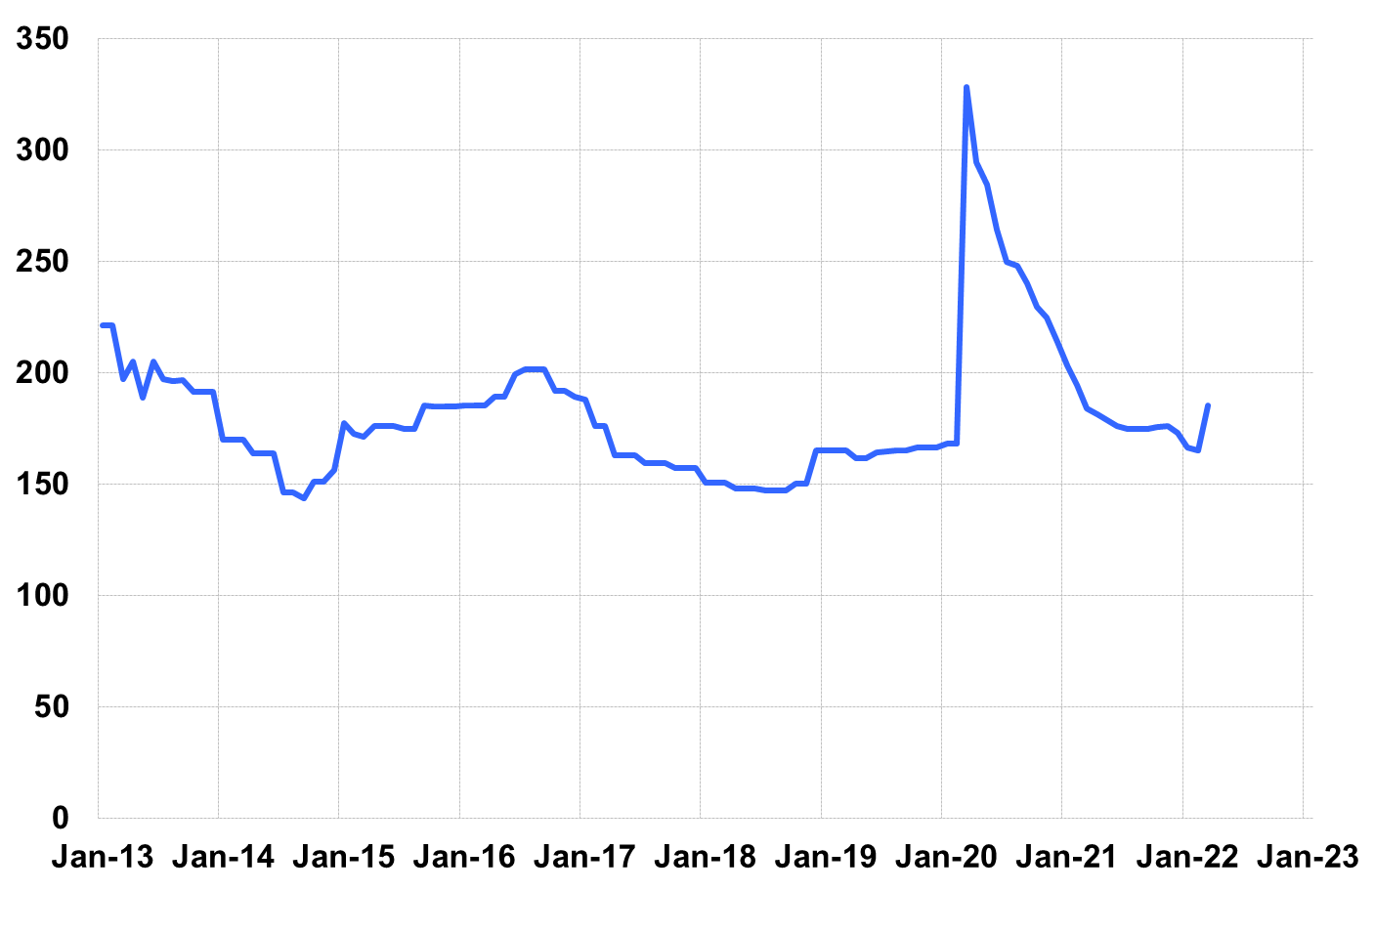

Source: Giliberto-Levy. Chart data are averages of office, apartment, retail and industrial property loans at 60% to 65% LTV for a term of ten years.

The table below summarizes G-L 1 results and statistics. Added detail and analysis will appear in the 1Q 2022 Giliberto-Levy Monitor.

 | G-L 1 Summary
 |  | Most Recent Period |  | Prior Period |  | Year Ago Comp. Period
 |  | 1Q 2022 |  | 4Q 2021 |  | 1Q 2021
 | Index Results:
 | Total Return | -4.41% |  | 0.28% |  | 1.16%
 | Income Return | 0.91% |  | 0.94% |  | 0.97%
 | Capital Value Return | -5.32% |  | -0.66% |  | 0.19%
 | Credit Effect (bp; annualized) | 3 |  | 3 |  | 6
 | Index-eligible Lending Activity [Note 1]:
 | Loan Volume ($ billions) | 12.7 |  | 11.3 |  | 6.6
 | Weighted Average:
 | LTV | 59.1% |  | 60.7% |  | 59.9%
 | DSCR | 1.96 |  | 2.16 |  | 2.38
 | Coupon Rate | 3.57% |  | 3.08% |  | 3.03%
 | Spread (basis points) [Note 2] | 163 |  | 158 |  | 168
 | Term to Maturity (years) | 10.6 |  | 9.6 |  | 11.0
 | Loan Size ($ millions) | 39.2 |  | 34.2 |  | 20.0
 | Notes:
 | 1. Lending activity statistics are subject to revision as more data are received.
 | 2. Spread is measured with respect to comparable maturity U.S. Treasury yield.
 | Source: Giliberto-Levy

The Index's components are fixed-rate commercial mortgage loans held on balance sheets of institutions such as life insurance companies and pension funds. Index returns are a market-value-weighted blend of office, apartment, retail, industrial, lodging, mixed-use and other miscellaneous property types. Index performance tracks senior loans only; it does not include construction loans, mezzanine and other subordinate instruments and bridge loans made by such institutions.

