# **Second Quarter 2022**

|  |  |  |  |  |  |
| --- | --- | --- | --- | --- | --- |
|  | **Giliberto-Levy Commercial Mortgage Performance Index** | | | |  |
|  | **Second Quarter 2022 Summary** | | |  |  |
|  |  |  |  |  |  |
|  | **Total Return:** | Total (all sectors) | | -1.94 |  |
|  | (in %) | Office |  | -1.47 |  |
|  |  | Multi-family | | -2.20 |  |
|  |  | Retail |  | -1.54 |  |
|  |  | Industrial |  | -2.15 |  |
|  | **Index Statistics:** | Capitalization ($ billion) | | 286.30 |  |
|  | (as of 6/30/2022) | Duration (years) | | 5.05 |  |
|  |  | Coupon (%) | | 3.90 |  |
|  |  | Maturity (years) | | 6.98 |  |
|  |  | Book LTV (%) |  | 44.62 |  |
|  |  |  |  |  |  |
|  | Source: Giliberto-Levy | |  |  |  |

**The Giliberto-Levy Commercial Mortgage Performance Index (G-L 1) produced -1.94% total return for 2Q 2022.** [1]As in 1Q,Treasury yields rose at all points on the yield curve. This caused a –2.93% capital value change in the index. After a sharp uptick in March 2022, commercial mortgage credit spreads were mostly flat during the quarter. However, we noted some increases in June (see Chart 1**).** Although this barely registered in Chart 1, the intra-month reduction in Treasury yields – the ten-year peaked at 3.49% in mid-June and was down to 2.98% at month end – could have prompted spread increases.

We noted last quarter that coupon rate increases likely would dampen the pace of lending in 2Q. Loan production volume did fall back meaningfully from 1Q’s strong showing (see the summary table below).

Investment-grade CMBS posted -2.88% total return, according to Bloomberg Barclays Indices. Interestingly, both G-L 1 and CMBS returns were in the same zone as intermediate-term Treasury issues. In contrast, corporate bonds experienced another drubbing: Baa-rated bonds with duration like G-L 1 were down more than 5%.

Chart 1. Spreads over Treasuries for Ten-year Commercial Mortgages

In basis points, reflecting 30/360-day count convention

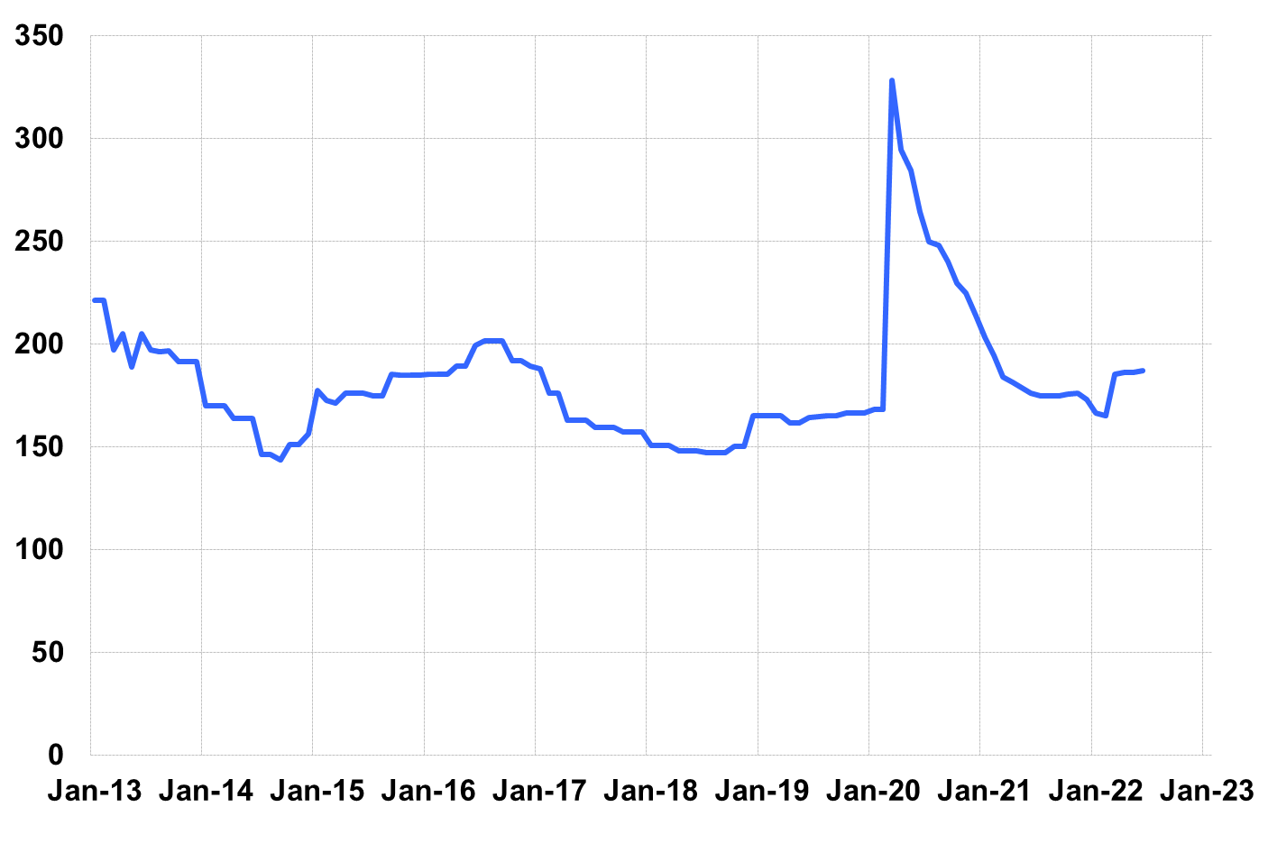

Source: Giliberto-Levy. Chart data are averages of office, apartment, retail and industrial property loans at 60% to 65% LTV for a term of ten years.

The table below summarizes G-L 1 results and statistics. Added detail and analysis will appear in the 2Q 2022 *Giliberto-Levy Monitor*.

|  |  |  |  |  |  |  |  |
| --- | --- | --- | --- | --- | --- | --- | --- |
|  | **G-L 1 Summary** |  |  |  |  |  |  |
|  |  | **Most Recent Period** |  | **Prior Period** |  | **Year Ago Comp. Period** |  |
|  |  | **2Q 2022** |  | **1Q 2022** |  | **2Q 2021** |  |
|  |  |  |  |  |  |  |  |
|  | **Index Results:** |  |  |  |  |  |  |
|  |  |  |  |  |  |  |  |
|  | Total Return | -1.94% |  | -4.41% |  | 2.45% |  |
|  | Income Return | 0.98% |  | 0.91% |  | 0.97% |  |
|  | Capital Value Return | -2.93% |  | -5.32% |  | 1.47% |  |
|  | Credit Effect (bp; annualized) | 4 |  | 3 |  | 6 |  |
|  |  |  |  |  |  |  |  |
|  | **Index-eligible Lending Activity** [Note 1]**:** | |  |  |  |  |  |
|  |  |  |  |  |  |  |  |
|  | Loan Volume ($ billions) | 5.9 |  | 14.1 |  | 8.9 |  |
|  | Weighted Average: |  |  |  |  |  |  |
|  | LTV | 59.6% |  | 58.9% |  | 59.6% |  |
|  | DSCR | 1.50 |  | 1.96 |  | 2.29 |  |
|  | Coupon Rate | 4.64% |  | 3.61% |  | 3.11% |  |
|  | Spread (basis points) [Note 2] | 174 |  | 163 |  | 157 |  |
|  | Term to Maturity (years) | 10.1 |  | 9.8 |  | 10.5 |  |
|  | Loan Size ($ millions) | 29.4 |  | 38.7 |  | 28.2 |  |
|  |  |  |  |  |  |  |  |
|  | Notes: |  |  |  |  |  |  |
|  | 1. Lending activity statistics are subject to revision as additional data are received. | | | | | | |
|  | 2. Spread is measured with respect to comparable maturity U.S. Treasury yield. | | | | | | |
|  |  |  |  |  |  |  |  |
|  | Source: Giliberto-Levy |  |  |  |  |  |  |

1. The Index's components are fixed-rate commercial mortgage loans held on balance sheets of institutions such as life insurance companies and pension funds. Index returns are a market-value-weighted blend of office, apartment, retail, industrial, lodging, mixed-use and other miscellaneous property types. Index performance tracks senior loans only; it does not include construction loans, mezzanine and other subordinate instruments and bridge loans made by such institutions.